LOG EVALUATION RESULTS
IN THE DEEP BASIN AREA OF ALBERTA

E. R. Crain, P. Eng.
E. R. Crain and Associates Ltd.
Presented by at the 8th Formation Evaluation Symposium, Canadian Well Logging Society, September 1981. Published in CWLS Journal Vol. 11 No 1 Dec 1982. This electronic version created Jan 2021.

ABSTRACT
A log evaluation based on random wells was undertaken to determine the gas-in-place in various formations in the Deep Basin area of Alberta. In addition, comparison of log analysis porosity and water saturation, core porosity and permeability, and in-situ (pressure build-up) flow capacity was made in order to find a relationship between log analysis porosity (or saturation or both) and well performance. Log to core comparisons were adequate, but core to in-situ data failed to produce an acceptable correlation. Thus no method was found, during this investigation, to predict well performance from log analysis data alone.

SUMMARY DF STUDY
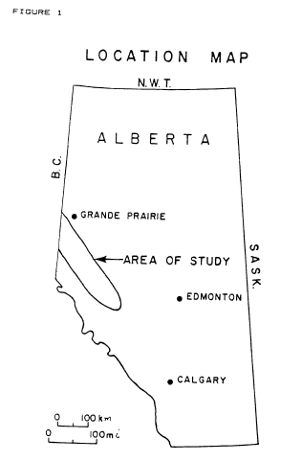
A study was undertaken to evaluate a number of wells drilled in the Deep Basin area of Alberta with the intent to determine:
1. total gas-in-place (i.e., the resource base) for the gas bearing zones in the area,
2. a relationship, if one existed, between porosity and permeability, so that log analysis results (hydrocarbon-meters or porosity-meters) could be used to predict apparent zone quality (permeability or permeability-meters),
3. a relationship, if one existed, between apparent zone quality and actual well performance, based on long term build-up tests both before and after fracturing.
The results were to be used to help evaluate the resource base in the Deep Basin, and to provide information needed for deliverability and supply cost estimates for the area. This paper discusses only the log analysis methods and results, and does not deal with the supply-cost estimates which were undertaken by another consulting firm.
Figure 1

To accomplish these objectives, we first computed a Log/Mate analysis on all prospective zones in 50 wells selected at random throughout the 200 township area. Data from 150 wells (500 zones) in the same area had been studied for other clients and, with their consent, the core versus log calibration data and selected results from most of these wells were incorporated into this study.

Since this data could be from so-called "sweet-spots", the 50 random wells were thought necessary to remove any bias, and thus prevent too optimistic a result. We then summarized, for various cutoffs on separate data files, the porosity-meters, hydrocarbon meters and net pay-meters for the 50 random wells and the 150 non-random wells. In addition, data from 19 specially selected wells were added to another file as these wells had extensive pressure build-up data for correlating log response to productivity. Crossplots of core permeability versus core porosity, and overlays of core porosity and log analysis porosity were made to demonstrate the direct relationship between these properties.

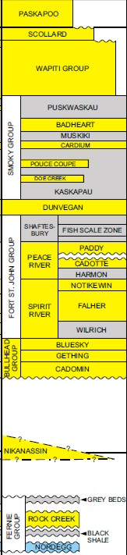
Finally, pore volume, hydrocarbon volume and net pay at various cutoffs were compared to well productivity before and after fracturing. No relationship was found to exist between these computed log properties and productivity, even though a good relationship exists between log analysis results and core analysis data. This demonstrates that, at least for now, there is an insurmountable problem in translating gas-in-place figures into economic terms in tight sands such as these, due mainly to the fact that core permeability or core-derived well productivity does not seem to correlate with in-situ data from extended pressure build-up data.

METHOD OF STUDY
The area of the study in the Deep Basin of Alberta was chosen to run in a northwest-southeast direction centered on a line extending from Twp. 46- 16W5 to the British Columbia border at Twp. 76-13W6, roughly 200 miles long by 40 miles wide. This is a smaller area than that postulated by other proponents of the Deep Basin concept. We did not extend the study into British Columbia, as we were requested to confine our attention to the Alberta portion of the basin. A sketch map of the area is given in Figure 1.

On the basis of previous work in the area, and according to published or public data, there are many prospective zones in the basin, ranging in age from late Upper Cretaceous to Lower Mississippian, and possibly Devonian as well. The stratigraphic sequence is shown in Figure 2.

This study did not evaluate zones below the Nordegg, but previous work, portions of which are incorporated into this report, evaluated zones to the Debolt (Mississippian).

Data available to us at the start of the study included about 600 Log/Mate analyses of some 180 wells in the area. The raw data and results were stored on disc in digital form, the work having been performed for a variety of clients. Permission was obtained from two companies to use their data as a component of this study, giving us some 500 zones in 150 wells to add to the statistical base.

FIGURE 2
Because this data was clearly from areas of interest within the study area, we felt that it may show a bias in favour of high reserves estimates if applied to the entire basin. Thus 50 additional wells, chosen at random, were selected and analyzed. The selection criteria were as follows:
1. no more than one well per township.
2. well penetrated to Spirit River or deeper.
3. well had good logging suite - eg: sonic, density and neutron, or any two of the three logs had been run.
4. preferably cored or tested in one or more zones.

These 50 zones are thus spread relatively uniformly across the study area. Nine wells were later rejected due to inadequate log data or logging suite.
To aid in calibration of log analysis results, a further 19 wells were selected, corresponding to wells with extensive pressure build-up tests. Only the zone tested was analyzed. The log analysis was performed using our proprietary Log/Mate evaluation system.
The steps taken were as follows:

1. selected zones of interest by inspection of the logs, and edited the logs,
2. digitized selected intervals, plotted raw data as a quality control step, and re-edited where necessary,
3. chose interpretation parameters and ran preliminary computations for cored and tested intervals,
4. compared results with core and DST data, and adjusted depths and parameters to obtain a reasonable match,
5. computed balance of the zones, using similar (but not always identical) interpretation parameters,
6. reviewed and compared preliminary computations of all subsequent zones, adjusted parameters, and re-computed as necessary,
7. plotted and printed final results,
8. computed porosity-meters and hydrocarbon-meters with various cutoffs for the entire analyzed interval, and for specific zones,
9. printed formation summaries and averages from summary files,
10. assembled and delivered results in loose-leaf binders.

The computation model varied with the data type and quality, and in order of preference was the following:

1. shaley-sand density-neutron crossplot method, where hole condition permitted and if logs were available,
2. sonic log porosity in bad hole or where density and/or neutron data was unavailable. (Some wells were done with this method even when density and neutron log data were available, in order to meet time deadlines),
3. in zones below the Nordegg, the complex lithology model was used, which is also a density-neutron crossplot method, with the sonic log porosity being used in bad hole.

All three of these methods correct for the presence of shale in the zone. Shale content was derived from the gamma-ray log response using a linear interpolation technique. Other computation models may be equally valid, but these were not investigated for this study.

Various parameters in the interpretation model were varied for each zone. These reflect changes in the shale, matrix rock and fluid properties of the zone. The values can be derived in various ways by comparison with core data. This was done on all wells incorporated in this study where core data was available.

Fortunately we have found the values to be quite consistent throughout the area, provided logs are normalized between wells. A few wells required shifts to logs to give consistent results. This was kept to a minimum, and wells were discarded from the study if the logs were not good enough, or if they required too much editing and shifting.

The usual parameters for the zones computed in this study are shown in the Table 1. These were varied from time to time to account for perceived changes in tool response between service companies or for log mis-calibration. Standard values of a = 0.62, m = 2.15 and n = 2.00 were used, since no special core studies were available to us.

TABLE 1: ANALYSIS PARAMETERS
Zone Name | Neutron Log Shale Value  PHINSH% |  | Density Log Shale Value  PHIDSH% | Matrix Density  RHOMA  gm/cc  (Kg/m³) | Sonic Log Shale Value  DELTSH usec/ft  (usec/m) | Sonic Log Matrix Value  DELTMA  Usec/ft  (usec/m) | Shale Resistivity  RSH  ohm-m | Water Resistivity  RW@FT  ohm-m | Formation Temp.  FT  ºF (ºC)
Bad Heart Cardium  Doe Creek Dunvegan | 30 |  | 0 to 10  Average 2 | 2.65 (2650) | 81 (265)  to  77 (253) | 55 (182) | 20 | 0.30 | 140 (40)
Paddy Cadotte | 27 |  | 2 | 2.67 (2670) | 77 (253) | 53 (174) | 20 | 0.20 | 122 (50)
Spirit River Falher | 27 |  | 2 | 2.69 (2690) | 70 (230) | 51 (167) | 20 | 0.15 | 131 (55)
Bluesky Gething | 27 |  | 0 | 2.69 (2690) | 70 (230) | 53 (174) | 25 | 0.10 | 149 (65)
Cadomin Nikanassin | 27 |  | 3 | 2.67 (2670) | 66 (215) | 51 (167) | 20 | 0.07 | 167 (75)
Halfway Doig Charlie Lake | 15 |  | -6 | 2.71 (2710) | 60 (197) | 48 (157) | 50 | 0.06 | 176 (80)
Belloy Stoddart Debolt | 10 |  | -6 | 2.71 (2710) | 60 (197) | 48 (157) | 50 | 0.05 | 185 (85)
Devonian | 10 |  | -6 | 2.71 (2710) | 60 (197) | 44 (144) | 50 | 0.04 | 195 (90)

Typical LOG/MATE results, alonq with comparisons to core porosity, are shown in Figures 3 through 7 for the Falher, Nikanassin, Gething, Cadotte and Cardium zones respectively.
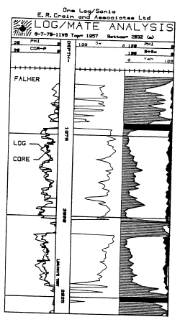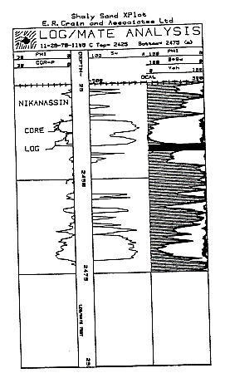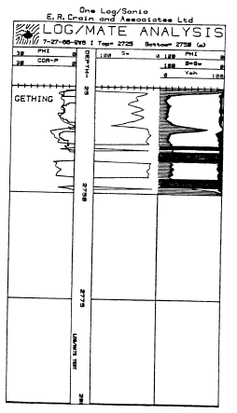
FIGURE 3 - Falher FIGURE 4 - Nikanassin FIGURE 5 - Gething,
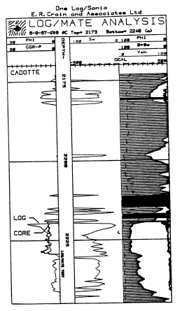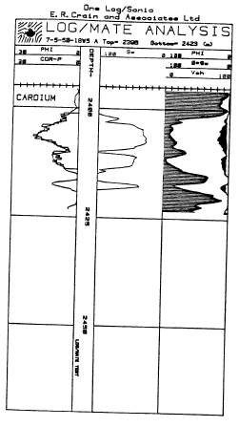
FIGURE 6 - Cadotte FIGURE 7 - Cardium
To illustrate the log to core comparison in a different way, we plotted core porosity versus log porosity crossplots. The example in Figure 8 is typical for the Falher (same data as Figure 3).
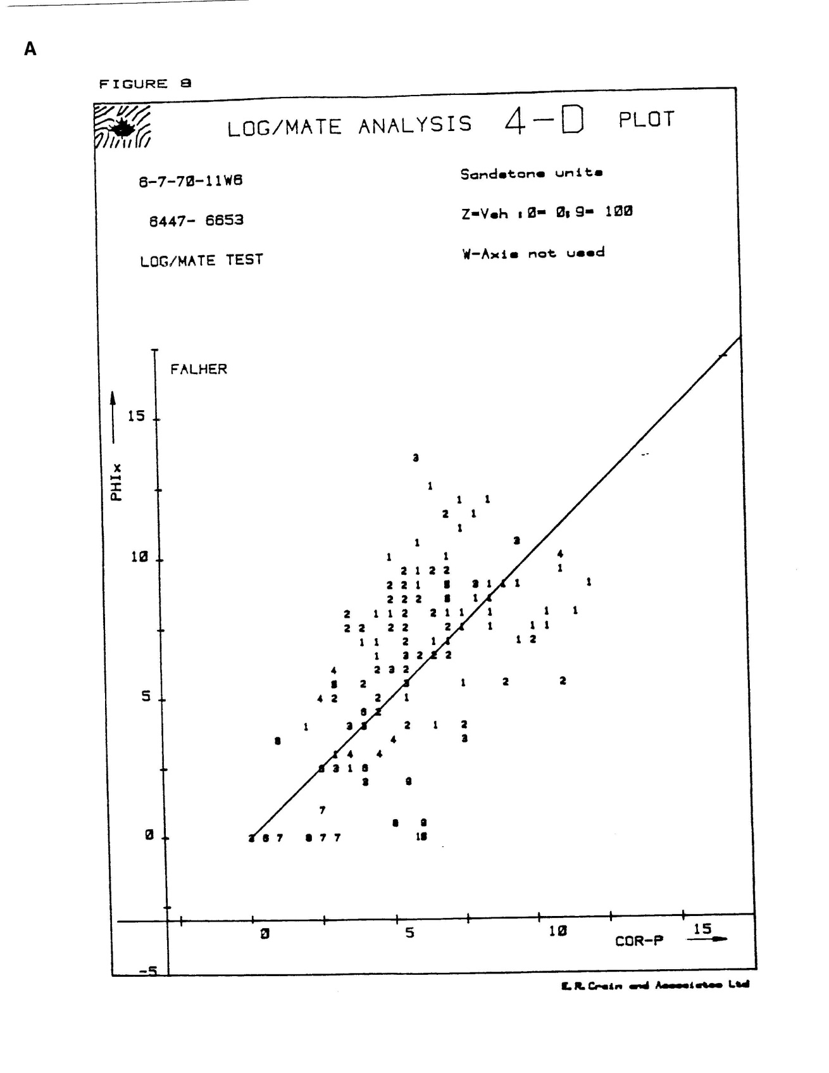
FIGURE 8: Core Porosity vs Log Analysis Porosity
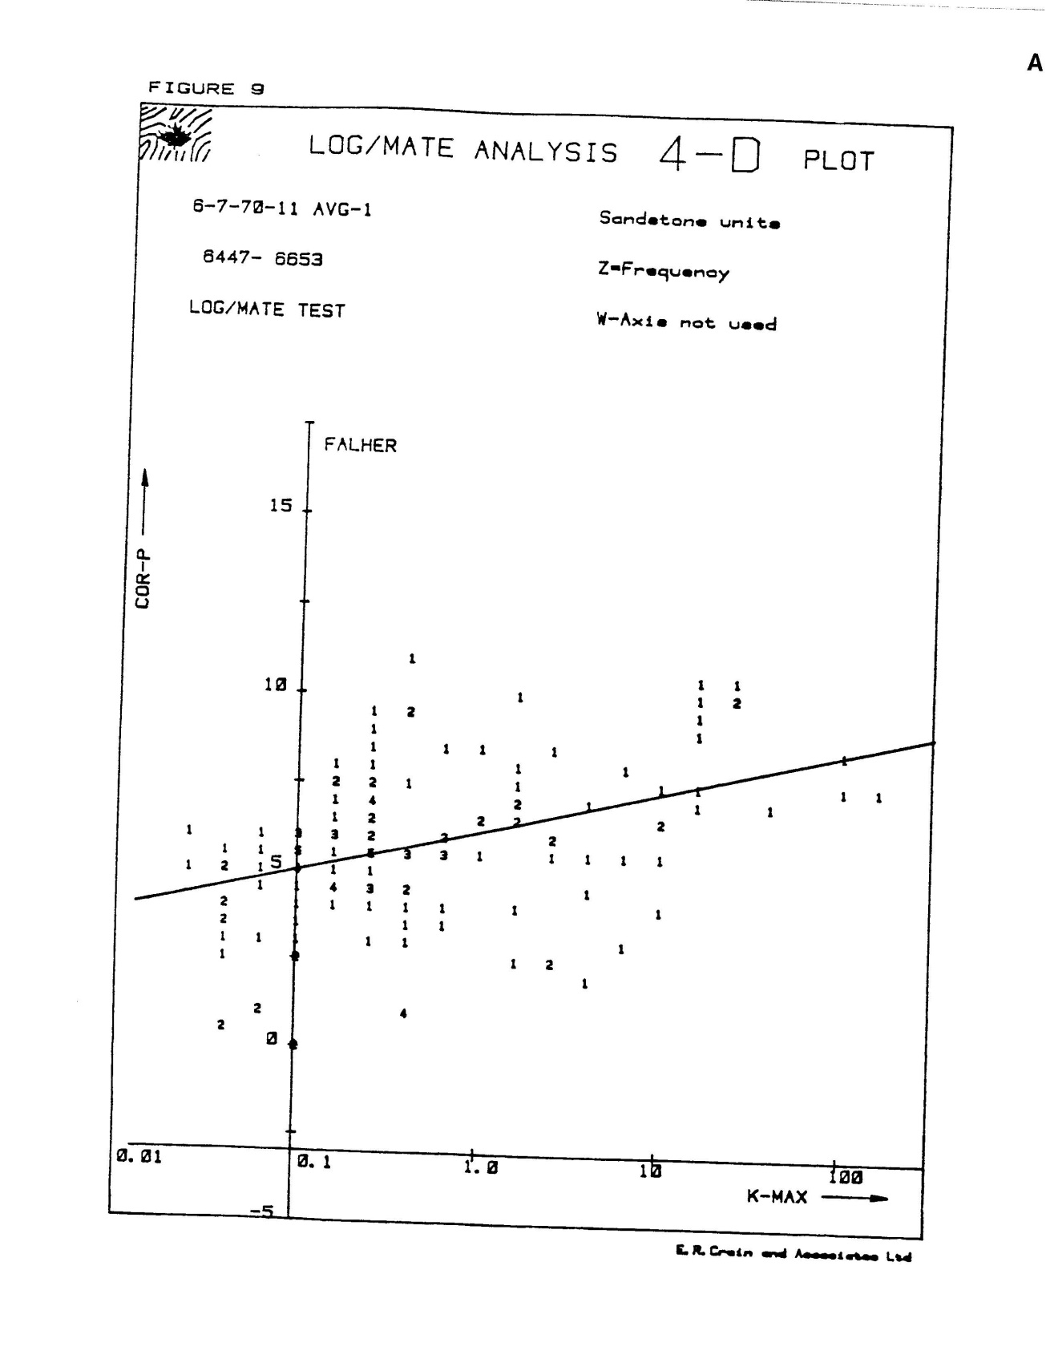
FIGURE 9: Core Permeability vs Core Porosity
We have found also that there is a reasonable correlation between core permeability and core porosity when plotted on semi-log paper (and hence a correlation between log analysis porosity and core permeability). This relationship is shown for a typical Falher well in Figure 9. The slope of the best-fit line is fairly flat, so small changes in porosity are significant.
Flow capacity (permeability-meters) calculated from core were compared to in-situ build-up test flow capacity. The results for a few of the more consistent data points is given in Figure 10, showing a 10 to 1000 times difference between core and in-situ values.
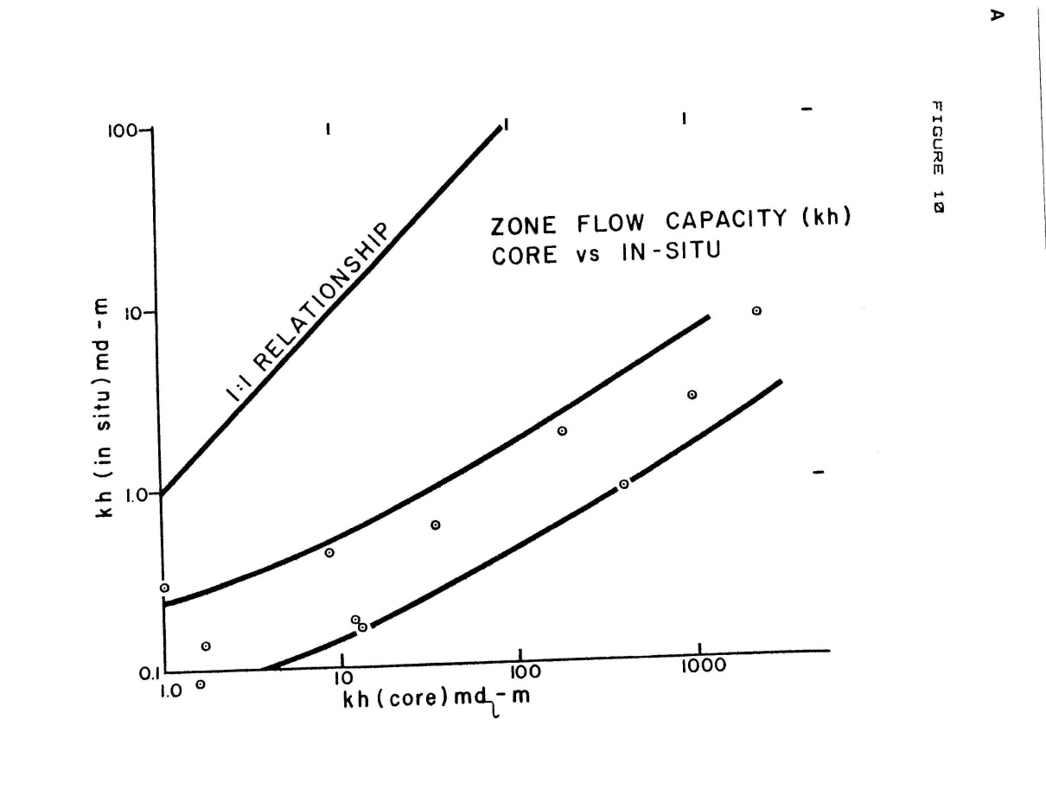
FIGURE 10: Flow Capacity from Pressure Build-Up vs Core KH

We concluded that the permeability (or permeability-meters) measured on cores does not correlate with in-situ values measured by conventional build-up test analysis. This may be due to changes to the core due to expansion and drying (or other measurement errors which have been known to be fairly small, or to errors in choosing the thickness value for the comparison that have the potential for a large error, or to inappropriate use of Horner or other methods for analysis of pressure data in these ultra-low permeability zones.

Since there is a good correlation between core porosity and core permeability, and between core porosity and log analysis porosity, there is a good relationship between log analysis porosity and core permeability. Due to our inability to match core Kh with in-situ Kh, we have no correlation between log analysis porosity and well performance.

Lack of resolution of this problem was a major disappointment in this study. However, both time and cost limits precluded any further research beyond that presented in this report. We are aware that such work is being actively pursued by others, and we hope to see results published at a later date.

RESULTS OF THE STUDY
Detailed listings of the pore volume, hydrocarbon volume, and net pay at various cutoffs were generated for the 41 random wells, for the 19 special wells and for the 150 non-random wells. The figures for the random wells at 5% porosity cutoff are summarized below:

TABLE 2: SUMMARY of RESULTS
Formation Name | No. of Zones | Avg Net  Pay-meters
Belly River | 1 | 8.5
Bad Heart | 15 | 2.0
Cardium | 35 | 9.0
Dunvegan | 22 | 8.2
Shaftedbury | 1 | 10.6
Paddy/Cadotte | 35 | 6.1
Spirit River | 30 | 30.1
Bluesky/Gething | 31 | 13.5
Cadomin | 17 | 36.6
Nikanassin | 7 | 23.8
Rock Creek/Nordegg | 6 | 5.9
TOTAL | 200
AVERAGE PER WELL | 4.9 | 58.8

Data from the 150 non-random wells (possibly biased by "sweet-spots") and the 19 special wells (definitely biased by "sweet-spots") produced similar average net pay, average porosity and average water saturation. This suggests that a large number of potential gas zones, with thick net pay intervals, and apparently ubiquitous gas saturation, are present in the Deep Basin of Alberta. This is no longer news, but some interesting points develop:
1. the log analysis suggests a very high gas-in-place figure based on the net pay, porosity, and water saturation figures - which are confirmed by cores,
2. "sweet-spots" of high productivity are not easily seen by log analysis,
3. much of the gas-in-place is in low porosity rock, which suggests very low recovery factors at foreseeable wellhead net-back prices, because of the high cost of delivery of such gas.

CONCLUSIONS
The following conclusions can be drawn:
1. Log analysis for porosity and water saturation is relatively straightforward in the Deep Basin area, and can be made to match core analysis data rather easily, using standard log analysis models.
2. Log analysis porosity and core analysis permeability are related in a semi-logarithmic function, at least in low permeabiities in the range 0.1 to 10 md.
3. Core permeability does not appear to reflect in-situ permeability as measured by extended build-up tests.
4. It does not seem practical at the moment to use log analysis results to predict in-situ permeability, and hence well productivity.
5. Further investigation would be required to resolve the discrepancy between Kh from core and Kh from build-up tests, which in turn might allow the use of hydrocarbon volume data from log analysis, at particular cutoffs, to be used as a prediction of well performance.

