MYTH-INTERPRETATION
PART 1
E. R. Crain, P.Eng.
Spectrum 2000 Mindware Ltd
Published in CWLS InSite Sept 2005.
Myth #1: Tornado Charts Correct for Invasion
The invasion correction for induction logs, as defined by service company tornado charts (see Figure 1), are supposed to correct the deep induction reading (RESD) to obtain a better value for true resistivity (Rt), based on the additional information contained in the shallow resistivity (RESS) and the medium resistivity (RESM). Most log analysis software packages have approximations to these charts built into the environmental correction module.
In a typical fresh mud scenario with invasion into a formation containing only salty formation water, the induction log curves are usually in the order RESD <= RESM <= RESS. The tornado chart computes a value for Rt that is less than or equal to RESD. This is a very rational solution.
However, if the resistivity curves are not in the order given above, no correction is applied and Rt = RESD. This can occur in a water zone if a low resistivity annulus occurs. In this scenario, RESM <= RESD <= RESS and these data points do not fall on typical tornado charts. So the tornado chart (and its equivalent computer algorithm) makes no correction and the Rt is not correct.
Worse yet, invasion into an oil or gas zone usually creates data sets that also do not fall on the tornado chart, so again, no correction is made, even if one is actually needed. If by chance the curves are in the order RESD <= RESM <= RESS, a correction will be made, but in the wrong direction – Rt will be made less than RESD. This is counter-intuitive, as invasion of even relatively fresh mud filtrate into an oil or gas zone will reduce resistivity. The tornado chart should increase Rt derived from RESD, not lower it or do nothing.
Below is a sample sensitivity analysis that shows that the correction factor (Rt/RESD) is greater than 1.0 for many real situations. Note that the same factor (Rt/Rild) on Figure 1 is never greater than 1.0. I have assumed a simplified step invasion model and the math model I used is shown below. You might want to try the math in a spreadsheet and see for yourself what happens. This work is taken from an unpublished research project that attempted to solve the invasion problem in Belly River sands in Alberta.
SENSITIVITY ANALYSIS
WATER SATURATION AND RESISTIVITY WITH INVASION
Archie's Equation
Sw = (A * RW@FT / (PHIe ^ M) / Rt) ^ (1 / N)
Assume A=1.0, M = N = 2.0
Sw = (RW@FT / (PHIe ^ 2) / Rt) ^ 0.5
Rearrange terms
Sw^2 = (RW@FT / (PHIe ^ 2) / Rt)
Solve for Rt in uninvaded oil zone
Rt = (RW@FT / (PHIe ^ 2) / Sw^2)
Solve for Rxo in invaded oil zone
Rxo= (RMF@FT / (PHIe ^ 2) / Sxo^2)
Solve for R0 in uninvaded water zone
R0= (RW@FT / (PHIe ^ 2)
Assume RESD gets 50% of signal from invaded zone and 50% from uninvaded zone
RESD = 1 / ((1 / Rt + 1 / Rxo) / 2)
Solve for SWa in invaded oil or water zone
Swa = (RW@FT / (PHIe ^ 2) / RESD) ^ 0.5
Multiply deep resistivity (RESD) by Rt/RESD ratio to obtain Rt from RESD
INVADED OIL ZONE Sw=0.25 RMF@FT=1.000
Sxo=0.6 Sxo=0.8 Sxo=1.0 Sw=1.0
RW@FT PHIe Rt Rxo R0 RESD SWa Rt/RESD Rt/RESD Rt/RESD Rt/RESD
0.25 0.25 64.0 44.4 4.0 52.5 0.28 1.22 1.78 2.50 0.63
0.25 0.15 177.8 123.5 11.1 145.7 0.28 1.22 1.78 2.50 0.63
0.10 0.25 25.6 44.4 1.6 32.5 0.22 0.79 1.01 1.30 0.55
0.10 0.15 71.1 123.5 4.4 90.2 0.22 0.79 1.01 1.30 0.55
0.03 0.25 7.7 44.4 0.5 13.1 0.19 0.59 0.65 0.74 0.52
0.03 0.15 21.3 123.5 1.3 36.4 0.19 0.59 0.65 0.74 0.52

INVADED OIL ZONE Sw=0.25 RMF@FT=0.50
Sxo=0.6 Sxo=0.8 Sxo=1.0 Sw=1.0
RW@FT PHIe Rt Rxo R0 RESD SWa Rt/RESD Rt/RESD Rt/RESD Rt/RESD
0.25 0.25 64.0 22.2 4.0 33.0 0.35 1.94 3.06 4.50 0.75
0.25 0.15 177.8 61.7 11.1 91.6 0.35 1.94 3.06 4.50 0.75
0.10 0.25 25.6 22.2 1.6 23.8 0.26 1.08 1.52 2.10 0.60
0.10 0.15 71.1 61.7 4.4 66.1 0.26 1.08 1.52 2.10 0.60
0.03 0.25 7.7 22.2 0.5 11.4 0.21 0.67 0.81 0.98 0.53
0.03 0.15 21.3 61.7 1.3 31.7 0.21 0.67 0.81 0.98 0.56

INVADED OIL ZONE Sw=0.25 RMF@FT=0.25
Sxo=0.6 Sxo=0.8 Sxo=1.0 Sw=1.0
RW@FT PHIe Rt Rxo R0 RESD SWa Rt/RESD Rt/RESD Rt/RESD Rt/RESD
0.25 0.25 64.0 11.1 4.0 18.9 0.46 3.38 5.62 8.50 1.00
0.25 0.15 177.8 30.9 11.1 52.6 0.46 3.38 5.62 8.50 1.00
0.10 0.25 25.6 11.1 1.6 15.5 0.32 1.65 2.55 3.70 0.70
0.10 0.15 71.1 30.9 4.4 43.0 0.32 1.65 2.55 3.70 0.70
0.03 0.25 7.7 11.1 0.5 9.1 0.23 0.85 1.11 1.46 0.56
0.03 0.15 21.3 30.9 1.3 25.2 0.23 0.85 1.11 1.46 0.56

INVADED OIL ZONE Sw=0.25 RMF@FT=0.10
Sxo=0.6 Sxo=0.8 Sxo=1.0 Sw=1.0
RW@FT PHIe Rt Rxo R0 RESD SWa Rt/RESD Rt/RESD Rt/RESD Rt/RESD
0.25 0.25 64.0 4.4 4.0 8.3 0.69 7.70 13.30 20.5 1.75
0.25 0.15 177.8 12.3 11.1 23.1 0.69 7.70 13.30 20.5 1.75
0.10 0.25 25.6 4.4 1.6 7.6 0.46 3.38 5.62 8.50 1.00
0.10 0.15 71.1 12.3 4.4 21.0 0.46 3.38 5.62 8.50 1.00
0.03 0.25 7.7 4.4 0.5 5.6 0.29 1.36 2.04 2.90 0.65
0.03 0.15 21.3 12.3 1.3 15.6 0.29 1.36 2.04 2.90 0.65

In all four tables, SW is assumed to be 0.25 and Sxo has values of 0.6, 0.8, and 1.0. The ratio Rt/RESD is the correction factor to find Rt for various RW and porosity values (assumed in the left hand columns of each table). The four tables represent four different RMF values. Rt, Rxo, and R0 are computed from the given data. RESD is computed from Rt and Rxo. SWa is calculated from this RESD and the given porosity and RW. You can see that the apparent water saturation (SWa) is too high compared to SW (0.25 for all tables). The right hand column labeled Sw=1.0 is the Rt/RESD for an equivalent water zone – this approximates the correction factor from a tornado chart.

As you can see, the correction factor Rt/RESD is greater than 1.0 for many real scenarios whereas the tornado chart would give a value of 1.0 or less.
Are there correction algorithms out there that can really do invasion corrections in oil and gas zones? I believe the answer is “Yes”. Some modern induction logs present computed values for Rt based on the three (or more) induction curves that were recorded. These results are derived from “invisible” 3–D inversion software inside the service company wellsite computer. But I don’t think you will find such corrections in typical “off the shelf” software.
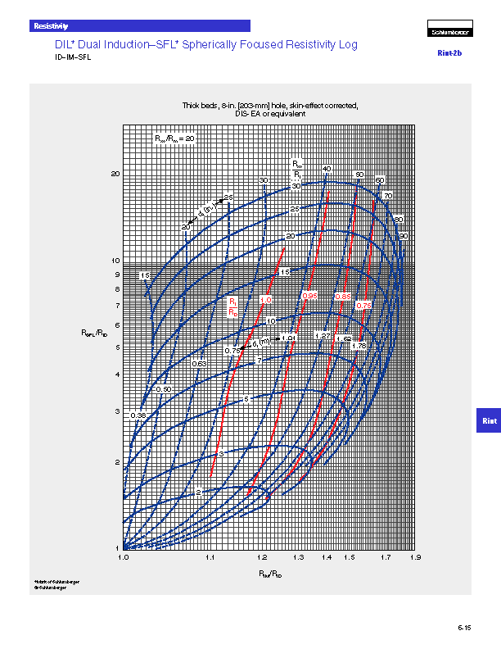
Figure 1: Typical Tornado Chart for an Induction Log (courtesy Schlumberger)

