MYTH-INTERPRETATION
PART 3
E. R. Crain, P.Eng.
Spectrum 2000 Mindware Ltd
Published in CWLS InSite Mar 2006.
Myth #3: High Water Saturation Means Water Production
Sometimes this is true, but often it is not. Pore geometry changes with depth can fool the best analyst. You need more than logs to resolve the issue. Production tests of clean oil from zones with high water saturation will do the trick. So will capillary pressure data from the zone concerned. Nuclear magnetic resonance logs might help, but how many of them have you seen recently?
Vuggy porosity, very fine grained texture, open fractures, and micro-porosity are possible causes of high water saturation, which can be detected from thin section petrology or SEM images.
Increased shaliness is a common cause, not from clay-bound water which is handled by appropriate clay corrections to porosity and saturation, but rather from an overall decrease in grain size coincident with the increased clay content. In a typical coarsening upward shaly sand sequence, it can be difficult to tell whether the zone is getting wet because it is getting shalier, or because we are approaching free water.
In the case of laminated shaly sands, the unexpectedly low resistivity leads to a false calculation of high water saturation. This topic was covered by the author in “Productivity Estimation in Milk River Laminated Shaly Sands, Southeast Alberta” in CWLS InSite, Dec 2004, so we will not deal with it here.
In the worst pore geometry, there may be no oil or gas because the pores are too small to contain both irreducible water and hydrocarbons. Such an interval could occur anywhere within a hydrocarbon column, leaving some confusion as to how best to complete the zone. And there is the special case of gas over water over oil in the McMurray Tar Sands where the high water saturation does indicate moveable water between the gas and the oil.
Finally, the analyst must distinguish depleted oil zones (with residual oil) from zones with naturally high water saturation. It’s a tough job but someone has to do it!
The example below is from a forensic analysis undertaken more than 10 years ago. The reservoir is a pure dolomite reef. Figure 1 illustrates the initial interpretation; Figure 2 shows the revised interpretation after production history and thin sections were reviewed. Figure 3 illustrates the different rock types on a porosity versus water saturation plot. Rock units with similar pore geometries fall along constant porosity – water saturation hyperbola.

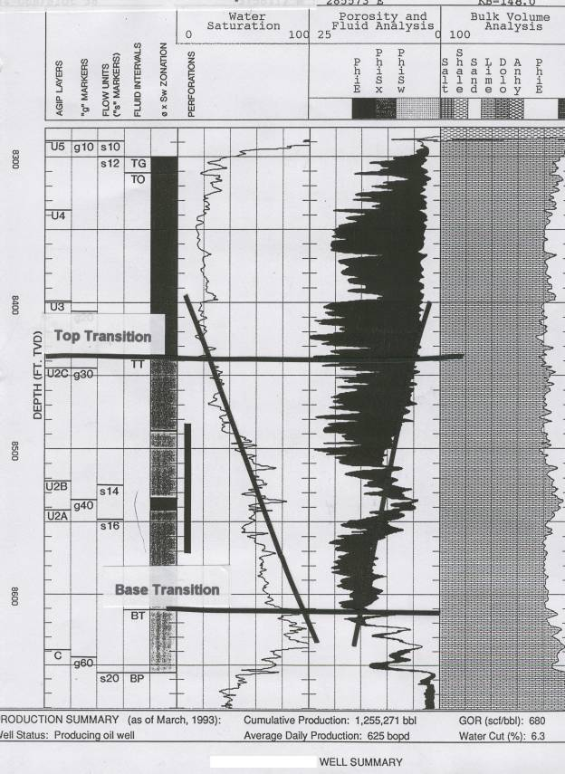
FIGURE 1: Example showing long apparent transition zone. Perfs in this interval produce clean oil so this cannot be a real transition zone.
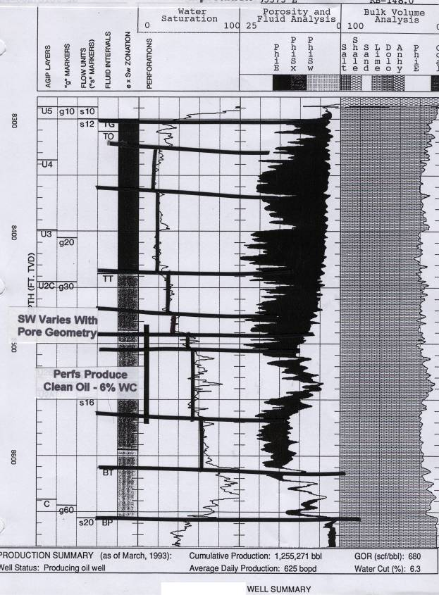FIGURE 2: Same example with short transition zone adjusted to agree with production data. The black bar in the saturation track shows the perforated interval.
The steps shown in the saturation profile represent pore geometry changes caused by progressively increasing isolated vugs. The porosity times water saturation product defines different "rock types” or pore geometry facies. These are shown best in a porosity vs water saturation crossplot with different colours to indicate the different facies, as shown in Figure 3.
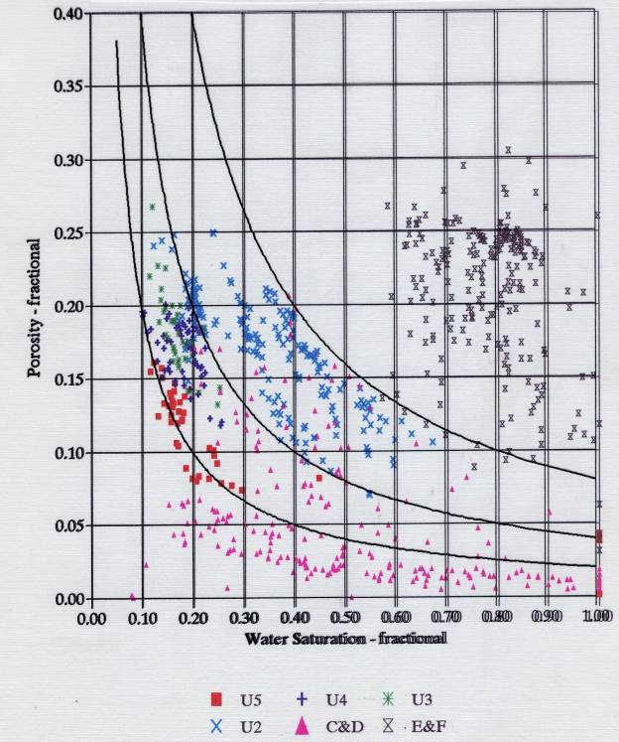FIGURE 3: Porosity vs Water Saturation crossplot showing different rock types tracing different hyperbolic trends. Notice the red triangles with very high water saturation at the bottom center and right – these points will not make any water. The black “X” symbols at middle right are from the water and transition zones and will make water.
It takes a sharp eye to stay dry in heavy weather. An integrated approach to petrophysics is your life preserver when it comes to predicting the possibility of water production.

