UNICORNS IN THE GARDEN OF GOOD AND EVIL
PART 8 – IGNEOUS and METAMORPHIC RESERVOIRS
E. R. (Ross) Crain, P.Eng.
Spectrum 2000 Mindware Ltd
Published in CSPG Reservoir, Jun 2011
Unicorns are beautiful, mythical beasts, much sought after by us mere mortals. The same is true for petrophysical models for unconventional reservoirs. This is the eighth in a series of review articles outlining the simple beauty of some practical methods for log analysis of the unusual.
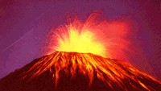
Igneous and Metamorphic BASiCs
Igneous and metamorphic rocks form reservoirs in many parts of the world. Reservoir quality varies and most benefit from natural fractures. Although some geologists believe the hydrocarbons in some granite reservoirs comes from deep in the earth, the majority can be shown to contain hydrocarbons that migrated from conventional sedimentary sources.
Figure 1: Eyjafjallajokull volcano, Iceland, 2010
Metamorphic rocks are conventional sedimentary rocks that have been exposed to high heat and pressure. My personal experience is that density, neutron, sonic and photoelectric values for metamorphic rocks are the same as the sedimentary equivalent although this may not be universally true..
- Contact metamorphism - changes in the rock due to heat from nearby magma.
- Regional metamorphism - causes change through intense heat and pressure.
- Hydrothermal metamorphism - chemical changes in the rock due to the circulation of hot liquids through the rock fractures.
- Fault zone metamorphism - metamorphic changes caused friction at fault movements.
The quality of the rock is based on the amount of heat and pressure applied to it during the metamorphic processes. Changes that occur during metamorphism are:
- Re crystallization - occurs when small crystals join together to create larger crystals of the same mineral.
- Neomorphism - new minerals are created from the original mineral composition.
- Metamorphism - new minerals are created by gaining or losing chemicals.
Specific sedimentary rocks become specific metamorphic rocks, as shown below:
Parent Rock | New Rock
Sandstone | Quartzite
Limestone, Dolomite | Marble
Basalt | Schist or Amphibolite
Shale | Slate
Granite | Schist
Rhyolite | Schist
Igneous rocks are classified in several ways – by composition, texture, and method of emplacement. The composition (mineral mixture) determines the log response. The texture determines the name used for the mineral mixture, and the method of emplacement determines the texture and internal porosity structure (if any).
Intrusive igneous rocks are formed inside the earth. This type of igneous rock cools very slowly and is produced by magma from the interior of the earth. They have large grains, may contain gas pockets, and usually have a high fraction of silicate minerals. Intrusions are called sills when lying roughly horizontal and dikes when near vertical.
Extrusive igneous rocks form on the surface of the earth from lava flows. These cool quickly. They have small grains and contain little to no gas.
Both intrusive and extrusive rocks may contain natural fractures from contraction while cooling, and may have carried non-igneous rocks with them, called xenoliths.
Intrusive rocks may alter the rocks above and below them by metamorphosing (baking) the rock near the intrusion. Extrusives only heat the rock below them, and may not cause much alteration due to rapid cooling. Extrusives can be buried by later sedimentation, and are difficult to distinguish from intrusives, except by their chemical composition and grain size.
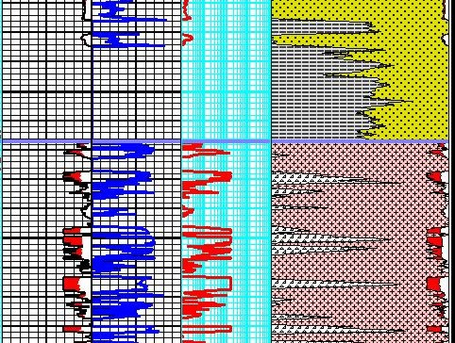
The mineral composition of an igneous rock depends on where and how the rock was formed. Magmas around the world have different mineral make up.
Figure 2: Granite Wash (yellow) and shale (gray) above granite (white) and diorite (tan). Porosity and lithology are calculated from conventional density, neutron, PE methods. Both zones are radioactive so the GR is not used for shale volume.
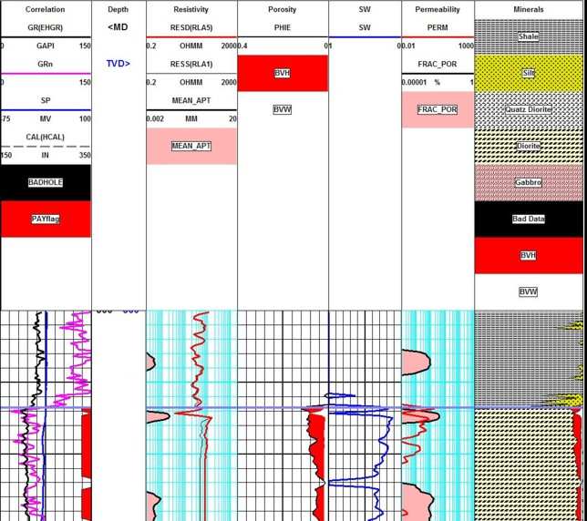
Figure 3: Diorite intrusion covered by shale, open fracture visible as low resistivity spike at top of diorite. Fracture aperture (Track 2) and fracture porosity (Track 5) are from resistivity image processing.

Felsic igneous rocks are light in color and are mostly made up of feldspars and silicates. Common minerals found in felsic rock include quartz, plagioclase feldspar, potassium feldspar (orthoclase), and muscovite. They may contain up to 15% mafic mineral crystals and have a low density.
Mafic igneous rocks are dark colored and consist mainly of magnesium and iron. Common minerals found in mafic rocks include olivine, pyroxene, amphibole, and biotite. They contain about 46-85% mafic mineral crystals and have a high density.
Ultramafic igneous rocks are very dark colored and contain higher amounts of the same common minerals as mafic rocks, about 86-100% mafic mineral crystals.
Intermediate igneous rocks are between light and dark colored. They share minerals with both felsic and mafic rocks. They contain 15 to 45% mafic minerals.
Plutonic and volcanic rocks generally have very low porosity and permeability. Natural fractures may enhance porosity by allowing solution of feldspar grains. Some examples with average porosity as high as 17% are known.
Tuffs and tuffaceous rocks have high total porosity because of vugs or vesicles in a glassy matrix. This is most common in pyroclastic deposits. Interparticle porosity may also exist. Some effort has to be made to separate ineffective microporosity from the total porosity. Pumice (a form of tuff) has enough ineffective porosity to allow the rock to float! When other minerals fill the vesicles by precipitation, the tuff is called a zeolite.
Plutonic | Volcanic | Pyroclastic |  | Gamma Ray
Coarse Crystalline | Fine Crystalline | Glassy | Silica Content | Density
Quartzite |  |  | Highest | Lowest
Granite | Rhyolite | Rhyolite Tuff
Granodiorite | Dacite | Dacite Tuff
Quartz diorite | Andesite | Andesite Tuff
Diorite | Basalt | Zeolite Tuff
Gabbro | Dolerite
Diabase
Dunite |  |  | Lowest | Highest

The numerical data below has worked well in igneous reservoirs using standard lithology models given earlier in this chapter (Mlith-Nlith, DENSma-Uma, etc.).
MATRIX PROPERTIES FOR IGNEOUS ROCKS
 | DENSMA | PE | UMA | PHINMA | DTC_MA | DTS_MA
Quartzite | 2.65 | 1.82 | 4.82 | 0.0 | 55.0 | 101.2
Granite | 2.65 | 2.70 | 7.00 | 1.0 | 50.8 | 82.7
Granodiorite | 2.72 | 3.25 | 8.75 | 2.0 | 55.0 | 97.1
Quartz diorite | 2.81 | 3.56 | 9.91 | 3.5 | 57.0 | 89.9
Diorite | 2.85 | 3.95 | 11.0 | 4.0 | 57.1 | 96.8
Gabbro | 2.94 | 4.80 | 13.3 | 5.0 | 42.4 | 90.1
Diabase | 2.98 |  |  |  | 44.6 | 85.8
Dunite | 3.29 | 3.40 | 11.2 | 4.0 | 38.2 | 76.9
The table is in English units. If you work in Metric units, divide neutron values by 100, multiply density by 1000, and multiply sonic by 3.281.
All these values have a moderate range (+/- 10%) and some tuning may be necessary. Don’t forget to metricate the numbers if needed. Use these matrix values in the matrix density or PE crossplots.
Since a typical log suite can solve for 3 or 4 minerals at best, you need to choose the dominant minerals and zone your work carefully. If you have additional useful log curves, you might try for more minerals or set up several 4 mineral models in a probabilistic solution. A good core or sample description will help you choose a reasonable mineral suite.
Sometimes lithology is determined by triggers. For example, where basalt beds are interspersed between conventional granites or quartzites, it is easy to use the PE or density logs to trigger basalt, leaving the remaining minerals to be defined by a two or three mineral model. This approach is widely used in sedimentary sequences to trigger anhydrite, coal, or salt.
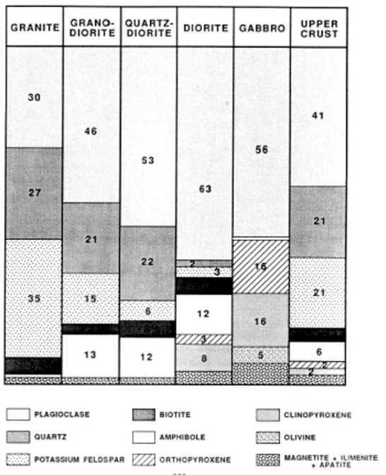
Figure 4: Typical igneous rock mineral composition (courtesy Schlumberger)
Two crossplots are useful for rock identification in metamorphic rocks, as shown in Figures 5 and 6.
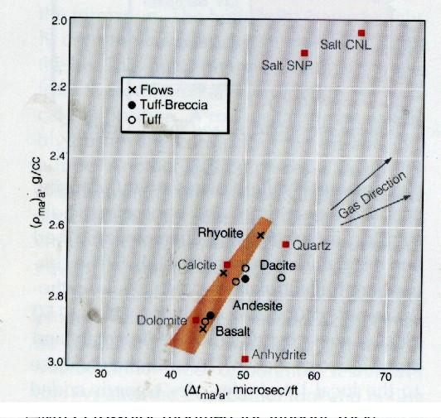
Figure 5: DENSMA vs DTCMA Plot (courtesy Schlumberger)
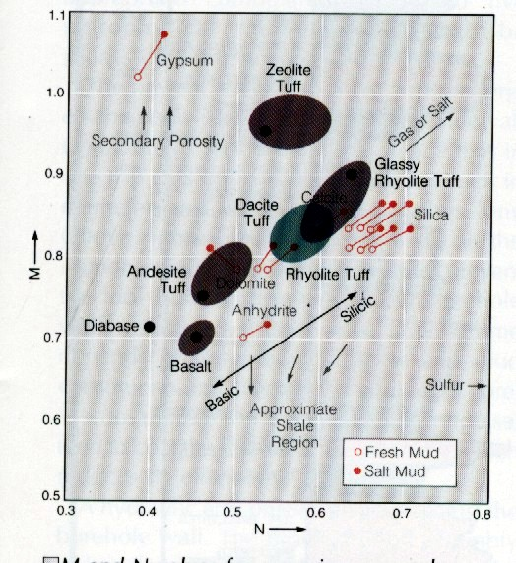
Figure 6: Mlith vs Nlith Plot (courtesy Schlumberger)

METAMORPHIC SAND / Granite Reservoir EXAMPLE
Here is a granite/metamorphic example from Indonesia. The reservoir has a porous granite at the base, metamorphic sandstone above, topped by conventional sandstone. Porosity is moderately low throughout but the gas column is continuous. Interbedded shales (schist or gneiss in the metamorphic interval) are present but do not act as barriers to vertical flow.
In this case, the mineralogy was triggered by quantitative sample descriptions, which in turn were keyed to raw log response to minimize cavings and depth control issues. Porosity and water saturation were derived from conventional log analysis methods. The reservoir is naturally fractured and a fracture intensity curve was generated from anomalies on the open hole logs. This was compared to the fracture intensity from resistivity micro image log data.
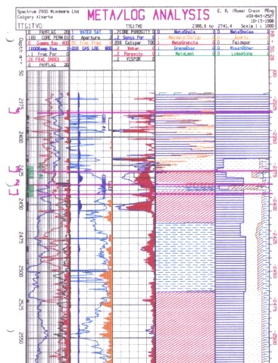
Figure 7: Metamorphic / Granite example with quantitative sample description, calculated lithology, log analysis porosity, saturation, and permeability, with core porosity and permeability overlay. A production log cumulative productivity curve was overlaid on a similar curve generated from log analysis flow capacity (KH). Since this is a gas play, cutoffs are quite liberal.
Quantitative sample description of mineral composition is shown in track five (right-hand track). Interpreted lithology is in track four; computed porosity in track three (middle track). The log analysis porosity matches core reasonably well (center track) and open hole fracture indicators (right edge of track one) correspond to resistivity image log data (left edge of track two).
FRACTURED Granite Reservoir EXAMPLE
Most people forget that there are many unconventional reservoirs in the world, including igneous, metamorphic, and volcanic rocks. Granite reservoirs are prolific in Viet Nam, Libya, and Indonesia. Lesser known granite reservoirs exist in Venezuela, United States, Russia, and elsewhere. Indonesia is blessed with a combination sedimentary, metamorphic, and granite reservoir with a single gas leg. Japan boasts a variety of volcanic reservoirs.
This example is from the Bach Ho (White Tiger) Field in Viet Nam.
Log analysis in these reservoirs requires good geological input as to mineralogy, oil or gas shows, and porosity. A good coring and sample description program are essential, as are production tests. The analyst often has to separate ineffective (disconnected vugs) from effective porosity and account for fracture porosity and permeability. All the usual mineral identification crossplots are useful but the mineral mix may be very different than normal reservoirs. Many such reservoirs seem to have no water zone and most have unusual electrical properties (A, M, N), so capillary pressure data is usually needed to calibrate water saturation.
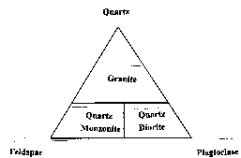
Figure 8: Ternary Diagram for Granite
In the example in Figure 9 and 10, the mineral assemblage was defined by the ternary diagram in Figure 8. The three minerals (quartz, feldspar, and plagioclase) were computed from a modified Mlith vs Nlith model, in which PE was substituted for PHIN in the Nlith equation. If data fell too far outside the triangle, mica was exchanged for the quartz.
Three rock types, granite, diorite, and monzonite, were derived from the three minerals. A trigger was set to detect basalt intrusions. A sample crossplot in Figure 9 shows how the lithology model effectively separates the minerals. This model was developed “on-the-job” by W.F. Clow.
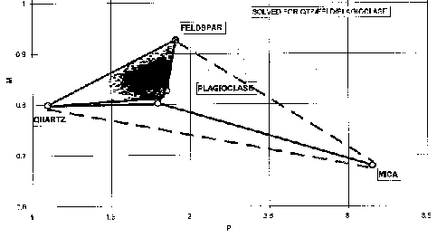
Figure 9: Mlith vs Plith crossplot for granite (micaceous data excluded)
A sample of the log analysis plot is shown in Figure 10. The average porosity from core and logs is only 0.018 (1.8%) and matrix permeability is only 0.05 mD. However, solution porosity related to fractures can reach 17% and permeability can easily reach higher than several Darcies. Customized formulae were devised to estimate these properties from logs, based on core and test data. My colleague Bill Clow devised most of the methods used on this project.
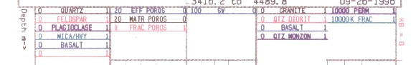
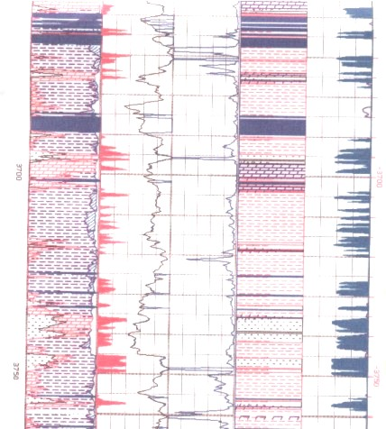
Figure 10: Depth plot for a granite reservoir
Note the fracture porosity and permeability derived from open hole log data. Fracture porosity from resistivity micro scanner logs was also computed where available to help control the open hole work. A black and white resistivity image log, Figure 11, shows some of the fractures. Both high and low angle fractures co-exist.

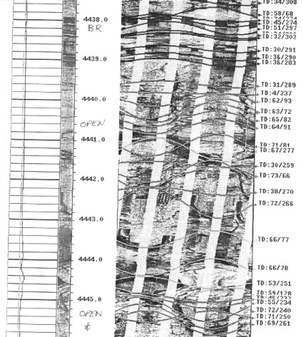
Figure 11: Resistivity micro scanner image in granite reservoir – dominant dips are 60 to 75 degrees from horizontal.
It is clear that non-conventional reservoirs may need some extra effort, customized models, and unique presentations. Everything you need to develop these techniques can be found elsewhere in this Handbook. The mineral properties need to be chosen carefully, but the mathematical models don't change too much.

