**SYNTHETIC LOG CURVES: AN ESSENTIAL INGREDIENT  
 FOR SUCCESSFUL STIMULATION DESIGN**

E. R. (Ross) Crain, P.Eng.   
Dorian Holgate, P.Geol.  
Spectrum 2000 Mindware Ltd  
  
*Published in CSPG Reservoir, May 2013.*

**INTRODUCTION**

Good quality sonic and density log data are required for calculating a petrophysical analysis for reservoir description, or for determining elastic properties of rocks for stimulation design, or for seismic modeling. Rough borehole conditions and gas effect are the most common problems that will need to be repaired.

Log editing to repair problem data goes by several names: log repair, log reconstruction, or log modeling. We can also create missing log curves by the same reconstruction methods. Some calibration data may be required from offset wells to do this reliably. The reconstructed logs are often called synthetic logs, to distinguish them from the original measured data set.

Reconstruction techniques are not new - they have been with us since the beginning of computer aided log analysis in the early 1970's and some primitive methods date back to the 1940’s. The problem is that few people understand the need for the work or are unfamiliar with appropriate techniques.

Exactly what you do to reconstruct the log data will depend on what you want to do with that data. For example, in a conventional quantitative petrophysical analysis, we go to great lengths to avoid using bad data to obtain our results. Gas effect in the invaded zone is handled by well-established mathematical techniques or by calibration of results to core analysis data if the logs are inadequate for the purpose.

For stimulation design modeling, you want the logs to accurately represent a water-filled reservoir. Since logs read the invaded zone, light hydrocarbons (light oil or gas) make the density log read too low and the sonic log read too high, compared to the water filled case. The magnitude of the error cannot be estimated without first reconstructing the logs from an accurate petrophysical analysis.

The light hydrocarbon effect alone would lead to erroneous elastic properties such as Poisson's Ratio and Young's Modulus, and thus in closure stress predictions. Add some rough borehole effects, and you have a meaningless set of elastic properties for stimulation modeling. Don't despair, there is a solution.

Geophysicists modeling seismic response also need good log data for creating synthetic seismograms, calibrating seismic inversion models, and for direct hydrocarbon detection models. The problem here is quite different than either the petrophysical analysis or stimulation design cases. If light hydrocarbon effect exists in the invaded zone, this must be removed and then replaced by a set of log values representing the un-invaded reservoir condition. This is the opposite of the stimulation design problem. In seismic modeling in light hydrocarbons, the density does not read low enough and the sonic does not read high enough to represent the undisturbed reservoir. Unless we fix this, reflection coefficients are too small, inversion models of Poisson's Ratio will not be calibrated, and direct hydrocarbon interpretations may be misleading.

Log editing and creation of synthetic logs is absolutely necessary in rough boreholes or when needed log curves are missing, or where gas effect has to be removed or augmented. Fracture design based on bad data guarantees bad design results. Seismic modeling, synthetic seismograms, and seismic inversion interpretations are worthless if based on inappropriate log data.

This article discusses the subject with respect to the needs of stimulation design. We will leave the seismic case to another day.

**SIMPLIFIED WORKFLOW**

The concept of log reconstruction is very simple:

1: Recognize bad data

2: Replace it with better data

The workflow for log reconstruction requires a competent petrophysical analysis for shale volume, porosity, water saturation, and lithology using as little bad log data as possible. After calibration to ground truth, these results are then "reverse engineered" to calculate what the log "should have read" under the modeled conditions we wish to impose. The parameters required will vary depending on whether the reconstruction is for a water-filled case, an invaded-zone case, or an undisturbed reservoir, but the mathematical model is identical for all three cases.

In intervals where there is no bad hole or light hydrocarbon, the reconstructed logs should match the original log curves. If they do not, some parameters in the petrophysical analysis or the reconstruction model are wrong and need to be fixed. It may take a couple of iterations. Remaining differences are then attributed to the repair of bad hole effects and light hydrocarbons in the invaded zone. The reconstruction needs to encompass somewhat more than the immediate zone of interest, but not usually the entire borehole.

There are a dozen or more published methods for generating synthetic logs, some dating back more than 60 years, long before the computer era. Most are too simple to do a good job; others are too complicated to be practical.

The most successful and practical model to implement and manipulate is the Log Response Equation. This equation represents the response of any single log curve to shale volume, porosity, water saturation, hydrocarbon type, and lithology.

Another valid modern method is multiple linear regression to generate missing or to replace bad data. This requires very careful consideration of a discriminator curve to select valid input data. The drawback is that the output curves cannot be manipulated with individual parameters in different lithologies or fluid types, as can be done with the Log Response Equation.

**CREATING SYNTHETIC LOGS FROM THE LOG RESPONSE EQUATION**

The best and easiest modern method for log reconstruction uses the Log Response Equation. Results are based on a complete and competent petrophysical analysis run using only good log data over the interval of interest, and a little above and below that interval. This article does not cover the petrophysical analysis methods needed - they are well documented elsewhere at <https://spec2000.net/index.htm>.

The equations needed are:

1: DENSsyn = Vsh * DENSSH + DENS1 * Vmin1 + DENS2 * Vmin2 + DENS3 * Vmin3   
 + PHIE * Sw * DENSW + PHIe * (1 - Sw) * DENSHY

2: DTCsyn = Vsh * DTCSH + DTC1 * Vmin1 + DTC2 * Vmin2 + DTC3 * Vmin3  
 + PHIe * Sw * DTCW + PHIe * (1 - Sw) * DTCHY

3: DTSsyn = Vsh * DTSSH + DTS1 * Vmin1 + DTS2 * Vmin2 + DTS3 * Vmin3  
 + PHIe * Sw * DTSW + PHIe * (1 - Sw) * DTSHY

Where:  
 DENSsyn, DTCsyn, and DTSsyn are synthetic density, compressional and shear sonic

DENSx, DTCx, and DTSx are density and sonic parameters for each mineral and fluid  
 Other symbols and abbreviations are listed in the Nomenclature at the end of this article.

Equation 1 is physically rigorous. Equation 2 is the Wyllie time-average equation, which has proven exceedingly robust despite its lack of rigor. Equation 3 is discussed below.

Sharp eyed readers will notice that there is a porosity term in Equation 3. Everyone knows that a fluid in a pore does not support a shear wave, but porosity does affect shear wave travel time in a manner similar to the compressional travel time. Consider the following equations:

4: Kc = Kp + Kb + 4/3 * N

5: DTC = 1000 / ((Kc / (0.001 * DENS)) ^ 0.5)

6: DTS = 1000 / ( (N / (0.001 * DENS)) ^ 0.5)

Bulk moduli are in GPa, density is in kg/m3, and sonic travel times are in msec/m in these equations.

It is clear from Equations 5 and 6 that both DTC and DTS depend on density, which in turn depends on mineral composition, porosity, and the type of fluid in the porosity. Both Kc and N depend on mineral composition and the presence of porosity.

So extending the Wyllie time-average equation to the case of shear travel time is not so far-fetched, and the use of a pseudo-travel time for the fluid term is merely a convenient way to avoid the pain and sorrow of the Wood-Biot-Gassmann equation set.

Parameters used in the response equations are chosen appropriately for the case to be modeled. The Sw term varies with what you are trying to model. If you want to model the undisturbed state of the reservoir, Sw is the water saturation from a deep resistivity log and an appropriate water saturation equation. If you want to see what a log would actually read in that zone, you need the invaded zone water saturation, because that's what most logs see. Invaded zone saturation, Sxo, can be derived using a shallow resistivity curve, or it can be assumed to be Sw^(1/5).

If you want to see what a water zone would look like, Sw is set to 1.00. That is what we do for a reconstruction destined to be used in calculating rock mechanical properties for stimulation design.

In all cases, you need to select fluid parameters to match the assumptions of the model. For example, to reconstruct a log run through an invaded gas zone to reflect the undisturbed case, you need to use the undisturbed zone water saturation and appropriate fluid properties for the water and gas in each equation. Note that for stimulation design, a gas model is not required. For seismic modeling, it is required.

Matrix and fluid values for each required log curve are given in Table 1. They may need some tuning to obtain a good match to measured values. Shale values are chosen by observation of the log readings in shale intervals. You may have to look to offset wells to find a shale that does not suffer from bad hole effects.

|  |  |  |  |
| --- | --- | --- | --- |
| Table 1: Recommended Parameters | | | |
|  | Density | DTC | DTS |
|  | kg/m3 | msec/m | msec/m |
| Shale | 2200 - 2600 | 280 - 500 | 490 - 770 |
| Fresh water | 1000 | 656 | 1280** |
| Salty water | 1100 | 616 | 1200** |
| Oil (light - heavy) | 700 - 1000 | 770 - 616 | 1200** |
| Gas | Not required for a log reconstruction for stimulation design | | |
| Granite | 2650 | 182 | 262 |
| Quartz | 2650 | 182 | 291 |
| Limey sandstone | 2680 | 170 | 292 |
| Limestone | 2710 | 155 | 294 |
| Limey dolomite | 2800 | 150 | 270 |
| Dolomite | 2870 | 144 | 245 |
| Anhydrite | 2900 | 164 | 280 |
| Coal | 1200-1800 | 328+ | 500+ |

The shear travel time values in Table 1 for fluids represent pseudo-travel-times that act as proxies in the Response Equations to account for the effect on density when gas, oil, or water are present. This is a pragmatic solution that works well. If you want more rigor, you need to use the Wood-Biot-Gassmann equation set.

|  |  |
| --- | --- |
| Table 2: KS8 – DTS / DTC Multiplier | |
| Coal | 1.9 to 2.3 |
| Shale | 1.7 to 2.1 |
| Limestone | 1.8 to 1.9 |
| Dolomite | 1.7 to 1.8 |
| Sandstone | 1.6 to 1.7 |

For those who are unhappy with Equation 3, the usual shortcut that can be used is to determine a DTC multiplier (DTS/DTP) based on the lithology as determined from the petrophysical analysis:

7: DTSsyn = KS8 * DTCsyn

It is reasonable to calculate a composite KS8 multiplier value using the volume weighted fraction of each rock component. The multiplier is relatively independent of porosity. Because the range of KS8 for typical rocks is moderately large, Equation 3 is actually easier to manipulate since each mineral and shale volume parameter can be tuned separately.

An example of a reconstruction using the response equation model for a stimulation design in a Viking reservoir is shown in Figure 1. A detailed petrophysical analysis, not shown here except for the lithology track, preceded the reconstruction, and provided the shale volume, porosity, water saturation, and mineralogy inputs required.

*Figure 1: Example of synthetic density and sonic logs used to calculate elastic properties for a fracture design study. Track 1(Correlation) has GR, caliper, and bad hole flag (black bar). Track 2 (Density) has density correction (dotted curve), neutron (dashed), original density (black), synthetic density (red). Track 3 (Sonic) shows the synthetic shear sonic (blue), synthetic compressional sonic (red), along with the original sonics (black). Track 4 (Poisson’s Ratio) displays calculated results using raw data (black) and using modeled data (red). Track 5 (Young’s Modulus) displays similarly shows results from the original log (black) and the modeled log (red). Track 6 (Bulk Volumes) displays the rock composition used as input to the modeling process. Note the error in the original shear sonic data above and below the sand interval (reading much too high). The modeling process was used to remedy this.*

**ERROR PROPAGATION**

The main reason for calculating synthetic log curves is to reduce the errors in calculated mechanical rock properties. Of all the properties that can be calculated from logs, Poisson’s Ratio suffers the worst error if there are even small errors in the log data used to derive it. Unfortunately, Poisson’s Ratio is also the most import input required in calculating the closure stress, a key parameter in hydraulic fracture design.

To illustrate where Poison’s Ratio fits into a frac design, consider the simple case of isotropic reservoirs as defined by:   
 8: R = DTS / DTC  
   9: PR = (0.5 * R^2 - 1) / (R^2 - 1)  
  10: Pclos = (PR / (1 – PR)) * Po + (1 – (PR / (1 – PR))) * Pp * ALPHA            
  
Both equations 9 and 10 amplify any errors in the initial DTC and DTS data by surprisingly large amounts. Figure 2 and Table 3 presents the propagation of error for four cases, representing a   
+/-5% error in individual inputs and a combined case in which all three inputs are in error and non-compensating.

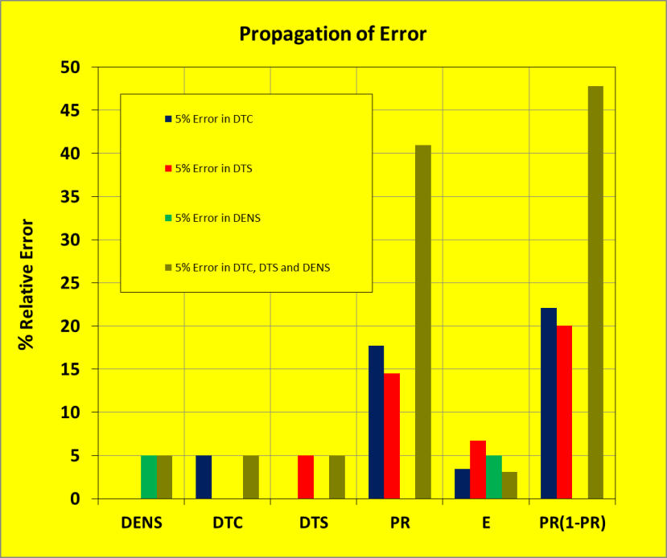  
*Figure 2: Effect of error propagation of a +/-5% error in DTC, DTS,  
 DENS, and all three combined on calculated rock properties.*

|  |  |  |  |  |  |  |
| --- | --- | --- | --- | --- | --- | --- |
|  | Table 3: ERROR PRAPAGATION | | | | | |
|  | Input Data Error Error in Calculated Results | | | | | |
| Case | DENS | DTC | DTS | PR | E | PR/(1-PR) |
| One | 0 | 5 | 0 | 18 | 3.5 | 22 |
| Two | 0 | 0 | 5 | 15 | 7.0 | 20 |
| Three | 5 | 0 | 0 | – | 5.0 | – |
| Four | 5 | 5 | 5 | 41 | 3.0 | 48 |

The bargraph and table show how a single 5% error is multiplied four-fold by the nature of the Poisson’s Ratio equation.

Another example of synthetic logs with the original measured curves, and the computed rock mechanical properties, is shown in Figure 3. Black curves show the original logs and calculated results from those original logs. Coloured curves show the synthetic logs and results from the synthetic logs.

**  
*Figure 3: Example of log reconstruction in a Dunvegan shaly sand sequence. Curve complement and colour codes are the same as Figure 1. Although the density correction is large (orange shading in Track 2), the reconstructed log shows a close resemblance to the recorded density. The shear and compressional sonic show larger differences caused by the rough hole and some light hydrocarbon effect.*

**CONCLUSIONS**We have shown how small input errors amplify to become surprisingly large due to the inherent nature of the equations that are used to obtain rock mechanical properties.

To reduce error propagation issues, reconstructed or synthetic logs are an essential input to stimulation design software packages. Creating such logs requires a significant effort to first produce a competent petrophysical analysis. However, that analysis has other uses, such as determining completion intervals and the best location for horizontal wells, not to mention the more usual applications such as reserves and productivity estimates. So the effort is not wasted.

In the end, the cost of the full analysis and reconstruction is trivial compared to the cost of completion, or worse, an unsuccessful completion design.

**NOMENCLATUIRE** DENS = density of rock including fluid filled porosity (kg/m3)

Kp = compressional bulk modulus of the pore space (GPa)  
 Kb = compressional bulk modulus of empty rock frame (GPa)  
 Kc = composite bulk modulus of rock including fluid filled porosity (GPa)

N = shear modulus of rock including fluid filled porosity (GPa)  
 DTC = compressional sonic travel time (msec/m)  
 DTS = shear sonic travel time (msec/m)  
 PR = Poisson’s Ratio (unitless)  
 Po = overburden pressure (KPa)  
 Pp = pore pressure (KPa)  
 Pclos = closure stress (KPa)  
 ALPHA = Biot’s Constant (unitless)