A 12-STEP PROGRAM TO REDUCE UNCERTAINTY
IN KEROGEN-RICH RESERVOIRS
Part 2 – Getting the Right Hydrocarbon Volume

E. R. (Ross) Crain, PEng.
Dorian Holgate, PGeol.
Spectrum 2000 Mindware Ltd
Published in CSPG Reservoir, Apr 2014, CWLS InSite Apr 2014,
Presented by D. Holgate at GeoConvention May 2014, Calgary.

INTRODUCTION
In Part 1 of this article, we described the workflow for a deterministic model that allows step by step calibration of the petrophysical analysis results leading to values for clay volume, kerogen volume, and effective porosity. The basis of this workflow was the shale and kerogen corrected density-neutron complex lithology crossplot model.

Part 2 below shows the remaining steps for lithology, saturation, and gas or oil in place estimates. None of these techniques are novel or new, but a review seems in order to demonstrate the importance of accuracy in the clay, kerogen, and porosity calculations.

MOVING ON
Step 5: Lithology
Lithology is calculated with a kerogen and shale corrected 2-mineral PE model or a 3-mineral model using kerogen-and shale corrected PE, density, and neutron data. Calibrate results to XRD data. Modify mineral selection or mineral end points to achieve a reasonable match.

Some people use a multi-mineral or probabilistic software package to solve for all minerals, including porosity and kerogen, treating the latter two as "minerals". In the case of rough borehole conditions, this method gives silly results unless a bad-hole discriminator curve is also used. These models are more difficult to tune because it is not possible to calibrate shale volume, TOC weight fraction, effective porosity, and mineralogy in a step-by-step sequence, as can be done with the deterministic model described here. Changing parameters in the multi-mineral model, to strive for a better match to ground truth, often gives unexpected results. It is a multi-dimensional jigsaw puzzle and some of the pieces just won’t fit unless you trim them in the correct sequence.

To reduce this problem, calibrate shale volume kerogen volume and effective porosity by the deterministic method shown earlier, then use these as input curves as constraints in the multi-mineral model.
Recently, we have seen excellent examples of elemental capture spectroscopy inversions that produce TOC, clay, and mineral weight fractions. TOC and XRD lab data are still used to drive the inversion in the correct direction.

Step 6: Water Saturation
From here onward, petrophysical analysis follows normal procedures. Water saturation is best
done with the Simandoux equation, which is better behaved in low porosity than most other models. Dual water models may also work, but may give silly results when shale volume is high or porosity is very low.
In many cases, the electrical properties must be varied from world average values to get Sw to match lab data. Typically A = 1.0 with M = N = 1.5 to 1.8. Lab measurement of electrical properties is essential. Skipping this step is the worst form of false economy. The wrong M and N values can give zero OGIP!
Calibration can be done with core water saturation or capillary pressure data. Both pose tricky problems in unconventional reservoirs, especially those with thin porosity laminations, so common sense may have to prevail over “facts”.

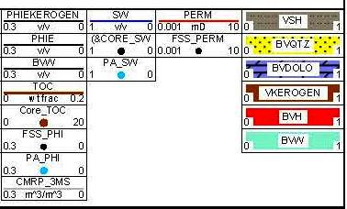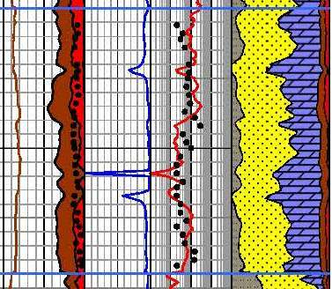
Figure 4: Example of TOC and density-neutron effective porosity after kerogen correction in a Montney interval, showing close comparison to core effective porosity (black dots). TOC reaches 4 weight percent, which converts to near 10% by volume (dark shading). Note that permeability of the free porosity is in the range of 0.01 to 0.1 milliDarcies, not the nanoDarcy range quoted in core reports based on the GRI protocol, which uses crushed sample grains instead of core plugs.

Step 7: Permeability
Permeability from the Wyllie-Rose equation works extremely well even in low porosity reservoirs. We generally assume that the calculated water saturation is also the irreducible water saturation for this model, although this assumption may be incorrect in a few cases. The calibration constant in the Wyllie-Rose equation can range between 100,000 to 150,000 and beyond, and is adjusted to get a good match to conventional core permeability.

An alternative is the exponential equation derived from regression of core permeability against core porosity. The equation takes the form Perm = 10^(A1 * PHIe + A2). Typical values for A1 and A2 are 20.0 and –3.0 respectively. This model will match conventional core permeability quite well, but will probably not match the permeability derived from crushed samples using the GRI protocol. High perm data points caused by micro- or macro fractures should be eliminated before performing the regression.

Step 8: Reconstruct the Log Curves
Reconstructed or synthetic logs have become an important part of a competent petrophysical workflow. We go to some pains to use only valid data in our petrophysical analysis, omitting bad data from our models. Reconstructed logs are generated from those results using the Log Response Equation.

There are two reasons for reconstructing the well logs. The first is to verify that the parameters used in all steps are reasonable. In good borehole conditions, the reconstructed logs should be close overlays of the original logs. If they are not, possibly some bad data snuck in, or some parameters in the overall model are wrong. You will need to use your CSI skills to chase down the guilty party and rectify the problem. A good match between reconstructed and original logs is not a guarantee of success, but it is one more piece of evidence pointing in that direction.
The second reason for reconstruction is to prepare a strong foundation for calculating rock mechanical properties. Mechanical properties developed from raw logs often contain spikes and noise, or worse, that destroys the stimulation design results. We strongly recommend that stimulation design should ALWAYS use edited or reconstructed logs, which presupposes that sufficient time and talent be allowed by management for this step to take place.
During reconstruction, we can also create missing logs, such as the shear sonic curve, for use in the mechanical properties calculation or for comparison to other wells in the project.

Step 9: Rock Mechanical Properties
All well completions in unconventional reservoirs involve expensive stimulation programs. Hydraulic fracture design depends on an accurate evaluation of rock mechanical properties based, in turn, on an advanced petrophysical analysis. Most frac design programs have only a rudimentary capacity to perform petrophysical analysis. Worse still, frac design software uses the raw, unedited log data with all its problems. Nothing good can come from this. So it is better to do the work outside the frac software and import the mechanical property curves.
The first step to accurate mechanical properties is a reconstruction of the sonic shear and compressional and density data to remove the effects of bad hole and light hydrocarbons. The frac design programs need the water filled case so the reconstruction is always needed in gas zones. More information on how to do this can be found at www.spec2000.net/10-mechsyn.htm.
The usual outputs from this step are shear modulus, velocity ratio, Poisson’s ratio, bulk modulus,
Young’s modulus (both dynamic and static), Lame's constant, and a brittleness coefficient. The original and reconstructed log curves, and the lithology track, are displayed with the mechanical properties results.

Triaxial (static) and dynamic lab measurements can be used to help calibrate the mechanical properties calculated from the petrophysical model. In the absence of lab data, most of these results must fit within known ranges, depending on lithology. If values are out of range, we must suspect the input data and check the log reconstruction procedure. This in turn depends on the current state of the petrophysical results, leading us to double check all parameters and calibration steps. This kind of manual iteration is a normal part of a petrophysicist’s daily grind.

Step 10: Net Reservoir and Net Pay
Once all these checks and balances are satisfied, we can get on with finding the “real” answers. Unfortunately, this is where the world gets a little fuzzier.
In many shale gas and some shale oil plays, typical porosity cutoffs for net reservoir are as low as 2 or 3% for those with an optimistic view, and between 4 and 5% for the pessimistic view.

The water saturation cutoff for net pay is quite variable. Some unconventional reservoirs have very little water in the free porosity so the SW cutoff is not too important. Others have higher apparent water saturation than might be expected for a productive reservoir. However, they do produce, so the SW cutoff must be quite liberal; cutoffs between 50 and 80% SW are common.

Shale volume cutoffs are usually set above the 50% mark. Multiple cutoff sets help assess the sensitivity to arbitrary choices and give an indication of the risk or variability in OGIP or OOIP calculations.

Step 11: Free Gas or Oil In Place
Now we move into the reservoir engineer’s territory, but it doesn’t hurt to know where our petrophysical results end up. If you have never done the math before, it can be quite instructive – it is much easier to compare zones or wells on the basis of OOIP or OGIP instead of average porosity, net pay, or gross thickness.

Free gas in place is calculated from the usual volumetric equation:
1: Bg = (Ps * (Tf + KT2)) / (Pf * (Ts + KT2)) * ZF
2: OGIPfree = KV4 * PHIe * (1 - Sw) * THICK * AREA / Bg

For oil reservoirs:
3: OOIP = KV3 * PHIe * (1 - Sw) * THICK * AREA / Bo
Where:
Bg = gas formation volume factor (fractional)
Bo = oil formation volume factor (fractional)
Pf = formation pressure (psi) Ps = surface pressure (psi)
Tf = formation temperature ('F) Ts = surface temperature ('F)
ZF = gas compressibility factor (fractional)
KT2 = 460'F KV3 = 7758 KV4 = 0.000 043 560
If AREA = 640 acres and THICK is in feet, then OGIP = Bcf/Section (= Bcf/sq.mile). OOIP is in barrels per square mile. Multiply meters by 3.281 to obtain thickness in feet.

Step 12: Adsorbed Gas In Place
TOC is widely used as a guide to the quality of shale gas plays. This only pertains to adsorbed gas content and has no bearing on free gas or oil. Some deep hot shale gas plays have little adsorbed gas even though they have moderate TOC content.
Using correlations of lab measured TOC and gas content (Gc), we can use log derived TOC values to predict Gc, which can then be summed over the interval and converted to adsorbed gas in place. Sample correlations are shown in Figure 5.
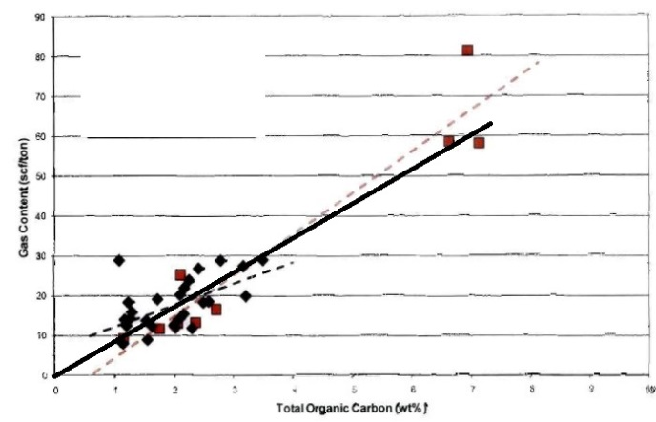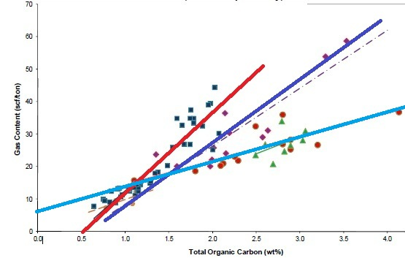
Figure 5: Crossplots of TOC versus adsorbed gas (Gc) for Tight Gas / Shale Gas examples. Note the large variation in Gc versus TOC for different rocks, and that the correlations are not always very strong. These data sets are from core samples. Cuttings give much worse correlations. The fact that some best fit lines do not pass through the origin suggests systematic errors in measurement or recovery and preservation techniques.
Gas content from a best fit line versus TOC can be applied to log derived TOC:
4: Gc = KG11 * TOC%
Where:
Gc = gas content (scf/ton)
TOC% = total organic carbon (percent)
KG11 = gas conversion factor range = 5 to 15, default = 9
Adsorbed gas in place is derived from:
5: OGIPadsorb = KG6 * Gc * DENS * THICK * AREA
Where:
DENS = layer density from log or lab measurement (g/cc)
KG6 = 1.3597*10^-6
If AREA = 640 acres and THICK is in feet, then OGIP = Bcf/Section (= Bcf/sq.mile)
Multiply meters by 3.281 to obtain thickness in feet.
Multiply Gc in cc/gram by 32.18 to get Gc in scf/ton.
A more sophisticated approach uses the Langmuir adsorption curve which can be derived from reservoir temperature and pressure. The correlation of Gc wth TOC seems to be adequate but the Langmuir method would be a useful calibration step.
CONCLUSIONS – PART 2
A full suite of TOC and XRD mineralogy from samples, along with core porosity and saturation data, are needed to calibrate results from any petrophysical analysis of unconventional reservoirs. The deterministic shale and kerogen corrected workflow allows all available ground truth data to be used in a logical and consistent manner at each step to calibrate and refine results.

From our experience, we have found that net pay and gas or oil in place estimates are very sensitive to small errors in effective porosity caused by poorly calibrated clay and kerogen volume. An error of as little as 0.5% porosity can make or break a play. This is why over-simplified methods are inappropriate, even dangerous, because some of the answers derived from petrophysical analysis now appear in public, in the form of investor information handouts and quarterly reports.

Petrophysical analysis results travel well beyond the initial need to know porosity and water saturation. Oil and gas in place, reservoir stimulation, and placement of horizontal wells are impacted. Shortcuts are not acceptable. In the end, the cost of the full analysis is trivial compared to the cost of completion, or worse, the cost of an unsuccessful or unnecessary completion.

