Rapid Discrimination of Potash Mineralization Using Crossplots – Case Histories
E. R. (Ross) Crain, P.Eng.
Donald G. Hill, PhD.
Presented by E.R. Crain at GeoConvention 2020, Calgary, AB, May 2020,
virtually via MP4 video of narrated PowerPoint slideshow. Published as Long Abstract in CSPG 2020 Online Archives.
Summary
A crossplot method is proposed that helps to discriminate between commercial and non-commercial potash ores. Termed the Potash Identification, or PID, plot, it utilizes natural gamma ray and neutron log responses as recorded in conventional exploration wells or core-holes.
Case histories of the use of PID crossplot in the evaporite basins of Michigan, Nova Scotia, Saskatchewan, and SE New Mexico are described.
Theory
Potash mineralization in the Prairie Evaporite Formation of Saskatchewan is a relatively simple mixture of halite, sylvite, and carnallite, with minor clay inclusions and interbedded shales. In other areas of the world, the mineral mixture is more complex, with up to four potash minerals, some of which are non-commercial, as well as a number of other evaporites, some of which negatively affect the potash milling process.
Many exploration wells lack sufficient log curves to resolve all the minerals in detail, but it is possible to at least determine if the potash minerals present are potentially commercial. In most cases, anhydrous minerals like sylvite and langbeinite are commercial possibilities; hydrous minerals such as carnallite and polyhalite are often not.
Gamma ray logs respond to the potassium and the neutron log to water of hydration in the various minerals. As a result, a crossplot of gamma ray versus neutron log response, termed the Potash Identification, or PID, plot will segregate anhydrous from hydrous minerals, giving a clear visual indication of potential commercial mineralization. Both log curves are commonly available in air and fluid filled open or cased holes, so the technique can be widely applied.
Case History Results
Case histories of the use of PID crossplots in the evaporite basins of Michigan, Nova Scotia,
Saskatchewan, and SE New Mexico are described below. The technique should also be useful in screening potash deposits in Europe, North Africa, and China.
Commercial potash ores are anhydrous (no water of hydration), such as sylvite and langbeinite, so the neutron log reads near zero. Hydrated potash minerals will have non-zero zero neutron response, such as carnallite, polyhalite, and kainite. High gamma ray response distinguishes all these minerals from other zero porosity minerals, such as halite and anhydrite, and from porous minerals, such as calcite, dolomite and clay.
Potash beds seldom contain pure minerals; usually they are a mixture of one or more potash minerals with halite. Thus data points will fall on trend lines joining the pure mineral points. Data points for commercial ores will trend vertically from the halite point at bottom left to top left on the PID plot. Non-commercial ores will trend from the halite point to the right and upward toward the pure mineral points.
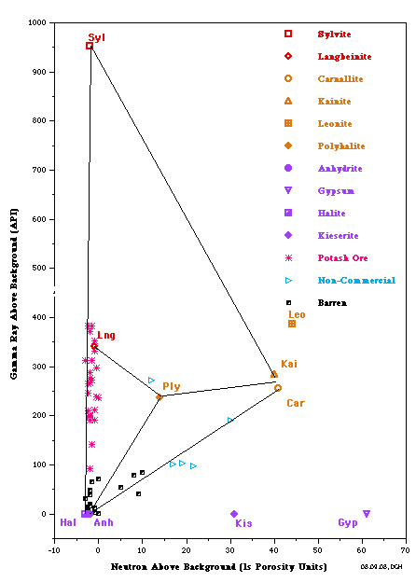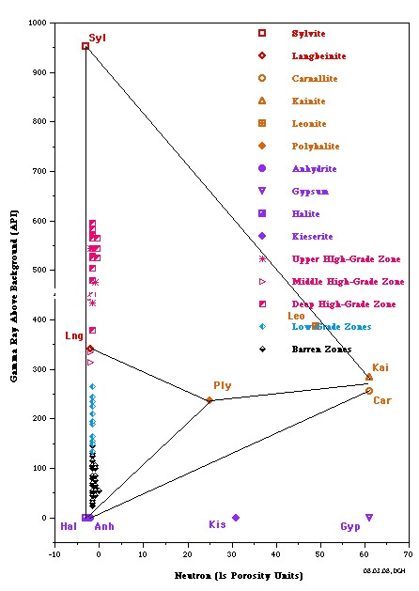
PID Plots for Prairie Evaporite in Saskatchewan (left) and Windsor Salt in Nova Scotia (right). Both show data points along the near vertical sylvite - langbeinite - halite trend line, indicating commercial grade potash ore. Only the Saskatchewan example shows some data trending toward the non-commercial carnallite data point. Note that the GR scale on the vertical axis is for a modern logging tool with a linear response. For older tools, the Y-axis could be replaced with a K20 axis, derived from the original Crain non-linear relationship.
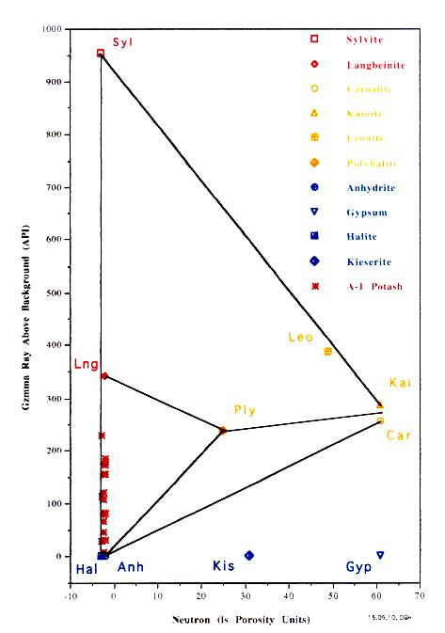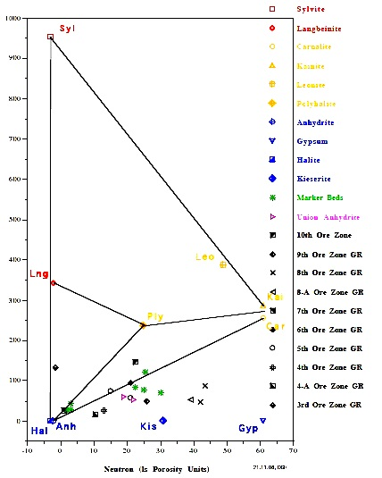
The Michigan Basin Salina A-1 Evaporite example (left) shows only commercial grade potash ore in this well. The SE New Mexico example of the McNutt Member of Salado
Formation (right) shows only non-commercial polyhalite ore in this well.

Conclusions
Potash Identification crossplots are an efficient method for screening well logs for potentially commercial potash ore zones. They can be created quickly from hand-picked or digital data sets.

References
Crain, E.R. and Anderson, W.B., Quantitative Log Evaluation of the Prairie Evaporite Formation of Saskatchewan,
Journal of Canadian Petroleum Technology, July 1966
Alger, R.P. and Crain, E.R. Defining Evaporite Deposits with Electrical Well Logs,
Trans Northern Ohio Geological Society - Second Symposium on Salt, Cleveland OH, 1966
Hill, D.G., Simple Screening Technique for Identifying Commercial Potash,
AAPG/ACE San Antonio TX ,19 – 20 May 2019.
Hill, D.G., Multiple Log Potash Assay,
Journal Applied Geophysics, 1993

