PETROPHYSICS IN THE GREEN ECONOMY
PART 3 – Geothermal: basics and examples
E.R. Crain, P.Eng.
Published in CSPG Reservoir Nov – Dec 2022

INTRODUCTION
Geothermal energy is a well established member of the Green Economy using many technical skills borrowed from the oil and gas industry, including drilling, logging, well completions, and of course petrophysics. This article describes basic geothermal concepts and illustrates the petrophysical aspects with extracts from several published case histories.
Geothermal energy has two distinct meanings. One is electrical power generation using medium and high temperature water or steam from wells drilled into the Earth’s subsurface. The virtue of this method is that it produces a constant base load of electricity, while wind, wave, and solar methods offer only intermittent or variable output. The logging tools and petrophysical analysis techniques developed for oilfield work are equally applicable to geothermal exploration and development.
The other meaning is the use of low temperature geothermal heat pumps (GHPs) for space heating or water heating applications in homes and small industrial settings. Such systems involve a continuous loop of plastic pipe buried about 2 feet below the frost line in an area beside the building to be heated. A pump and heat exchanger are connected to the pipe and a fluid is circulated through the system. Most internet searches will pop up dozens of webpages offering to sell and install these systems for your home or business. GHPs are of no direct interest to petrophysicists.
Geothermal power projects are classified "High Temperature”, above 150 degrees C and up to 260 C or more OR "Medium Temperature”, below 150 degrees C and down to about 60 C. The high temperature systems drive steam turbines directly; medium temperature systems use a heat exchanger and a secondary fluid with a low boiling point to drive the turbine. High temperatures are found near volcanoes, dormant or not, and the lower values in the deeper portions of sedimentary basins.
High temperature systems come in two flavours: dry steam plants, which directly use geothermal steam to turn turbines, and flash steam plants, which pull deep, high-pressure hot water into lower-pressure tanks and use the resulting flashed steam to drive turbines back into the reservoir.
TABLE 1 UnitS conversionS
Energy - Joules (J)
1 Joule = 0.2338 Cal
1 Cal = 4.187 J
1 kWh (kiloWatt.hour) = 3.6 MJ
1 MWy (MegaWatt year) = 31.56 TJ
1 BTU (British thermal unit) = 1055 J
1 barrel of oil equivalent = 5.7 GJ
1 tonne of oil equivalent = 42 GJ
1 m3 of natural gas = 38 MJ
Power - Watts (W)
1 W = 1 J/s
1 W = 3.412 BTU/Hr
1 kW (kiloWatt) = 1.341 horse-power
Heat Flow - Watt per sq. metre (W/m2)
1 W/m2 = 0.2388 x10^-5 cal/cm2sec
1 cal/cm2 sec = 41.87 kW/m2
Geothermal gradient - Kelvin/metre (K/m)
1 mK/m = 1 C/km
1 mK/m = 0.5486 x 10^-3 F/ft
Thermal Conductivity - Watts/metre. Kelvin
(W/mK)
1 W/mK = 2.39 x103 cal/cm sec C
Range: Coal = 0.3, Water = 0.6, Rocks = 1.5 to 4.0, Metals = 40 to 400 W/mK.
Prefixes: SI Units
k kilo 10^3 m milli 10^-3
M Mega 10^6 u micro 10^-6
G Giga 10^9 n nano 10^-9
T Tera 10^12 p pico 10^-12
P Peta 10^15
E Exa 10^18
Geothermal reservoirs are described as "Conventional" when they are hot, wet, porous, permeable, often fractured, OR "Unconventional" when they are hot, dry, non-porous, non-permeable, no natural fractures.
Conventional geothermal reservoirs are exploited by producing hot water or steam from the reservoir and disposing of the spent steam to the atmosphere or condensing and injecting it back to the reservoir. Typical oilfield practices are used to enhance production, such as hydraulic fracturing and horizontal wells, provided the temperature does not exceed the limits of available technology.
Unconventional geothermal reservoirs are often called Enhanced (or Engineered) Geothermal Systems (EGS) or "hot, dry rock" reservoirs. They require hydraulic fracturing and horizontal wells to obtain a flow path through which water can be circulated in a closed loop.
To add more complexity, it should be possible to extract lithium from the natural brines in conventional geothermal reservoirs as they pass through the plumbing before or after passing through the turbines.
The heat generation in a geothermal reservoir comes from proximity to plutonic rock or is continuously supplied by radioactive decay in or below the reservoir.
The properties of heat and heat transfer are not usually part of a petrophysicist's lexicon. Table 1 covers some of the basic terms and units of measurement. Source: GSC Open File 5906 ➔
Heat content is expressed in μW/m3 (microWatts per cubic meter). Normal values range from undetectable to 10 μW/m3.
A single geothermal well-pair can produce a few to more than 10 megaWatts of power. That's enough to cover the base load electricity demand of about 1000 homes without creating any significant greenhouse gases (GHGs). A project to service a city would be a major undertaking. But a good number of larger units using medium temperature sedimentary reservoirs combined with wind and solar would go a long way to reduce GHGs.
Capital costs for conventional geothermal are about twice that of a similar gas fired plant. Drilling accounts for over half the costs, and exploration of deep resources entails significant risks. A typical well-pair can support 4.5 megawatts (MW) of electricity generation and costs about $10 million to drill. In total, electrical station construction and well drilling costs $2 – 5 million per MW of electrical capacity, while the energy cost is $0.04 – 0.10 per kW·h. Enhanced geothermal systems are on the high side of these ranges, with capital costs above $4 million per MW and costs above $0.054 per kW·h in 2007 dollars.
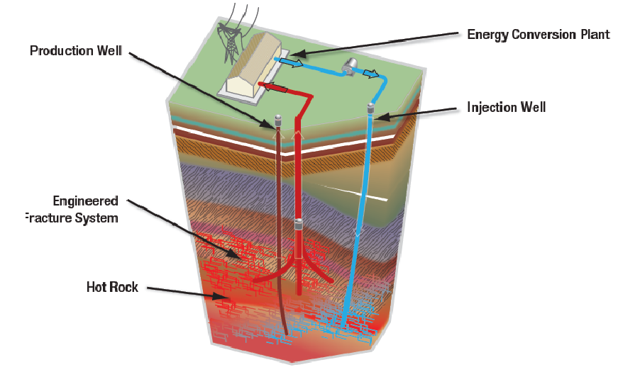FIGURE 1: Schematic diagram of geothermal energy system. The "hot rock" portion, shown in red, could be porous, permeable, and fractured, making a conventional geothermal reservoir. Or it could be tight and un-fractured -- subsequent drilling of horizontal wells and hydraulic stimulation could be used to exploit this type of unconventional geothermal reservoir. (USGS image)
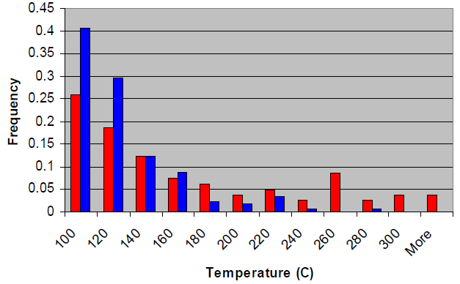FIGURE 2: About 70% of known geothermal reservoirs are below the 150C temperature limit for conventional logging tools; most are below the 260C limit for hostile environment tools. (red = magmatic, blue = non-magmatic reservoirs).
The Geysers geothermal system in California reaches 656F (346C). (USGS image)

geothermal ENERGY IN CANADA
The largest conventional geothermal power resources in Canada are located in British Columbia, Yukon, and Alberta. These regions also contain potential for Enhanced Geothermal Systems. The most advanced project exists as a test geothermal site in the Meager Mountain-Pebble Creek area of British Columbia, where some exploration wells reached 240 - 260C at depths between 400 to 800 meters. Other wells had much lower temperatures. Three directional wells were then drilled in the hotter areas. Each well was estimated to be capable of producing 4 to 9 MWe, but there has been no attempt at commercial production.
In 2021, two medium-temperature pilot projects were announced, one in northwest Alberta, the other in southeast Saskatchewan. Both would be binary systems, using 110C (+/-) source water in sedimentary rocks. To date (2022) there is no commercial geothermal electricity in Canada. A good reference for the Canadian scene is "Review of National Geothermal Energy Program Phase 2 – Geothermal Potential of the Cordillera", by A. Jessop, 2008, GSC Open File 5906.
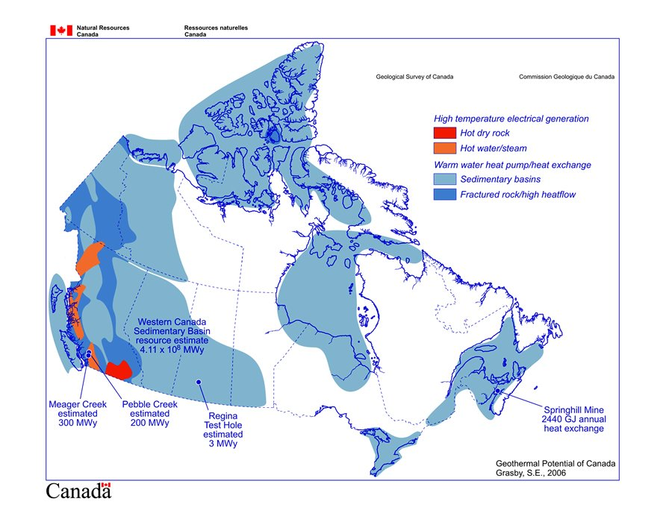FIGURE 3: Geothermal map of Canada. Red colours show areas where hot water or hot rock reservoirs may be present. Blue indicates warm water possibilities. (GSC image)

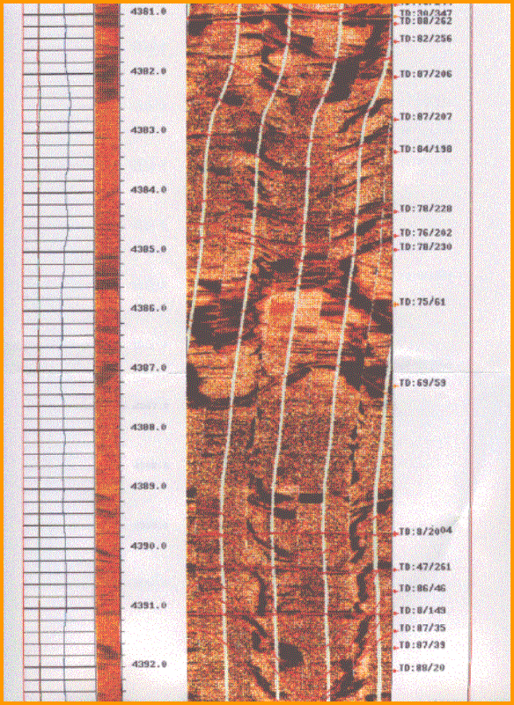
LOG ANALYSIS IN geothermal WELLS
Well logging to assess reservoir properties of geothermal prospects is possible in most cases. Lithology, porosity, permeability, fracture intensity, temperature, borehole shape and stability, stress regime, and elastic moduli are typical results that can be calculated from well logs, time lapse temperature logs are used to estimate stabilized geothermal well temperature. Casing and cement integrity logs ensure safe and permanent well completions.
FIGURE 4: Resistivity image log in a fractured granite, with true dip and direction on right side of the log
Standard oilfield logging tools can survive 300F (180C) for short periods and hostile environment logging tools are good to 500F (260C). Such tools have been available since 1981 (but the USGS website about logging geothermal wells seems to be unaware of this). Resistivity and porosity logs are available for the high temperature range, but some specialty logs, such as acoustic and resistivity imaging, may not reach 500F yet. Technology is always on the move, so check with service companies for current availability. Purpose-built tools have also been used and logs of these may be found in project files.
There are numerous problems associated with petrophysical analysis of logs for any purpose, and geothermal wells are no exception. Poor borehole condition, high temperature, and unusual lithology are well known issues, even in the oil and gas industry.
Unfortunately, a DOE report written in 1979, based on the logging technology of the early 1970's, is still widely distributed and still believed even by USGS professionals. See "Geothermal Well Log Interpretation Midterm Report" by S.K. Sanyal, L.E. Wells, R.E. Bickham, 1979, LA-7693-MS Informal Report UC-66e. Sadly, the SPWLA Geothermal Log Interpretation Handbook dates from 1982 so it too is not much help to 21st century petrophysicists.
Most 1970's era complaints have long been resolved over the 45 years since the logs reported upon were run. Modern computer software, digital logging tools, new understanding of multi-mineral models, better knowledge of tool responses, realistic estimates of measurement accuracy, higher temperature and pressure ratings, statistically based calibration to ground truth, and 45 years of published works from 1000's of practitioners have solved a lot of the uncertainty concerns.
To perform a competent petrophysical analysis in a geothermal well, as for any well, we need a good set of digitized well logs, sample descriptions, core data (if any), and some basic well location and directional information. We can then use the standard deterministic or probabilistic models. You will need some skill with complex lithology, fractured reservoir models, and possibly igneous and metamorphic reservoir analysis.
The minimum log suite would include resistivity, shear and compressional sonic, neutron, density, photo-electric, spectral gamma ray, caliper, acoustic and/or resistivity image logs, where temperature limitations can be met. A temperature profile and some time lapse bottom hole temperatures are essential. If the well can flow, spinner surveys can be run to assess flow rates.
Deliverables expected are rock mineralogy, porosity, water resistivity, matrix permeability, fracture intensity, fracture aperture, fracture porosity, fracture orientation and dip angle, and rock mechanical properties, such as shear and bulk modulus, Young's modulus, Poisson's ratio, and Biot's constant. Since logs respond only to minerals, the initial log analysis model will generate the mineral composition of igneous rocks (e.g. quartz, feldspar, mica, etc. and not generic rock types such as granite or diorite). If needed, the minerals can be composed into rock types for comparison to sample descriptions.
Once mineralogy, porosity, and temperature are known, rock properties pertinent to the geothermal industry can be derived. Thermal conductivity, specific heat capacity, volumetric heat capacity, isobaric enthalpy change, and diffusivity are derived from empirical curve fits to measured rock property data published in the literature. From these results and the reservoir volume, a complete assessment of its potential as an economic energy source can be made. These calculations are best performed by experts in geothermal energy and are probably beyond the scope of petrophysical practice.
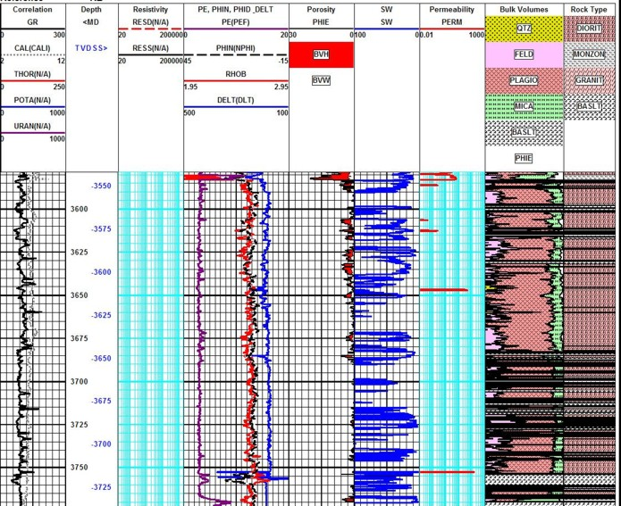FIGURE 5: Fractured granite example: raw data curves in Tracks 1, 2, and 3 with effective porosity, water saturation, and matrix permeability in Tracks 4, 5, and 6. The mineral model calculated from the log analysis is in Track 7 and the rock type model calculated from the minerals using a ternary diagram is in Track 8. Basalt was triggered from high density or high PE or both. This is an oilfield example in a deep, hot pluton.
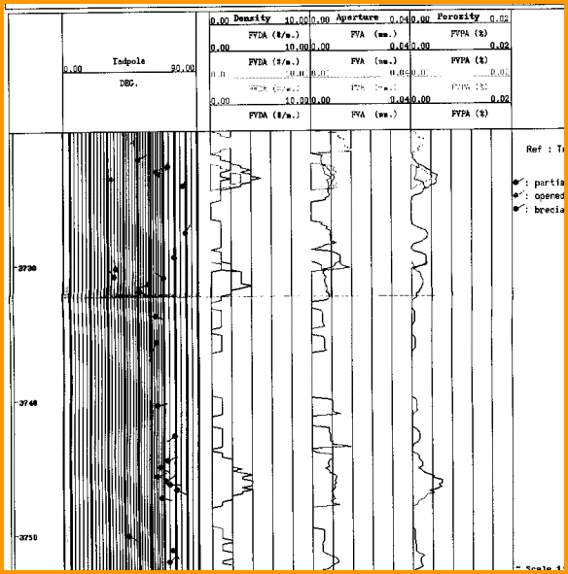
FIGURE 6: Fracture frequency, aperture, and porosity log in a fractured granite reservoir derived from a resistivity image log. The most accurate method is based on the measured resistivity curves on the image log. The pixel count method is much less accurate because of borehole erosion and breakouts.
LOGGING EXAMPLES IN geothermal WELLS
EXAMPLE 1: Temperature Logs From Meager Mountain, BC
From: "Review of National Geothermal Energy Program Phase 2 – Geothermal Potential of the Cordillera", by A. Jessop, 2008, GSC Open File 5906.
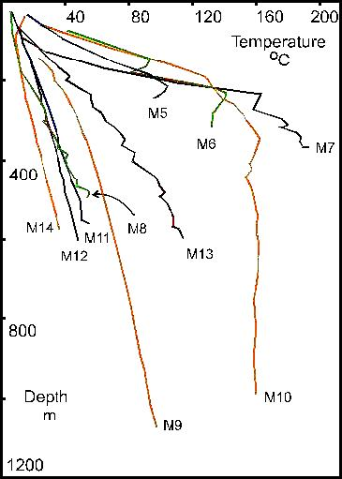
FIGURE 7: Temperature logs from a Canadian geothermal prospect in the Rocky
Mountains of BC. (GSC image)"
EXAMPLE 2: Fracture identification at Coso, CA
From "Comparison Of Acoustic And Electrical Image Logs From The Coso Geothermal Field, Ca" by Nicholas C. Davatzes and Steve Hickman, USGS, 2005.
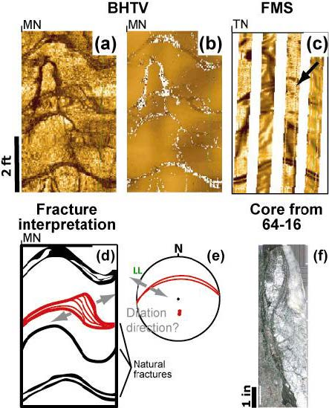
FIGURE 8: Comparison of acoustic image log and resistivity image log in a geothermal well. (a) BHTV amplitude image, (b) BHTV travel time image, (c) FMS resistivity image,
(d) sketch of fractures, (e) fracture orientation, (f) core image. Dark colours are fractures or borehole breakouts, light colours are unaltered rock. Direction scale at top of each log is N - E - S - W - N.
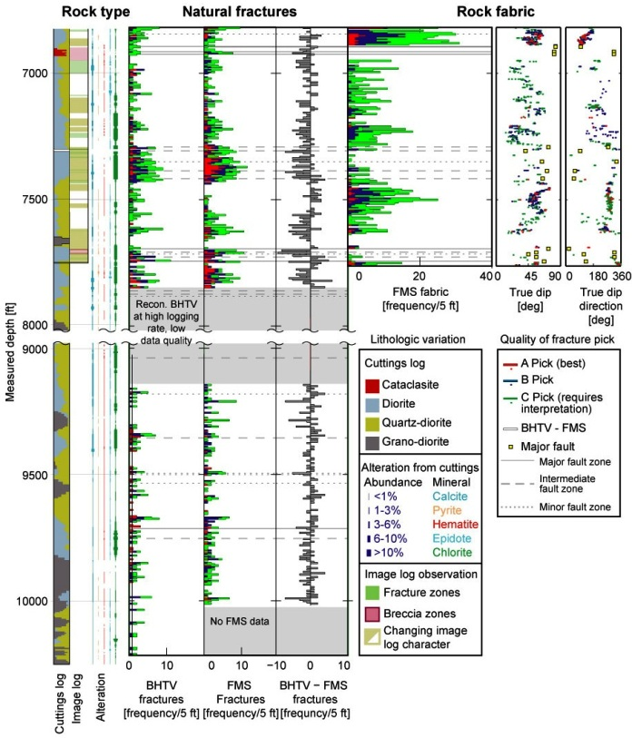 FIGURE 9: Synthetic and processed logs based on BHTV and FMS logs to quantify fracture intensity in a geothermal reservoir.
EXAMPLE 3: Spinner Survey, Geysers Field, CA
From: "Well Logging In Hostile Environments - A Status Report", by E. Frost and W.H. Fertl, CWLS, 1985
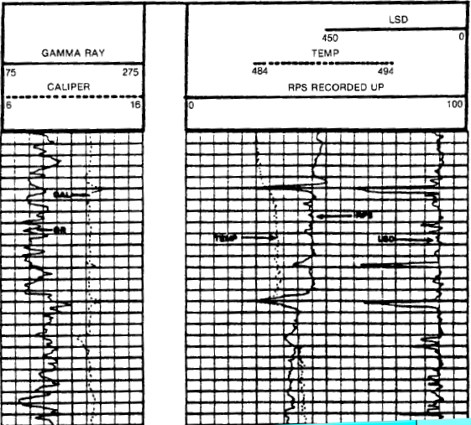
FIGURE 10: Gamma ray, caliper, spinner, temperature, and long spaced density (full bore, counts per second) logs in a Geysers well in California, 1985. Temperature is above 485’F.
REFERENCES
As noted in captions to illustrations

