PETROPHYSICS IN THE GREEN ECONOMY
PART 7 – Helium: old wells are new again
E.R. Crain, P.Eng.
Published in CSPG Reservoir Jul – Aug 2023

INtRoduction
The inert, or noble, gases comprise helium, neon, argon, krypton, xenon, and radon, of which helium is probably the most important. These gases are formed during the natural radioactive decay of elements such as uranium and thorium within the interior of the Earth and migrate upward to become trapped in porous rocks in sedimentary basins, usually in association with nitrogen and carbon dioxide. The helium content seldom exceeds 7% by volume, but as little as 1% or even less can be economic.

Petrophysics plays an important role in defining porosity and gas saturation, but the porosity estimate is tricky because the gas correction implicit in the usual log analysis models fail to account for the lack of hydrogen in the gas. Solutions are provided, including examples.
Helium is a valuable inert gas used in commercial, military, and medical applications. It doesn't burn or combine chemically with other elements.
It has unusual cryogenic properties and is used in welding to cool material adjacent to the weld and to cool the magnets in MRI machines, as well as the magnets at CERN that helped discover the Higgs boson. It also fills kids' balloons, weather balloons, dirigibles, makes your voice go squeaky when you breathe it, and helps spaceships get off the ground.
Helium and other inert gases are often found in conjunction with carbon dioxide and nitrogen, in wells that were originally drilled for oil or natural gas as early as 1903 (in Kansas). This discovery led to development, by the US government, of a large helium resource stretching from Kansas through Oklahoma into the panhandle of Texas. Pipelines, separation facilities, and a large strategic reserve storage facility were built during the 1950's and 1960's. Some processing was privatized in the 1960's and private development was permitted from the 1990's. Canada and Poland produced small quantities in the 1960's and 1970's.
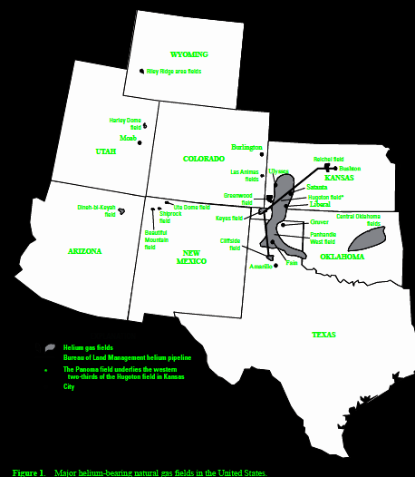
FIGURE 1: Map of US helium reservoirs in mid-continent region. Trend continues into SE Alberta and SW Saskatchewan. (Image courtesy US BLM)
Today, the USA produces about 55% of World supply, Algeria and Qatar about 40%, the balance from a half dozen other countries. The price is a little volatile, averaging US$ 100+/- per thousand cubic feet (mcf), compared to natural gas at US$ 4.00+/-.
Gas analysis reports from helium bearing wells show high concentrations of CO2 or N2 with traces to several percent helium. Some have hydrocarbon gases (methane, ethane, propane) in quantities too small to allow the gas mixture to burn. A typical analysis might show 5% He and 95% N2, or 5% He with 95% CO2, or 5% He, 35% methane, with 60% N2. Wells with less than 0.5% He are probably uneconomic; an average producing well in the USA has about 4% He.
The method used to separate helium from a gas mixture is fractional distillation to create crude helium, followed by low temperature liquefaction to produce Grade-A 99.995% pure helium.
The major source of helium is radioactive decay of uranium and thorium in basement rocks or shales below potential reservoirs. Many helium producing fields are associated with volcanic intrusions or deep-seated basement shears. Some helium may also come from the primordial lithosphere through faults; this is the lighter isotope of helium. Few isotope ratios have ever been performed so the source is not precisely known in many cases.
To trap helium in a reservoir you need the same geological setting as for natural gas: source rock, migration path, porous reservoir rock, structural or stratigraphic trap, and a seal at the top of the trap.

Migration path is usually through faults or fractures but could be direct contact of a reservoir with a source rock. Reservoirs are usually sedimentary strata, but some igneous rocks may be porous and permeable enough to hold helium.

Traps are often structural, as drape over domes or anticlines. Strat traps are harder to seal. The seal is more critical than for conventional oil or gas. The helium molecule is about half the size of a methane molecule so it can penetrate through smaller pores and fractures than methane. This makes it difficult to contain in samples and the seal on any trap must be lower permeability than a similar trap for oil or natural gas. The best seals are salt, salt plugged porosity, lava flows, or very fine claystone (shale).
Production rates vary with reservoir quality, thickness, and pressure. Many were overpressured and blew out in the early days of helium exploration. CAUTION: If you find production rates or production rate graphs, be sure to distinguish between total flow rate of all gases versus helium flow rates -- it isn't always clear.
If you are concerned about the environment, the inert gases, other than helium, are vented to the atmosphere, including CO2 and any hydrocarbons in the mixture. A few wells are actually completed to capture CO2 or N2 for commercial purposes, but most are not.
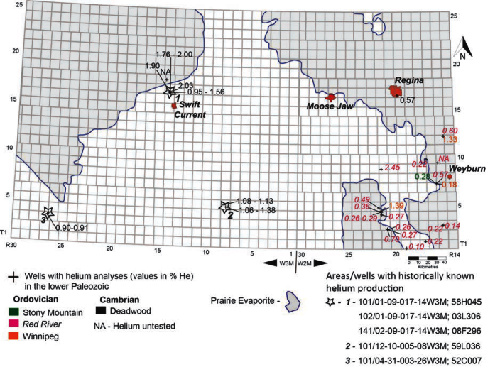
FIGURE 2: Distribution of all known helium tests in the lower Paleozoic: Deadwood, Winnipeg, Red River and Stony Mountain formations. Image from "Helium in Southwestern Saskatchewan", Melinda Yurkowski, Saskatchewan Geological Survey, Open File Report 2016-1
LOG ANALYSIS IN HELIUM WELLS
Petrophysical analysis of inert gas reservoirs involves the same steps as any other gas well: shale volume, effective porosity, lithology, water saturation, permeability, gas-in-place. There are a number of pitfalls in analyzing the well logs in helium bearing zones in addition to the usual problems of rough hole condition, highly variable mineralogy, salt plugged porosity, and varying water resistivity which can occur in any well. Here are the critical things that need to be considered:
1. Old wells have minimum log suites (Electrical survey (ES), possibly a microlog (MLC). By 1960 there may be a single transmitter sonic log, by 1965 possibly a density log, and if the Gods are willing, a gamma ray and neutron log (GRN), probably through casing. Each of these logs require special handling, covered elsewhere in this Handbook, BUT ALSO subject to all the concerns listed below.
2. All porosity models must be corrected for shale volume. The gamma ray may permit this, but it should be calibrated to XRD clay volume on at least a few samples.
3. Inert gases have no hydrogen, so in theory the neutron log reads zero porosity. In air-drilled holes, there is no mud-filtrate invasion, so neutron reads near zero. On liquid-filled holes, neutron varies somewhat with the actual water saturation in the invaded zone and depth of investigation of the log. Clay volume, and whether or not the gas column contains hydrocarbon gas in addition to the inert gases will increase neutron porosity. In some wells, invasion is deep enough for the neutron log to read a reasonable porosity value. In other wells, the neutron log reads zero or even slightly negative apparent porosity.
4. Sonic and density logs when transformed to porosity will read too high a porosity due to gas effect, unless invasion is very deep and residual gas in the invaded zone is negligible (unlikely). Standard gas correction models will be needed, calibrated to core porosity. Variations in matrix rock properties will need to be controlled by sample and core description.
5. With the neutron log reading too low compared to a hydrocarbon gas (possibly near zero), the standard gas corrected density neutron complex lithology model for porosity may not work well, giving a porosity that is too low. Some limited experience in Saskatchewan suggests that invasion may be sufficient to minimize this problem, but there was no core data available to prove this. In other project areas, the neutron reads zero and cannot be used as a porosity indicator.
6. NMR porosity is unaffected by clay, mineralogy, or gas effects, so it will give a reliable porosity in an inert gas reservoir, provided the borehole is not too rough and there is some drilling fluid invasion. Some core analysis control is comforting but less essential than for sonic and density porosity.
7. The only lithology model that works properly in a gas reservoir is the PE 2-mineral model. The PE curve was not common until the 1990's and may be missing in many wells drilled after that date, so there may be no direct method to calculate mineralogy. Sample and core descriptions are a necessity to assist in understanding the mineralogy and the higher quality reservoir facies.
8. After a porosity algorithm has been calibrated to core, the deep resistivity can be used to calculate water saturation, provided the correct Rw regime can be identified. This allows the calculation of total gas in place. Multiply by helium fraction to obtain helium in place.
9. If salt plugging is present, it might be possible to identify it by very high resistivity and very low neutron and/or NMR porosity. The efficacy will depend on whether or not the drilling fluid has dissolved the salt in the zone investigated by the neutron log. Sonic and density porosity may be lower than non-plugged intervals due to the different log response of salt and gas. Results may still be ambiguous. When identified, salt plugged zones are flagged and porosity set to zero.
10. Once porosity and saturation are calculated, and salt plugged intervals are flagged, permeability can be calculated from the usual Wyllie, Timur, or Lucia methods. An estimate of total gas deliverability at initial unstimulated conditions is possible based on the sum of permeability thickness values. There is a large possible error in this result as natural fracture permeability is not included.

11. Helium concentration CANNOT be calculated directly from any well log result.
12. Inert gas wells are among the most difficult to quantify using well log data. Core analysis data and sample descriptions, with a little help from XRD mineralogy data, can make the job a little more conclusive. Commercial software will most likely fail to give an accurate estimate of porosity unless you add some user-defined equations to account for the peculiar gas effect caused by inert gases.
LOGging program for inert gas wells
While we are stuck with the log suite in existing wells, we can run an appropriate program today that will give optimum results. The recommended suite is:
1. array induction or array laterolog with SP and gamma ray. (In air-drilled holes, laterolog cannot be run).
2. density neutron with PE and spectral gamma ray.
3. nuclear magnetic resonance log with gamma ray.
4. array sonic log for correlation with older wells and to assist seismic interpretation.
5. resistivity image log to assist in facies description, and trap and seal definition.
Items 3 and 5 are needed only from TD to 100 meters above the zone of interest.
Gas log, conventional or drilled sidewall cores, close spaced sample description, and XRD mineralogy and bulk clay are strongly recommended.
LOG ANALYSIS EXAMPLES IN HELIUM WELLS
1. ANCIENT LOG EXAMPLES WITH NO QUANTITATIVE PETROPHYSICAL ANALYSIS
These two examples are from "Oil and Gas; and Helium Production Potential of Oil and Gas Assets in Navajo County, Arizona" by Olufela Olukoga, prepared for Blackstone Exploration Company Inc.

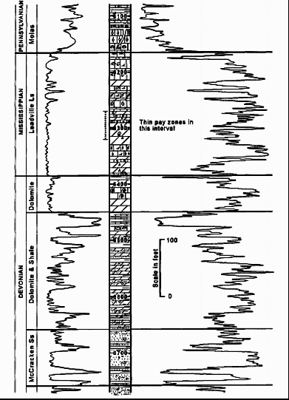 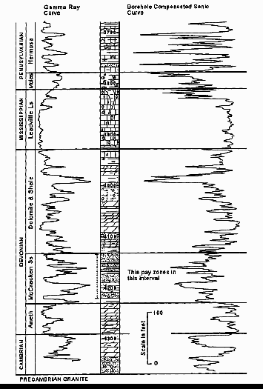
FIGURE 3: Left: Ancient gamma ray neutron log in helium bearing reservoir in the Tohache Wash Field. Gas in the Mississippian was 6.03% helium. Cumulative production was 385 Bcf total gas. Neutron deflections to the right are low porosity OR inert gas. Right: Borehole compensated sonic log in Kerr-McGee #2 Navajo-C well showing the stratigraphic position of the helium-bearing reservoir in the Dineh bi Keyah Field. Gas in the Devonian ranges from 3.11% to 6.23% helium and averages 4.83% helium and produced 1.4 Bcf total. High sonic travel time is high porosity or shale.

2. MODERN PETROPHYSICAL ANALYSIS EXAMPLES
These examples are from wells that have tested or produced inert gas with helium in economic quantities. The analyses were performed for North American Helium Ltd and are reproduced here with their permission.
EXAMPLE 1: Air-drilled Inert Gas Well
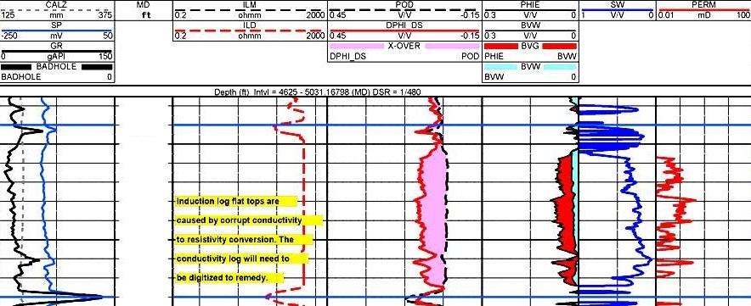

FIGURE 4: Left hand tracks contain gamma ray, deep resistivity, density, neutron (with gas crossover shaded pink) curves. Right hand tracks show calculated effective porosity (with inert gas volume shaded red), water saturation, and permeability. Neutron log reads zero porosity since inert gas has no hydrogen content and there is no invasion from a liquid borehole fluid. SP, shallow resistivity, and sonic are missing as they cannot be recorded in an air-drilled hole. (Image courtesy NA Helium).

EXAMPLE 2: Liquid-filled Borehole

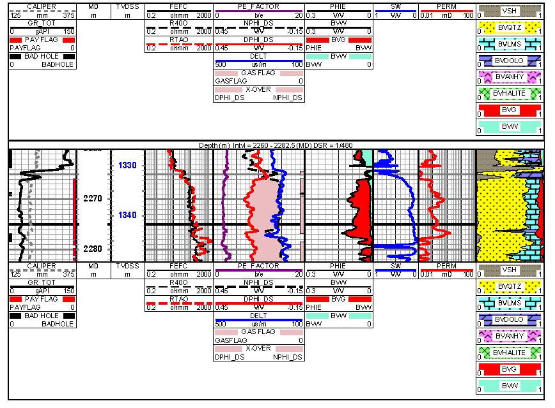 FIGURE 5: Left hand tracks contain gamma ray, deep and shallow resistivity, density, neutron (with gas crossover shaded pink), PE, and sonic curves. Neutron log responds to invasion water but may read a bit low due to residual inert gas in the invaded zone. Right hand tracks show calculated effective porosity (with inert gas volume shaded red, water saturation, permeability, and lithology analysis. (Image courtesy NA Helium).

ACKNOWLEDGEMENT
Thanks to NA Helium for permission to show results from one of their projects and to Dorian Holgate of Aptian Technical for creating the examples in Figures 4 and 5.
REFERENCES
1 Inert Gas Technical Data
Various Wikipedia pages, 2022.

