LOG EVALUATION OF NON-METALLIC MINERAL DEPOSITS

M.P. Tixier
R.P. Alger
Schlumberger Well Services Corp.
Houston, Texas
Published in SPWLA Transactions 1967 and Geophysics Vol. 35 #1, 1970. This paper is a compilation based on prior work by the authors and other SWSC employees. Content from my 1966 potash paper is included in an abbreviated form. Equations have been updated to computer-ready format. This electronic version created Feb 2021.
ABSTRACT
Well logs can be used to locate and evaluate deposits of various commercially important minerals. It is only necessary that the mineral of interest represent a significant fraction of the formation bulk volume, and that it exhibit characterizing properties measurable by logs. Because modern logging methods measure electrical, density, acoustic, radioactivity, and certain nuclear characteristics of formations, they may be used to identify many minerals.
- For evaluation of sulfur deposits, either density or sonic logs provide good resolution when compared with porosity computed from neutron or resistivity logs.
- Trona beds are identified by a sonic reading of approximately 65 microsec/ft, neutron porosity index of about 40%, low natural radioactivity, and pronounced hole enlargement.
- Gamma ray logs provide important information in the location, identification, and evaluation of potash mineral deposits. Neutron, sonic, and density logs, in various combinations, augment the gamma ray data in such studies.
- Coal beds are characterized by high resistivities, and by high apparent porosities on sonic, neutron, and density logs.
- Density logs are particularly suited for evaluation of yield from oil shales.
In all such explorations for non-metallic mineral deposits, logs provide a fast, detailed, and economical reconnaissance of the entire length of the well which can be calibrated with core assays, where available.

INTRODUCTION
Because well logging is so intimately related to petroleum prospecting it is easy to overlook advantages offered in other industries. In the search for oil, logs provide a fast, detailed and economical reconnaissance of the entire length of drilled hole. They offer the same advantages in finding and evaluating deposits of several other commercially important minerals.
The available variety of logs enables measurement of many parameters useful in mineral identification. Logs measure electrical, density, acoustic, radioactive, and certain nuclear characteristics of formations. Appropriate combinations of these measurements can be used to describe not only the type minerals in the formation but also the amounts or concentrations.
During the past several years a number of papers have been presented on the subject of defining lithologies of petroleum reservoirs. ⁽¹⁻³⁾ These papers show how various log parameters are compared to distinguish between sandstones, limestones, dolomites, and various combinations of these and other rock minerals. These techniques enhance the accuracy of petroleum reservoir evaluation. The same basic approach is used in prospecting with logs for non-metallic mineral deposits.
To locate and evaluate mineral deposits with logs several requirements must be met. First, the mineral of interest must have characterizing properties measurable by logs. Second, the mineral must represent a significant fraction of the formation bulk volume.
This paper is directed toward engineers experienced in logging and log interpretation. The purpose is to show how logs have been used to find and evaluate deposits of several commercially important minerals: sulfur, trona, potash, coal, and oil shale. Although the discussion concentrates on these minerals, the methods are not similarly restricted. They are appropriate for any mineral deposit that meets the previously stated basic requirements.
PROSPECTING FOR SULFUR
Sulfur, like oil, has long been commercially valuable. Also like oil, the demand for sulfur continues to grow, There are other similarities. Most domestic sulfur is produced from wells. Further, native sulfur usually occurs in the interstices of other rock minerals, rarely representing as much as half the bulk volume of the formation.
To adapt the principles of mineral definition by logs to sulfur prospecting, it is necessary to consider the properties of both sulfur and the minerals which commonly occur with it. These properties, as measured by sonic and density logs, are presented in Table 1. The table indicates these two properties of sulfur are particularly useful: the sonic interval transit time is exceptionally large; the density is low. Thus, either sonic or density measurements offer a means of evaluating sulfur deposits.

TABLE 1
MINERAL LOGGING PARAMETERS FOR SULFUR EXPLORATION

MINERAL | SONIC  T_{ma} –μsec/ft | APPARENT  LOG DENSITY  ρ_{ma} – gm/cc | POROSITY INDEX _%  (ASSUMING LIMESTONE)
 |  |  | SONIC | DENSITY
Sulfur | 122.0 | 2.030 | 53.0 | 40.0
Calcite | 47.5 | 2.710 | 0.0 | 0.0
Dolomite | 43.5 | 2.876 | -2.8 | -10.0
Quartz | 51.5 | 2.648 | 2.8 | 4.0
Anhydrite | 50.0 | 2.977 | 1.7 | -15.5
Gypsum | 52.5 | 2.351 | 3.5 | 21.0
Halite | 67.0 | 2.032 | 13.8 | 40.0

Water at 90ºF | SONIC  _{tf} – μsec/ft | DENSITY  ρf – gm/cc
Fresh | 200 | 1.000
100,000 ppm NaCl | 189 | 1.067
200,000 ppm NaCl | 176 | 1.144

EVALUATION OF SULFUR-BEARING LIMESTONE
The usual occurrence of native sulfur is as infilling within the pore structure of limestone. If only limestone and sulfur are present, the values recorded by either a sonic or density log are simple functions of the relative quantities of each. Thus,
1: DENS = Vsulfur * DENSsulfur_{r} + (1 - Vsulfur) * DENSlimestone
2: DTC = Vsulfur * DTCsulfur_{r} + (1 - Vsulfur) * DTClimestone

were Vsulfur is the fraction of bulk volume occupied by sulfur. Because the log characteristics of sulfur and limestone are known (Table 1), either of the above equations would provide an easy determination of sulfur content - if only sulfur and limestone were present.
In practice, however, some fluid-filled porosity is present in sulfur-bearing limestone. Because log values are affected by porosity, it must be considered. Thus,
3: DENS = PHIe * DENSwater + Vsulfur * DENSsulfur + (1 – PHIe
- Vsulfur) * DENSmatrix
4: DTC = PHIe * DTCwater + Vsulfur * DTCsulfur + (1 - PHIe - Vsulfur) * DTCmatrix
where PHIe is the actual formation porosity, and DTCwater and DENSwater are the log characteristics of the contained fluid.
Table 1 gives log characteristics for waters of different salinities. Charts are available for determination of fluid properties at other conditions.
Many modern density, sonic, and neutron logs are linearly scaled in terms of porosity. This permits direct comparison of various types of logs to appreciate and account for variations in formation lithology. To scale the logs in porosity, however, it is necessary to assume lithological and fluid characteristics. The porosity scales on most such logs are based on an assumed limestone lithology with water occupying the pore space.
Thus, in a water-filled limestone the apparent log porosity equals the true porosity. For other lithologies the apparent porosity on any one log can, and usually does, require correction. The comparison of several logs serves to indicate the direction and magnitude of the necessary corrections.
This concept of an apparent limestone porosity enables simplification of Eqns. 3 and 4. Furthermore, the simplification is greatest when using logs scaled directly in terms of apparent limestone porosity. For example, consider a density log, so scaled, used with Eqn. 3. In a sulfur-bearing limestone the log effects due to limestone drop out, and the apparent log porosity, φ_{D}, is a function only of the actual porosity and the sulfur content.
Table 1 shows, for density logging, that the apparent limestone porosity for pure sulfur is 0.40. Thus, assuming DENSfluid = 1.0 and substituting in Eqn. 3 we obtain:
3a: PHID_LS = PHIe * PHIDwater + Vsulfur * PHIDsulfur + (1 - PHIe - Vsulfur)
* PHIDmatrix
which reduces to:
5: Vsulfur = (PHID_Ls – PHIe) / 0.40
where PHID_LS is the apparent limestone porosity recorded by the density log.
A similar simplification can be applied to the sonic equation (Eqn. 4) for sulfur-bearing limestones. Only the constants differ. The simplified sonic equation is:
6: Vsulfur = (PHIS_LS – PHIe) / 0.53
where PHIS_LS is the apparent limestone porosity obtained from a sonic log.
In each of Eqn’s 5 and 6 there are two unknowns. Therefore, to determine the sulfur fraction by either density or sonic equations, it is first necessary to determine the actual porosity PHIe. If the porosity evaluation is to be from log data, a second log is required. Theoretically, a density and a sonic log could do the job. However, because the apparent limestone porosities of sulfur from density and sonic logs are similar, this combination lacks resolution. Much better resolution is obtained if the second measurement is from a neutron log. Resistivity logs also provide good resolution for porosity if no hydrocarbons are present.
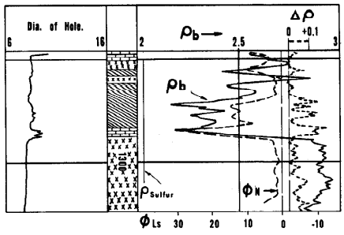
Figure 1. Sulfur in caprock identified by density and neutron log comparisons. Sulfur is present in beds identified by diagonal hatching in the depth column.
Density-Neutron Overlay for Sulfur Identification
Figure 1 illustrates a simple qualitative detection of sulfur in caprock as given by a comparison of density and neutron logs. The density log was recorded on an apparent-limestone porosity scale. The neutron values were converted to the equivalent scale and were traced onto the density log. Thus, where only limestone is present, the curves coincide. Sulfur is indicated by a divergence of the curves, with the density curve indicating the higher apparent porosity. These sulfur bearing zones are indicated by diagonal hatch lines in the depth column.
This simple definition of sulfur content is based on the assumption that the formation is comprised only of limestone, sulfur, and water. Appreciable fractions of other minerals destroy the validity of the interpretation. For example, the illustrated section contains anhydrite, indicated by x’s in the depth column. Anhydrite causes a divergence of the curves in an opposite direction from that of sulfur. While bedded anhydrite is easily recognized and causes little trouble in interpretation, either gas saturation or interbedded salt (halite) could give the same log appearance as rich sulfur deposits.
In sulfur bearing sections of limestone the divergence between the density and neutron curves (of apparent limestone porosity) is proportional to the sulfur fraction. This provides a basis for quantitative evaluation of sulfur content.
Measurements in sulfur blocks and in cored wells indicate some variation in sulfur response for different types of neutron tools. These studies indicate little or no sulfur effect on the Sidewall Neutron Porosity log (SNP). In other words, sulfur and limestone appear the same to the SNP. Therefore, the SNP value of apparent porosity can be used in Eqn. 5 as the true value of water-filled porosity. Thus:
7: Vsulfur = (PHID_LS – PHINsnp) / 0.40
Limited experience indicates that both the 15.5-in and 19.5-in spacing GNT-F neutron logs exhibit sulfur effects. The effect on the 15.5-in spacing GNT-F is relatively small and good results have been obtained with a slight modification of Eqn. 5:
8: Vsulfur = (PHID_LS – PHINgnt15) / 0.45
A larger sulfur effect has been noted for the 19.5-in case. Better agreement with core assays is obtained using:
9: Vsulfur = (PHID_LS – PHINgnt19) / 0.60
The foregoing equations 7, 8, and 9 are based on limited experience. Greater experience may indicate modification of these simple relationships.
The density log (FDC) in Fig. 2 was recorded through a thick caprock section on a Gulf Coast salt dome. Overplotted on the log, and to an equivalent scale, is a curve of apparent limestone porosity from a neutron log (GNT-F, 19.5-in spacing). The caprock section from 1,015 to 1,220 ft appears rich in sulfur because the density curve indicates a much higher apparent porosity than shown by the neutron.
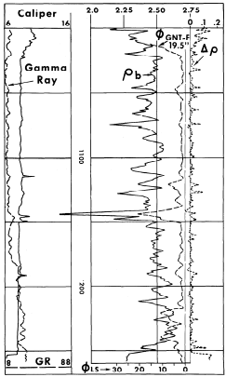
Figure 2: Density Log and overplotted neutron data recorded through a thick caprock section on a Gulf Coast salt dome. Large separation between density and neutron curves indicates rich sulfur content.
Core analysis shows this is indeed the case, This section is rich in sulfur. However, the core assay was presented in a form not directly comparable with the logs. The sulfur assay was reported as averages over five foot lengths of hole. Furthermore, as is the custom with core assays, sulfur content was reported as percent by weight of formation solids.
To make the logs and core data comparable several steps were taken. Core-assay values were converted from percent by weight to percent by volume of the formation solids. There was little source for error in this conversion since core analysis indicated insignificant quantities of solids other than limestone and sulfur. Log values were averaged over corresponding five foot intervals and were used to compute the sulfur fraction as percent of matrix volume (See Appendix for the method of computation).
A comparison of the sulfur content derived from the logs and that given by cores is shown in Fig. 3. In addition, core recovery is also indicated. The major discrepancies between log and core assays occur in levels of poor core recovery. And, in these levels, the core assay generally reports a lower sulfur content. We feel the core assay is pessimistic in these intervals because sulfur is soft and brittle, and is easily lost in the coring operation.
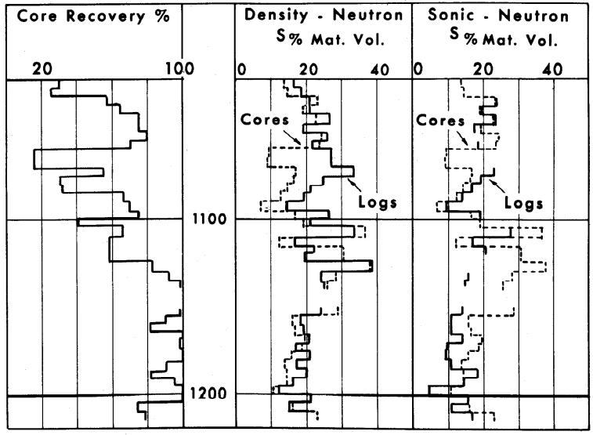Figure 3: Comparison of sulfur content derived from logs and core assay.
Sonic Neutron Overlays
Comparisons of sonic and neutron logs give a good qualitative evaluation of sulfur content. However, because sonic response in carbonates (with secondary porosity) is less predictable than that of density logs, sulfur fractions computed from the sonic-neutron method are more subject to error than from density-neutron studies.
When the SNP neutron log is used with sonic data for sulfur computation Eqn. 6 applies directly:
10: Vsulfur = (PHIS_Ls – PHINsnp) / 0.53
For the GNT-F Neutron logs Eq. 6 is adjusted as follows:
11: Vsulfur = (PHIS_Ls – PHIgnt15) / 0.60
And
12: Vsulfur = (PHIS_Ls – PHINgnt19) / 0.80
A comparison of sulfur content computed from sonic and neutron logs is also compared with core assay in Fig. 3. The sonic-neutron data generally indicate lower fractions of sulfur than obtained from either core assay or density-neutron computations. This is particularly noticeable in the section from 1,175 to 1,205 ft, where core recovery was relatively good. We attribute the discrepancy to pessimism of the sonic log in secondary porosity. ⁽⁶⁾ Since sulfur often occurs in vugs or solution enlargements in limestone, the sonic log is frequently pessimistic for quantitative evaluation.
Another source of trouble in the sonic-neutron method is the tendency for cycle-skipping to occur on the sonic log at shallow depths. ⁽⁷⁾ This cycle-skipping is a perturbation of the log that is unrelated to the presence of sulfur. Furthermore, in intervals where cycle-skipping occurs the sonic data are useless for sulfur computation. Cycle-skipping occurred in several intervals on the sonic log used in this study.
In some cases, however, the sonic-neutron method may give better answers than the density-neutron. The sonic log characteristics of limestone and anhydrite are similar. Therefore, if significant fractions of anhydrite occur in the sulfur-bearing limestone they have little effect on the sonic-neutron sulfur computation. As indicated by Fig. 1, density-neutron values would be pessimistic.
Resistivity-Sonic (or Density) Approach
A resistivity log sometimes provides the porosity control necessary for sulfur evaluation with either sonic or density logs. It is necessary, however, that the formation be 100% water saturated; it must not contain hydrocarbons. Furthermore, the resistivity of the saturating water (Rw) must be known. If these conditions are met, porosity can be computed from the true resistivity of the water-saturated formation (Ro).
13: PHIe = (Rw / Ro)^0.5
The value of porosity thus computed can then be used in Eqn. 5 or 6 to obtain the bulk volume fraction of sulfur.
The Induction-Electrical Survey and Sonic Log in Fig. 4 were recorded in a well in Coastal Louisiana. Although sulfur is present in the illustrated limestone caprock section, its presence is not apparent on a casual inspection of the logs. Computations are necessary.
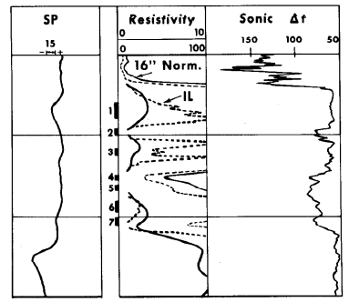
Figure :. Induction-Electrical Survey and Sonic Log recorded through sulfur-bearing caprock of well in Coastal Louisiana.
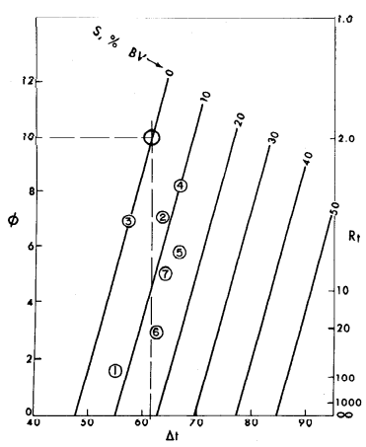
Figure 5: Sulfur fraction indicated by plot of sonic vs. resistivity data from logs in Fig. 4.
These computations may be performed graphically, as in Fig. 5, where resistivity values are plotted versus corresponding sonic values on a special grid, ⁽⁸⁾ The zero percent sulfur line originates at DTC = 47.5, the sonic matrix value for limestone. The slope of the line is defined by the resistivity of the formation water (Rw = 0.02 in this example). The lines, for sulfur percent of bulk volume parallel this line and represent equal spacing between DTC = 47.5, for limestone, and DTC = 122, for sulfur. Thus, for each crossplot of resistivity and sonic data, the sulfur fraction is indicated.
While resistivity-sonic or resistivity-density methods are of some utility, we again emphasize that the formation must be fully saturated with water. Oil or gas saturation would displace the crossplots downward and to the right, and would thus lead to erroneously optimistic estimations of sulfur content.

DETECTION OF SULFUR IN COMPLEX LITHOLOGY
In each of the previously discussed techniques, the assumption was made that only limestone, sulfur, and water were present in significant quantities in the formation. Such is often the case. The relatively simple methods, using only two log parameters, then apply. However, in some areas of sulfur exploration other rock minerals may be present in appreciable quantities. There, additional logs are required.
In West Texas, for example, it is customary to use sonic, density, and neutron logs in sulfur studies. From each of these logs an equation can be written for four unknowns. A fourth equation then derives from the truism that the sum of the component fractions must equal unity. The equations used in West Texas, with the appropriate constants, are as follows:
14: DTC = 122.0 * S + 47.5 * L + 125.0 * X + 189.0 * PHIe
15: DENS = 2.03 * S + 2.71 * L + 2.30 * X + 1.00 * PHIe
16: PHINsnp = 0.00 * S + 0.00 * L + 0.25 * X + 1.00 * PHIe
17: 1.00 = 1.00 * S + 1.00 * L + 1.00 * X + 1.00 *PHIe
In the above equations S, L, X, and PHIe are the bulk volume fractions of sulfur, limestone, silt, and porosity, respectively. Also,PHIsnp is the apparent limestone porosity given by an SNP neutron log. The constants for silt are log values of shale observed in sulfur studies in West Texas. For the area of the investigation these constants give the best correlation with core assays. In other areas it is quite possible that other constants would give better results.
It will be noted that Equations 14-17 are linear equations. This infers that the individual log responses vary linearly with variations in the mineral fractions. Such is not necessarily true. However, results have been good using this simplified but practical approach.
Solution of these equations is best handled by electronic computer. The program used provides a machine output in the form of a log such as shown in Fig. 6. On the output log the bulk volume fractions of silt, limestone, sulfur, and water-filled porosity are shown from left to right in the first track. To the right of the depth column, the log presents the sulfur content, expressed as percent by weight of the formation solids. This presentation enables a direct comparison with core assays of sulfur, which are customarily presented in the same terms.
The core assay of sulfur from this well is presented alongside the log study. A reasonably good correlation exists between log and core data. In the richer sulfur intervals the log values of sulfur content are generally higher than core values. This is due, in part, to loss of sulfur in the coring operation. In some intervals the incomplete core recovery leads to errors in depth correlation with log data.
Gypsum is encountered in these shallow sulfur-exploration wells in West Texas. However, gypsum is easily detected because it leads to computations of absurdly high values of porosity, and to negative fractions of sulfur. Three zones of gypsum are readily apparent in Fig. 6 (indicated by x’s).
Large fractions of anhydrite are easily detected as they lead to negative values for both porosity and sulfur content. There are no indications of anhydrite in the shallow well of Figure 6.
We have already mentioned the tendency for the sonic log to indicate pessimistically the occurrence of secondary porosity. The neutron and density logs are not similarly inclined; they respond to all porosity. Thus, where the sonic responds to a different porosity than the neutron and density logs Eq. 14-17 are not appropriate. In severe cases the equations lead to computation of negative fractions of silt. When negative silt fractions are computed, the computer program reverts to a solution of the following three equations:
18: DENS = 2.03 * S + 2.71 * L + 1.00 * PHIe
19: PHINsnp = 0.00 * S + 0.00 * L + 1.00 * PHIe
20: 1.00 = 1.00 * S + 1.00 * L + 1.00 * PHIe
This is the same solution used before, where limestone and sulfur are assumed to be the only solid components.
Admittedly, there is appreciable room for error in these log computations of sulfur content. Unaccounted for variations in lithology introduce errors. Log readings can be adversely affected by rough borehole walls. These, and other previously mentioned factors, preclude blind confidence in absolute values of computed sulfur. However, in spite of these shortcomings, sulfur prospectors have applauded the utility of logs for location and evaluation of sulfur deposits.
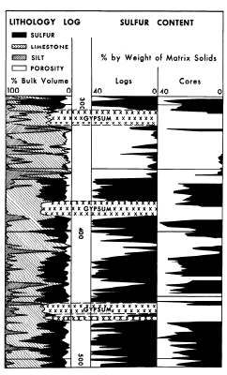
Figure 6: Machine computed log of lithology and sulfur content from a West Texas well. Sulfur assay from core analysis is also shown.
STUDY OF EVAPORITES
Logging techniques are well suited to locating and identifying commercial evaporite deposits. Bedded evaporite minerals are essentially nonporous and electrically nonconductive. Thus, they are characterized by extremely high readings on resistivity logs. Unless affected by borehole enlargement, resistivities recorded opposite evaporite beds are higher than obtained in adjacent sedimentary formations. Because some evaporites are quite soluble in water-base drilling fluids and lead to enlarged holes, the caliper is an important adjunct in the logging program.
While resistivity and caliper measurements locate evaporite deposits, they do not identify the evaporite mineral. But, since evaporite beds have little or no porosity, a single porosity log - sonic, density, or neutron - will usually provide identification. Characteristic log responses for some of the more common evaporite minerals are given in Table 2. Also listed are characteristic responses for sedimentary minerals and formations.
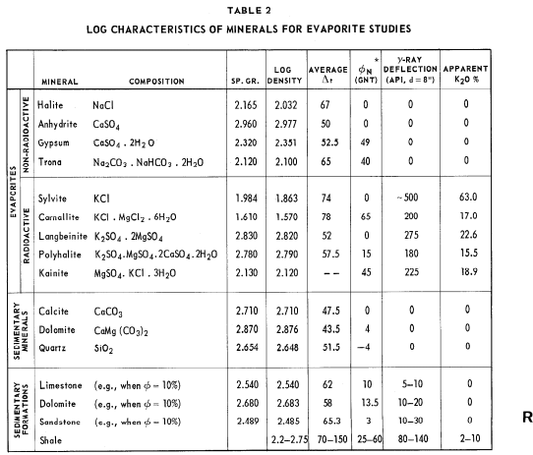
When evaporite beds contain mixtures of minerals, or are intercalated in sedimentary rocks, several logs are required for mineral identification. Graphical comparisons of data from two porosity logs, such as in Fig. 7, simplify mineral identification. In this chart, the sonic-neutron crossplot positions of non-radioactive minerals are shown. Similar crossplots of sonic-density and density-neutron characteristics are available. ⁽⁵⁾ The zero indications represent the readings for pure minerals. Extensions to the upper right show the direction of shift caused by porosity if present in the respective minerals.
The evaporite beds most commonly encountered are halite (rock salt), anhydrite, and gypsum. Prior to the introduction of sonic and density logs, deposits of these evaporites were not readily identified. Furthermore, they often caused erroneous interpretations in wells drilled for oil and gas. Now, with more discriminating logs available, these evaporites are easily identified.
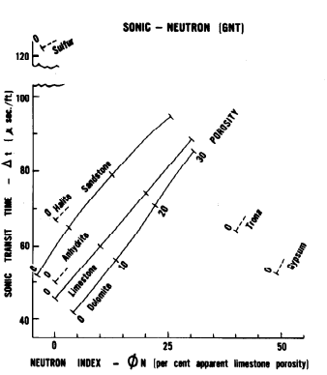
Figure 7: Crossplot comparisons of sonic and neutron data for mineral identification.

NON-RADIOACTIVE EVAPORITES
An example of the discrimination between halite and anhydrite is shown in Fig. 8. Gamma ray, caliper, and density curves are recorded through a section of interbedded shale, halite, and anhydrite. This well was drilled with a brackish water drilling mud. Thus, the caliper shows hole enlargement in the salt beds. It also shows the hole is enlarged in the shale zones. However, pure halite has a log density of 2.03 gm/cc and many zones approach this value. Anhydrite, with a log density of 2.98 gm/cc, is readily identified where the density curve approaches that value. Shale intercalations are signaled by departures from these characterizing densities, and are confirmed by the gamma ray curve.
Trona is a commercially important evaporite mineral. As indicated in Table 2, it is hydrous sodium carbonate and bicarbonate. It is non-radioactive and is water soluble. A principal source of trona is the Green River formation in Wyoming, from which the logs in Fig. 9 were obtained. (9) The well on which these logs were run was also cored. The lithology legend in the depth track, with trona indicated in black, was based on core description. The mineral is clearly identified by the logs. The gamma ray curve indicates low radioactivity, and the caliper curve shows pronounced hole enlargement in the trona beds. The Sonic Log, in the thicker beds, indicates a low t of approximately 65 μsec/ft. The neutron log reflects the high water of hydration with an apparent porosity index of approximately 40%.

RADIOACTIVE EVAPORITES
Potash minerals are among the radioactive evaporites most extensively sought and mined. The radioactivity stems from an isotope (K₄₀) which comprises a constant fraction of the total amount of naturally occurring potassium. Thus the gamma ray log is an important part of the logging program used in potash prospecting.
However, it is necessary to relate the gamma ray log response to variations in potassium content. To do this an extensive empirical study was made by E. R. Crain ⁽⁹⁾.
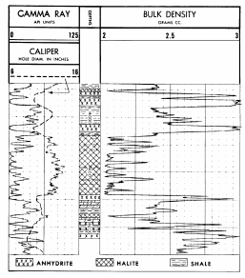
Figure 8: Formation Density Log with Gamma Ray and Caliper recorded through a shale and evaporite section.
In his study, Crain related log response to apparent K₂0 content, the unit customarily used in the potash industry. The study was made for an eccentered, scintillation type (SGD-F) gamma ray detector, and effects of the hole size and mud weight were considered. The results of Crain’s study are show in Fig. 10.
Although the gamma ray response defines the apparent K₂0 content, other definitions are important to the potash prospector. As noted in Table 2, there are several potash minerals. Some are more valuable than others. Furthermore, potash beds may contain mixtures of these and other evaporite minerals. They often contain insoluble impurities. Therefore, for effective evaluation of potash deposits the logs must identify the potash minerals and enumerate their respective fractions.
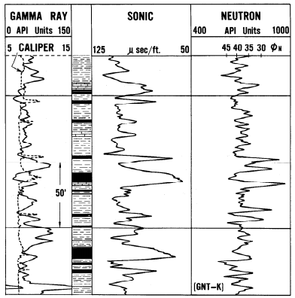
Figure 9: Logs recorded through Green River formation in Wyoming identify beds of trona; they are indicated in black in the lithology column.
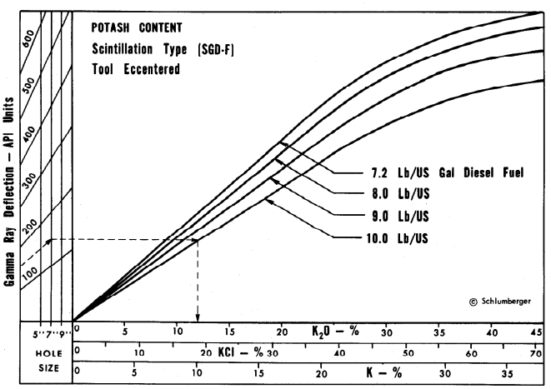
Figure 10: Empirical chart relating gamma ray deflection to apparent potassium content.
Cross-plotting gamma ray data versus formation density is one means of identifying potash deposits. Fig. 11 presents the appropriate intercepts for evaporite minerals encountered in such efforts. The densities are those appropriate for density log response in nonporous zones. The abscissa values are apparent K₂0 content as obtained from Fig. 10. An alternate abscissa shown at the top of the figure, is appropriate for an eccentered SGD-F gamma ray recorded in a 6-l/8” hole which is filled with 9-lb/gal, oil base mud. When only a single evaporite mineral is present it is readily identified by such a plot; only polyhalite and langbeinite lead to similar plots. Further, a mixture of two of these evaporites is often described by cross plotting because the points fall on a line between the two points. For more complex mixtures additional information is usually required.
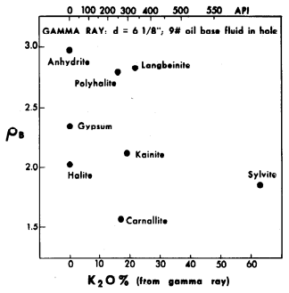
Figure 11: Crossplots of density and apparent K₂0 content (from Fig. 10) identify potash minerals.
One example of the extensive potash exploitation is the Prairie Evaporite formation of Saskatchewan, Canada. (10) In this region the formation is comprised essentially of sylvite, carnallite, halite, and some insolubles. High fractions of potassium-rich sylvite are desirable. Carnallite is not commercially attractive at this time; zones high in carnallite are avoided. Zones of high insoluble content are also avoided. Because of the large water of hydration content of carnallite neutron logs provide effective discrimination when used with gamma ray and either sonic or density logs.
Fig. 12 is a comparison of core assay and log data from a well in the Prairie Evaporite formation. In addition to gamma ray, neutron, and sonic curves, the log-computed fractions of sylvite, carnallite, and insolubles are shown. The reported mineral fractions are expressed as percent of bulk volume. The halite fraction, which accounts for the remainder of the bulk volume, is not shown. The dotted overplots of mineral fractions are the core assays for the respective minerals. In this figure the neutron and sonic are presented in an opposite polarity from normal to facilitate comparison with the computed mineral fractions.
With the exception of several massive halite beds, this section is indicated by both core and log data to be rich in sylvite and low in carnallite fraction. The major discrepancies between log and core data occur in the insoluble fraction values. However, the two agree on the zones of higher insoluble content.
The results in Fig. 12 were obtained by machine computation of data read from the logs. The machine program incorporates Table 2 characteristics for sylvite, carnallite, and halite. The log characteristics used for insoluble content are: apparent K₂0 = 0.05; PHIN = 0.30; and DTC = 120.0. When a density log is used, a grain density value of 2.60 is assumed for insolubles. These values were empirically derived and, for the most part, seem to correspond best with those for shale.
For manual computation of the mineral fractions in the Prairie Evaporite, appropriate equations were established and then processed on electronic computers to yield the following relations:

21: Sylvite = 0.00094 * DTC + 1.57690 * K₂0 - 0.42827 * PHIN - 0.06278
22: Carnallite = 0.00957 * DTC + 0.10631 * K₂0 + 1.67957 * PHIN + 0.640103
23: Halite = 0.01210 * DTC - 1.45287 * K₂0 - 0.95373 * PHIN + 1.81062
23: Insolubles = 0.0273 * DTC - 0.23033 * K₂0 - 0.29057 * PHIN - 1.38891
Similar sets of equations are available when the density log is substituted for either the sonic or neutron log. Furthermore, when the problem is complicated by significant fractions of a fifth mineral, langbeinite, for example, it may be solved if all four log measurements are made: gamma ray, neutron, sonic, and density. Equations are also available for this problem.
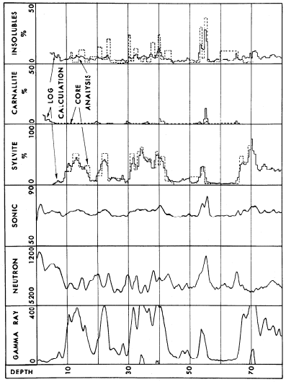
Figure 12: Comparison of core assay and log data from a potash core test in the Prairie Evaporite formation of Saskatchewan, Canada.
COAL IDENTIFICATION
As early as 1931 electric logs were used to locate coal seams. ⁽¹¹⁾ The high resistivity of coal beds causes distinctive anomalies on resistivity curves. In fact, early logs through coal seam anomalies helped define the characteristic response of resistivity curves for thin, highly resistive beds. On an electrical survey, as in Fig. 13, thin coal beds cause high lateral curve readings opposite the beds and very low readings in the “blind zones” immediately below the coal. The long normal curve gives sharp “reversal” readings opposite coal beds thinner than the electrode spacing.
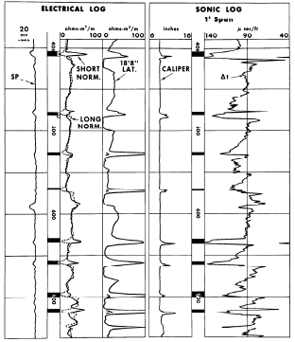
Figure 13: Thin coal beds cause distinctive anomalies on electrical and sonic logs from well in Kentucky.
Occasionally an SP anomaly develops in a coal bed so that it resembles a good oil or gas pay zone. When coal or lignite beds are encountered in oil or gas explorations the problem is often resolved by sidewall sampling. However, modern porosity logs readily identify coal beds. Sonic, neutron, and density logs all indicate unusually high values of apparent porosity in such zones.
The sonic log in Fig. 13, exhibits _{t} values approaching 140 μsec/ft opposite coal beds. This is an appreciably higher value than recorded through the shale sections in this shallow Kentucky well. Most of these coal beds in this figure are also identified by anomalies on the caliper curve. We have observed that coal beds frequently tend to cave, particularly toward the base of the coal seam.
Experience shows that the t recorded in coal is usually greater than in adjacent shales. And, as with shales, the t of coal varies inversely with compaction. The greater the compaction, the lower is the sonic value of t - other factors being equal. Schwaetzer and Desbrandes ⁽¹²⁾ reported in 1965 that the t of coal seams is influenced by depth of burial. They reported on a coal field in Lorraine, France, where DTC ranged from 135 to 143. Their observations indicated a t decrease of 0.5 μsec/ft per 100 ft increase in depth. A similar change with depth has been observed in the U. S.
However, sonic response is also affected by the grade of coal. Lignite beds exhibit the higher range of _{t}, with values from approximately 140 to 170 μsec/ft. For bituminous coals the _{t} values range from 100 to approximately 150 μsec/ft. Logging experience with anthracite coals is too limited to specify sonic t values, but we expect them to be lower than for bituminous coals. The bedded coal in Fig. 13 is a bituminous grade (high volatile A bituminous). It has specific gravity of 1.33 to 1.43, ash content 9 to 15%, moisture content about 7%, and fixed carbon around 45%.
The coal beds in Fig. 14, from a well in Colorado, are also bituminous (subbituminous A grade). They are of a lower grade than the Pennsylvania coal in Fig. 13, and might be expected to exhibit higher values of _{t}. However, since these beds are much deeper, they give a lower _{t} of approximately 120 μsec/ft.
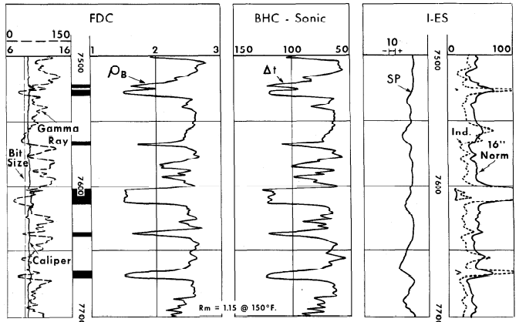Figure 14: Density, sonic and resistivity logs define coal beds in a Colorado well.
Density logs are also excellent for coal identification. The densities of coals range from 1.4 to 1.8 for anthracite, 1.2 to 1.5 for bituminous, and 0.7 to 1.5 for lignite. These low densities cause distinctive log anomalies, as indicated in Fig. 14. Here the 1.5 gm/cc densities correlate closely with the large _{t} values on the sonic log. Mined coals of this age and locale typically contain 12% moisture and 6% ash.
The ash content of coal is an expression of the quantity of included mineral impurities, such as silica, alumina, iron oxide, etc. It is an important factor in determining the commercial value of coal. Because all mineral impurities of significance have appreciably higher densities than the hydrocarbon coal, a density log provides an estimation of the variations in ash content for any given coal seam. ⁽¹³⁾ Fig. 15, illustrating this point, was taken from a report on a coal seam in England, ⁽¹⁴⁾ The ash content appears closely and linearly related to specific gravity, or density. While this ash estimation is effective for any given coal seam, other variables preclude direct extrapolation to seams in a different environment.
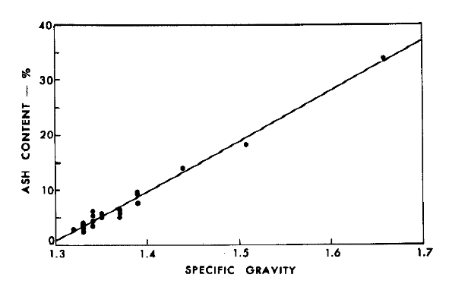
Figure 15. Comparison of specific gravity and ash content for a coal seam in England.
The log sections in Fig. 16 were recorded at approximately 7000 ft in a Wyoming well. A subbituminous coal bed is indicated by sonic and density logs with values of t = 128 μsec /ft and ρb = 1.44 gm/cc. The coal is also readily apparent on the SNP neutron log, with a porosity index of 62%!! Since carbon is a good moderating material for neutrons, a very low counting rate (and thus a high porosity index) results opposite coal beds. The gamma ray curve indicates a low level of radioactivity in this coal bed. This is usually the case, with the radioactivity of coal beds approximately the same as observed in limestone. However, since carbon actively reduces hexavalent uraniferous salts in solution to an insoluble tetravalent salt, uranium concentration may occur and high gamma ray curve deflection results. This high radioactivity is observed in the lignites of the Black Hills Region.
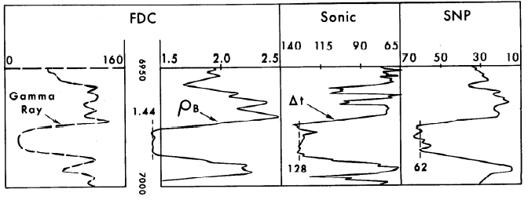Figure 16 - Bed of subbituminous coal is identified by characteristic anomalies on logs from a Wyoming well.

IMMATURE OIL SHALE EVALUATION
Another mineral area in which logs have demonstrated utility is in the evaluation of oil shales.
In 1963, Bardsley and Algermissen ⁽¹⁵⁾ discussed the use of both sonic and density logs to predict the yield of oil shales. In zones of higher oil yield both logs indicate increases in apparent porosity. Of the two logs, the density appears to give greater resolution.
In a recent paper, Tixier and Curtis ⁽¹⁶⁾ presented an example of oil shale evaluation using a density log. The log, shown in Fig. 17, was recorded over a 300 foot section of oil shale in the Piceance Basin of Colorado. Superimposed over the density log is a plot of yield from core assay. Correlation between density and assay yield is very good.
A plot of assay yield, in gallons per ton, versus density from Fig. 17, is shown in Fig. 18. The excellence of the correlation is again apparent. A least squares fit of 152 points gives the following equation:
Yield = 154.81 - 59.43 * DENS
This linear equation relating log density to yield has a standard deviation of 2.94 gallons/ton and a correlation coefficient of -0.876. Standard deviation is small as compared with the 25-30 gallons/ton yield that seems necessary for economic exploitation. Furthermore, this equation gives results similar to those of Bardsley and Algermissen, and to a U. S. Bureau of Mines laboratory study of oil shale specific gravities versus yield. ⁽¹⁷⁾
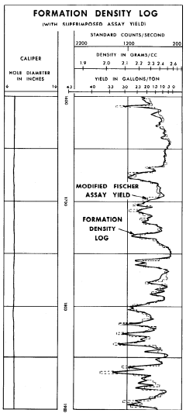
Figure 17 – Comparison of oil shale yield from core assay with density log recorded in Piceance Basin of Colorado.
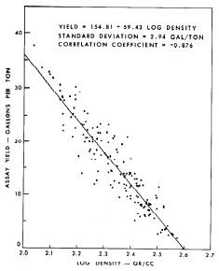
Figure 18 – Plot of assay yield vs. log density for oil shale section in Figure 17.

CONCLUSIONS
The foregoing discussions have presented logging techniques for locating or evaluating various non-metallic mineral deposits. Just as in the search for oil, log data are applied in the light of available information regarding the environment or habitat of the mineral in question. In many cases assumptions must be made regarding the environment. The errors created by these assumptions are sometimes large, sometimes small. Since the interpretation methods and assumptions are largely empirical, their accuracy improves with added experience. Excellent results are obtained when local experience is sufficient.
We have shown how logs are used in prospecting for sulfur, trona, potash, coal, and oil shale. Similar logging methods can be used to locate or evaluate other mineral deposits. It is only necessary that the target mineral cause characterizing responses on the logs. Although assays given by logging are subject to error, for some mineral explorations they are as good as, or better than, established methods.

REFERENCES
- Alger, R. P.: “Modern Logging Programs and Interpretation Methods,” SPE of AIME Formation Evaluation Symposium, Houston, Texas (Nov. 21-22, 1960).
- Tixier, M.P.: “Modern Log Analysis,” Jour. Pet. Tech. (Dec., 1962).
- Savre, W. C.: “Determination of a More Accurate Porosity and Mineral Composition in Complex Lithologies with the Use of the Sonic, Neutron, and Density Surveys,” Jour. Pet. Tech. (Sept., 1963).
- Alger, R. P., Raymer, L. L., Hoyle, W. R., and Tixier, M P.: “Formation Density Log Applications in Liquid-Filled Holes,” Jour. Pet. Tech. (March, 1963).
- Raymer, L. L. and Biggs, W. P.: “Matrix Characteristics Defined by Porosity Computations,” Transactions Fourth Annual Logging Symposium, SPWLA (May, 1963).
- Poupon, A.: “Contribution of the Formation Density Log and of Other Porosity Logs to Formation Evaluation,” paper presented at Association Francaise des Techniciens du Petrole (March, 1962).
- Tixier, M. P., Alger, R. P., and Doh, C. A.: “Sonic Logging,” Jour. Pet. Tech. (May, 1959).
- Tixier, M P., Alger, R. P., and Tanguy, D. R.: “New Developments in Induction and Sonic Logging,” Jour. Pet. Tech. (May, 1960).
- Alger, R. P. and Crain, E. R.: “Defining Evaporite Deposits With Electrical Well Logs,” Transactions Northern Ohio Geological Society Second Symposium on Salt (1965).
- Crain, E. R. and Anderson, W. B.: “Quantitative Log Evaluation of the Prairie Evaporite Formation in Saskatchewan,” Jour. Canadian Pet. Tech. (July-Sept., 1966).
- Johnson, H. M: “A History of Well Logging,” Transactions Second Annual Logging Symposium - SPWLA (1961).
- Schwaetzer, T. and Desbrandes, R.: “Divergences Constatees Dans La Mesure De La Vitesse Des Ondes Acoustiques Longitudinales De Charbon,” Revue de I’lnstitut Francais de Patrole (Jan., 1965 ).
- Doll, H. G., Martin, M., and Tixier, M. P.: “Application of Wire-Line Well Logging to Subsurface Geology,” International Geological Congress, XXI Session (1960).
- White, J. A. W.: “Schlumberger Coal Borehole Logging,” Societe de Prospection Electrique Schlumberger, Paris, France (Jan., 1963).
- Bardsley, S. R. and Algermissen, S. T.: “Evaluating Oil Shale by Log Analysis,” Jour. Pet. Tech. (Jan., 1963).
- Tixier, M. P. and Curtis, M R.: “Oil Shale Yield Predicted from Well Logs,” paper presented at Seventh World Petroleum Congress, Mexico City, Mexico (April, 1967).
- Stanfield, K. E., Smith, J. W., Smith, H. N., and Rabb, W. A.: “Oil Yields of Green River Oil Shale in Colorado 1954-57,” Bureau of Mines Report #5614.
APPENDIX
Eqn. 10 provides a determination of the bulk volume fraction of sulfur when using density and 19.5”-spacing GNT-F data. To compare log and core assays it is necessary to convert the bulk volume fraction to a fraction in terms of matrix volume. This is accomplished through the following equation:
A1: S% of matrix rock = Vsulfur / (1 – PHIe)

Eqn. A1 requires knowledge of the actual porosity. The report of core assay did not list porosity data. Furthermore, because of the sulfur effect on both the density and neutron logs, they cannot be used directly. However, we can use the two logs to solve for porosity.
Vsulfur = (PHID_Ls – PHIe) / 0.40 = (PHID_Ls - PHINgnt19) / 0.60
Then PHIe = PHID_Ls - 0.67 * (PHID_Ls - PHINgnt19 )
Giving PHIe = 0.33 * PHID_Ls - 0.67 * PHINgnt19
The values of porosity obtained from this equation are used in Eq. A1. This method was used in the example of Fig. 3 to convert sulfur fraction of bulk volume to sulfur fraction of matrix volume. A similar approach can be used for other types of neutron logs when the tool response to sulfur is known.

