REVIEW OF SEMI-AUTOMATIC VELOCITY ANALYSIS TECHNIQUES
E. R. (Ross) Crain, P.Eng. and Rick Bogehold
Digital Technology Pty. Ltd., Sydney, Australia

Published in ASEG Bulletin, Vol 2 No 1, Sydney, 1971. This electronic version created
Jan 2021. Equations were updated to computer-ready format.

INTRODUCTION
A large number of semi-automatic velocity techniques have been developed in the past few years. The principle of such techniques is based on computerized approximations to the familiar Delta-T or Normal Moveout (NMO) analysis, usually done by hand until recently. The success of these programs depends largely on the exact mathematics of the program , the quality of the data, and most importantly, the form of display used to present results. This review will attempt to show results from a number of different programs using different mathematical methods in various types of displays. The reader is referred to various published papers such as: (1) Schneider, Backus, et all, 1966; (2) Garotta and Michon, 1967; and (3) Tanner and Koehler, 1969; for the detailed calculations of a few of these methods.
In addition, this paper will review a few of the uses of velocity information such as synthetic seismograms and depth sections, as well as some of the analysis methods used to verify the validity of velocity functions determined by semi-automatic means.

THEORY
If we are interested in finding interval velocity from seismic data, instead of from a sonic log, we must use equations that represent the physics of the seismic recording process. Since the geometry of the reflecting horizons is unknown, we must make some assumptions that may later turn out to be untrue. The equations work for both shear and compressional waves when the respective two way times are used.

The far trace time is:
1: Tx = To + NMO
Stacking Velocity is:
2: Vstk = (X ^ 2 / (Tx ^ 2 - To ^ 2)) ^ 0.5
Based on the geometry shown below (Figure 0), interval velocity between any two points in the section is:
3: Vint = (((Vstk2 ^ 2) * T2 - (Vstk1 ^ 2) * T1) / (T2 - T1)) ^ 0.5
Interval thickness:
4: Hint = 0.5 * Vint * (T2 - T1)
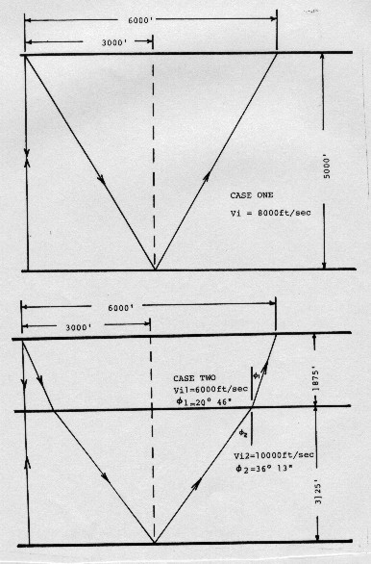
Figure 0: Geometry for interval velocity calculation

The apparent velocity, or stacking velocity (Vstk), is the velocity which yields the exact NMO from the NMO equation. Therefore, it could be derived from real seismic data with a T^2 - X^2 plot, an NMO analysis, or a computer velocity analysis (CVA). It is the only velocity that will yield the best stacked seismic section.
In order to calculate depth from time and velocity information, the average velocity Vavg derived above is not adequate. Instead, the RMS (time-weighted) average from Dix’s equation should be used.
This calculation compensates for the curved ray path which occurs in real life as opposed to the straight ray path which is usually assumed for normal moveout applications.

VELOCITY ANALYSIS METHODS

- CONSTANT VELOCITY ANALYSIS (CVA)
The CVA method, illustrated in Figure 1, is a very simple visual display of a common depth point record that can be used to pick a reasonable velocity function on good data. The method employs standard digital processes to correct the CDP record for different constant velocities. The particular example shown displays the same record corrected with 17 different velocities ranging from 5000 to 18,000 feet per second. Velocity-time pairs are chosen from those records in which the reflection appears flattest. The highest time velocity pairs are chosen so that the multiple reflections can be avoided. The common depth point record is used instead of the 100% record so that the effect of dip is eliminated. It is usually advantageous to run a good deconvolution and bandpass filter on the CDP record prior to applying the constant velocity moveout. The picks from this display will be shown on all of the examples in this paper, but this does not infer that the CVA picks are more correct than any other set. In fact, they are less likely to give good results except in good data.
This method is relatively cheap because the program running time for most normal moveout programs is fairly short. The length of time required for display of 18 records and the cost of the materials involved is a disadvantage, as is the fact that the velocity increments used are necessarily large, resulting in rather course definition of stacking velocities.
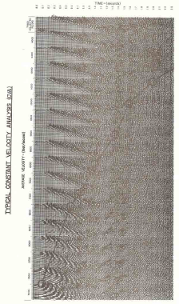 | 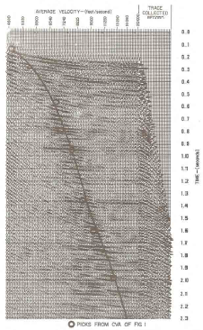
Figure 1: Typical Constant Velocity Analysis (CVA) | Figure 2: Typical Constant Velocity Stack (AVS)
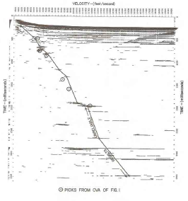  Figure 3: Typical Automatic Velocity Analysis (AVEL) | 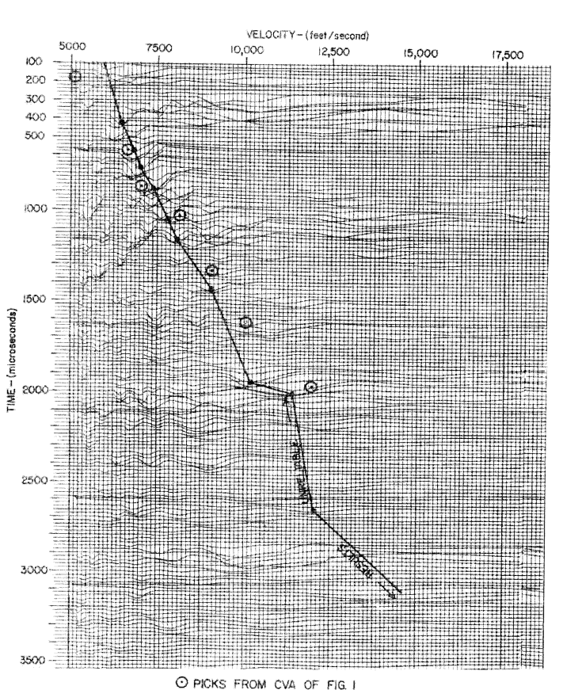  Figure 4: Typical Velocity Analysis (VELA)

- CONSTANT VELOCITY STACK (CVS)
The CVS is created in much the same manner as a CVA, but instead of displaying all 24 traces of each constant velocity record, the 24 traces are stacked into one trace and then displayed. The example in Figure 2 shows the CDP record and 96 constant velocity stacked traces. The velocities used were chosen such that there is a constant Delta-T increment between traces. A smooth curve drawn through the maximum amplitudes on this display should have the same shape as the Delta-T curve. This example vividly illustrates the fact that a wide range of velocities will often provide quite adequate stacking amplitude; however, where multiple reflections have average velocities close to that of the primary, as much separation as possible is desired, and the curve should be chosen within this in mind.
This technique demands considerable more computer time because there are 96 NMO records involved instead of 17, but the compact size of the display, it's visual impact, and its small velocity increment are features which tend to compensate for its cost.

- AUTOMATIC VELOCITY ANALYSIS (AVEL)
The AVEL technique is the first described here to make use of correlations between CDP’s traces instead of stacking amplitude. The objective of the program is to plot the cross-correlation coefficients of constant velocity corrected records, determined over short time gates. The display in Figure 3 shows the results from such a program, displayed as a VA section with no wiggle traces. A fairly high threshold was used to eliminate background noise. A similar style of display could be used to portray the CVA and the CVS as the visual results would much the same. When properly programmed to make use of a convolver or an array processor, the program can be faster than the CVS. The cost, therefore, is somewhat less. An area of unreliable results is shown on this figure since the deepest reflection on the test data is near 2 seconds. It is crucial, therefore, that all velocity analysis be interpreted alongside a near trace display or 100% wrong records to avoid forcing an interpretation through meaningless data. The CVS and CVA results are equally unreliable in this area, but were not shown on the display.

- VELOCITY ANALYSIS (VELA)
The VELA display shown on Figure 4 is possibly one of the most familiar displays to the average geophysicist. It also uses cross correlation techniques and displays traces representing the correlation coefficients. In the VLA program the correlation coefficients are calculated for constant times, whereas in AVEL program they are calculated for constant velocities. The running time for this program is faster still due to the reduced number of correlations required, and if the display is done on the seismic plotter, it is relatively cheap. Results, though, are often brought out on a Calcomp plotter which is unnecessarily expensive.

- VELOCITY CONTOURS
All of the techniques discussed so far suffer from one major problem; That is the difficulty in picking the exact maximum of the stacking or correlation amplitudes displayed. One solution is to present displays which are contoured so that a 3 dimensional surface can be presented in which the X and Y axis are time and average velocity, and the Z axis is stacking amplitude or correlation coefficient. An example of such technique is shown in Figure 5a. Here a Delta-T analysis has been created on the computer line printer and the correlation coefficients have been scaled from 0 through 9 with a dot representing 10. The peaks on this surface are picked and the corresponding Delta-T's used to determine the velocity function. The same data presented as wiggle trace information is shown in Figure 5b . The difficulty in choosing the position of the Delta-T curve is clearly shown. Contouring methods are more amenable to automatic picking of the peaks by the computer, since some logical rules can be put into the programs. These rules are based on a fan of permissible values and constraints which would normally allow the largest and most coherent peaks to be chosen. Surface fitting routines can be used to pin down the exact location of the peaks more precisely.
The cost of contouring techniques is still quite high due to the relatively undeveloped state of the art.
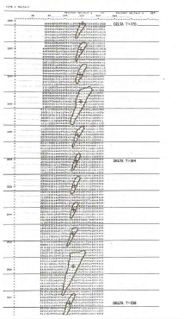  Figure 5a: Typical velocity contour | 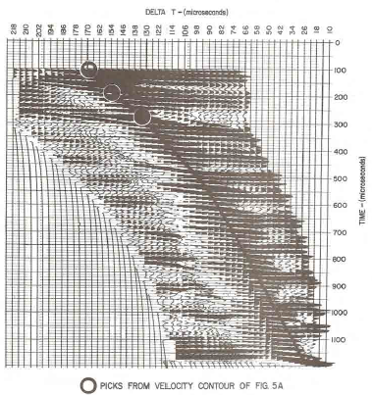  Figure 5b: Coherency values (before contouring)
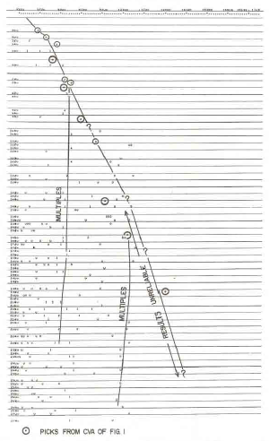  Figure 6a: VCOH – no velocity fan or coherence test | 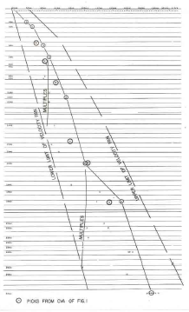  Figure 6b: VCOH – Coherence Test no Velocity fan
- VELOCITY ANALYSIS WITH COHERENCE TEST (VCOH)
This program makes use of the data generated in the VELA program, but the user can provide more constraints on permissible results, and the program picks and displays only the local maxima. Figure 6a represents the same data as the VELA of Figure 4. The numbers represent the maximum correlation amplitudes, normalized on a scale running from 0 to 9. The multiple reflection velocities are quite obvious from this display, but the primary reflection velocities below 1 second are not well defined.
In Figure 6b a coherence test has been applied to VELA's from 5 adjacent common depth point records. By coherence we mean a test for three measures of reasonableness of a velocity pick. For each pick in Figure 6a a test is made to see if the time, the velocity and the amplitude of that pick are within certain limits on the other four VELA's. The limits are specified by the user and depend largely on the quality of the data. The limits used on this example are as follows:
Time = 20 milliseconds, Velocity = 250 ft/sec, Amplitude = 20%

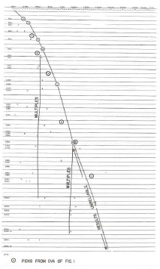  Figure 6c: VCOH-Velocity Fan and Coherence Test | 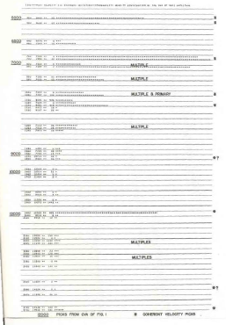  Figure 6d: VCOH – statistics over five velocity analysis
Only time-velocity pairs which satisfy these constraints are output. The use of the printer as a display mechanism reduces the cost considerably, although the coherence test itself can take as much time as the VELA calculations. One method used to reduce the calculation time is to provide a fan within which the result must fall. This will eliminate coherence calculations on better than 2/3 of the total information in VELA and cut running time appropriately.
The results of such a run are illustrated in Figure 6c. The fan is usually designed to be rather tight in the shallow section and the broader in the deeper section. Some knowledge of the velocities to expect is obviously required. Multiples can still be seen within the boundaries of the fans so very little useful information is lost with this approach. It is quite feasible to run a VELA on every common depth point and test for coherence between adjacent depth points and print the results for evaluation by the interpreter. The results from Figure 6c are shown in the table below.

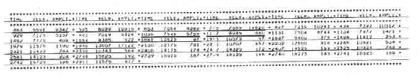
The function that would be used in each case is underlined on the printout. A statistical analysis of the results of all 5 VCOH’s is also printed (Figure 6d). This is an added tool for the interpreter. The statistics show the time, the average velocity, and it's standard deviation, and the probability density distribution of the sum of those picks which are coherent on all 5 VCOH’s. It is a simple matter to pick time velocity pairs with high probability as defined by the program, and to eliminate most unlikely picks. By ensuring that the average velocity must increase with increasing time, any coherent multiple picks will be eliminated. On Figure 6d we have marked with an asterisk those picks that are coherent and would have a high probability of being correct. This program is by far the most accurate and reduces ambiguities to a minimum. Time-velocity pairs can be picked confidently from this display, even in relatively poor data.

VERIFICATION TECHNIQUES
- VELOCITY GRAPHS
The most important phase of velocity interpretation from these semi-automatic programs is to verify that the functions are reasonable, consistent, and agree with the geology of the area. To check for reasonableness, 4 graphs should be prepared as shown in Figure 7a, 7b, 7c, and 7d. The first and most obvious is a detailed time versus average velocity graph. The example shown in Figure 7a was taken from well data, but the same result can be achieved from velocity functions picked from methods described earlier. The average velocity graph should be checked to see that the sharp breaks in the curve do in fact occur at reflections and that rates of change are reasonable based on the lithology of the area. Inversions in the average velocity graph should be checked closely.
A time versus Delta-T graph, such as shown in Figure 7b, further illustrates any problems with inversions or two abrupt velocity changes. The time versus depth graph, as illustrated in Figure 7c, is useful in relating average velocity information to the geological section.
The best test for reasonableness is to create a time versus interval velocity graph from the average velocity function. Interval follow velocities must agree with the inferred lithology or the velocity function is invalid. As well, unreasonably low or negative interval velocities will clearly indicate those portions in velocity function that are in error. The graph shown in Figure 7d was calculated from the average velocity function of Figure 7a and does compare favorably with the lithologic section.

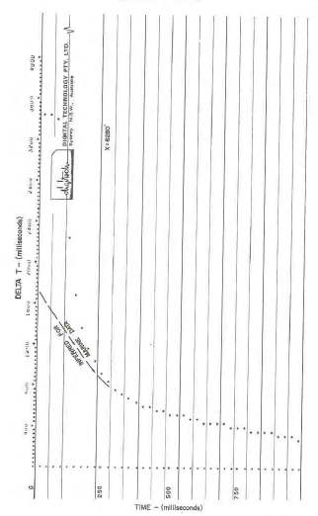
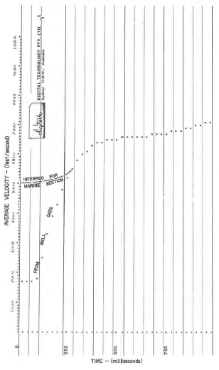
Figure 7a: Time vs Average Velocity Figure 7b: Time vs Delta T
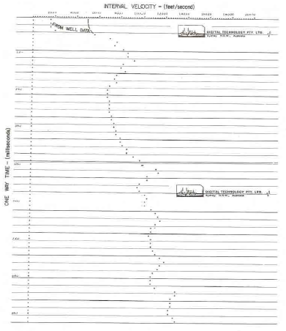
Figure 7c: Time vs Depth Figure 7d: Time vs Interval Velocity
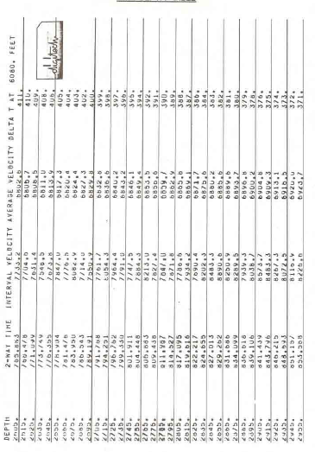
Finally, a listing of all this information such as shown in Figure 7e can be quite useful. It is recommended that the interval velocity and average velocity graphs be created at all line intersections so that a reasonably consistent set of functions can be used for an area. They can be run more often, of course, in problem areas. The use of the computer to generate this information is inexpensive and saves much argument as to the validity of a function.

Figure 7e: Time Depth Table

ISO-VELOCITY PROFILES
To check for consistency, the velocity functions should be compared laterally along each line. A fast and cheap method is to prepare an iso-velocity profile on the line printer as illustrated in Figure 8. This presentation shows lines of constant average velocity on a graph of time versus shot point number. Any sharp breaks in these lines should be confirmed by a geologic structure or else the function probably should be revised. In addition, iso-velocity lines can be drawn by hand through the near trace displays to confirm that the iso-velocity lines follow the geologic horizons.

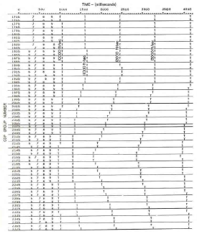
Figure 8: Iso-Velocity profile
A computer program is available to generate traces with spikes at every 500 feet per second interval which can be displayed on film to the same scale as the near trace and final stack sections.
This is very useful for management displays, but too expensive for day-to-day production. Another method which is cheaper is to present such a trace between every stack output record. The only disadvantage to this is the slight gap required between records. The spikes can be connected together by hand or left alone, as the user desires.
AUXILARY USES OF VELOCITY INFORMATION

- SYNTHETIC SEISMOGRAMS
A common use of detailed velocity information is in the construction of synthetic seismograms. These can be made from velocity functions derived from good seismic data, or better still, from Sonic logs run in boreholes. An example of a synthetic seismogram and a portion of the adjacent seismic line are shown in Figure 9a. The primaries only synthetic seismogram is constructed with the following step:
- Digitize sonic log at 1-foot intervals
- Calculate interval velocity for each foot (or provide interval velocities from velocity functions);
- Calculate reflection coefficients at each interface;
- Convolve a suitable wavelet with the spikes that represent the reflection coefficients.
Typical wavelets are shown in figures 9B, 9C, and 9D. The frequency of the wavelet can be specified and synthetics may be made using several frequencies with more than one wavelet so that a good match to field data can be obtained.
In addition to the primaries only synthetic, a simple multiples only, dogleg multiples only , inter-bed multiples only, and all multiples synthetics can be made. These are very helpful in analyzing multiple problems on single-fold or multi-fold data.
The same time depth velocity information can be plotted for the synthetic as described earlier, if the synthetic was made from well data it is then easy to tie specific events to particular horizons, and reflection identification on the basis of both time and character can be made.
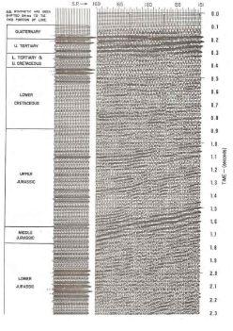 | 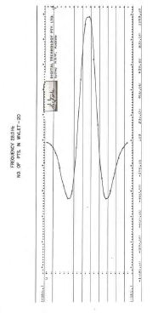
Figure 9a: Primaries only synthetic seismogram and portion of adjacent line | Figure 9b: Wavelet No. 1
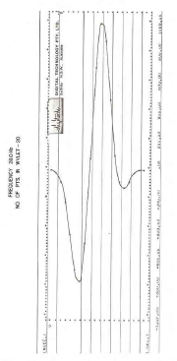 | 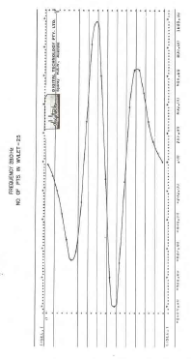
Figure 9c: Wavelet No. 2 | Figure 9d: Wavelet No. 3
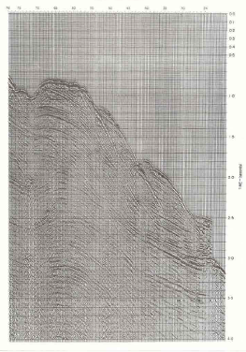 | 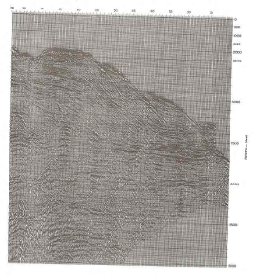
Figure 10a: Time Section | Figure 10b: Depth Conversion

DEPTH SECTIONS
The ultimate use of detailed velocity information is in the preparation of seismic depth sections and maps from the corresponding time sections. An example of both the time and depth section over the same shot points is shown in figures 10a and 10b. These sections are most useful in deep water or steeply dipping shelf areas, or where large thicknesses of salt are present.
Velocity data must be at the highest quality and there must be a large number of functions in order to adequately describe the velocity characteristics of the section. The example clearly demonstrates the need for such sections since the mental image obtained from the depths section is far different from the obtained from the time section. Note the relatively flat reflection at 8000 feet and at 10,000 feet which dips steeply on the corresponding time section. The vertical exaggeration of the depth section is approximately 2 to 1 in this example, and true dip of the sloping beds can be estimated quite easily. While migration would be helpful to establish more closely both depth and dip, it is relatively expensive and does not contribute as much to the interpretation as does a simple depth conversion.

CONCLUSIONS
There are a large number of velocity analysis techniques available to the geophysicist today. This paper has illustrated some of the most commonly used programs and shows how the results may be checked for validity and how they may be used to assist in interpretation. While the prime use of velocity information has been for normal moveout correction prior to stack, it would be a terrible waste not to use all the information available in the final analysis, that is, the interpretation of the stacked sections. Therefore all velocity information should be presented to the interpreter as an integral part of the seismic processing job.

ACKNOWLEDGEMENTS
The authors would like to thank the companies who so kindly permitted use of their data in these displays, and also the staff of Digital Technology Pty. Ltd. for preparation of all the displays.

