LOG/MATE ESP – SYSTEM DESIGN: STATUS AND EXAMPLE OUTPUT

E. R. (Ross) Crain, P.Eng.
D&S Petrophysical - a Division of
D&S Petroleum Consulting Group Ltd.
Calgary, Alberta
Author’s Note: The original of this document was created in Dec 1985 (Memo M851205) for D&S Petroleum Consultants Ltd. It formed the starting point for a joint venture research project between D&S and Alberta Research Council to create a rule-based expert system for log analysis. This is the updated version from April 1986.

The software described here was written 5 years before Microsoft delivered a Windows operating system on a desktop computer. We wrote our own windowing screen handler based on demonstrations seen on large computer systems developed by Xerox Palo Alto Research Center (Xerox PARC). Very few of the LOG/MATE ESP graphics, calculation, or printing features were available on any log analysis system in 1986. Full colour screen shots of depth plots and crossplots generated by the system were presented in two D&S brochures published in 1985, appended to the end of this report. ERC Jan 2005.

ABSTRACT
LOG/MATE ESP is a fourth generation, menu driven, integrated command language for data base management, calculation, and display of scientific or engineering data. It has been specially adapted to meet the needs of log analysts, geologists, and reservoir engineers by paying special attention to the interactive graphics, data entry, computation, report generation, and communications functions.

The key concept is the use of data files, accessible by the user, to contain much of what is normally considered to be program code. These files include data record descriptors, plot and report descriptors, as well as all mathematical algorithms and routines. They can be modified or augmented by the user to adapt the system to his or her own needs. The system interprets the contents of these records to perform the appropriate task, much as existing third generation languages interpret hard-coded Basic or Fortran programs.

The major functional modules of LOG/MATE ESP are:

1. data base and file manager
2. interactive colour graphics
3. mathematical processing
4. report generation
5. data communications

LOG/MATE ESP is the foundation system for research and development of fifth generation software for log analysis, as well as other areas of evaluation and analysis in the oil and gas industry for the next decade.

INTRODUCTION
The basic problem with most computer aided log analysis programs is that they are hard-coded to a specific design on a specific machine. This results in an inflexible program which cannot easily be adapted to changing needs of users, new logging tools or methods, or more advanced hardware. Even adding a new curve name or interpretation parameter is costly in many systems. Adding new
math algorithms, permanently, requires a cooperative programmer familiar with the system and a computer department manager or supplier willing to allocate resources to the task. Only major requests that suit the needs of many users get satisfied. The once only, lets try it and see what happens stuff, never gets to a useable stage. Systems which do provide some flexibility still do not, as a rule, allow the user access to the guts of the system.

We have addressed this problem by devising an integrated fourth generation computer language for data base design and display, interactive colour graphics, mathematical processing, and report generation, most of which is accessible to the user, or at least a high level professional user. This allows one to adapt, add to, or change data record formats, screen presentations of data, log analysis methods and algorithms, as well as depth, crossplot, and printed report formats to suit the job at hand or the corporate style. The original software designers' view of the world can therefore be adjusted to conform to reality. The result is a software package similar in concept to an integrated spreadsheet program, like Lotus 1-2-3 or Symphony, but on a much grander scale, and designed with scientific users in mind.

GENERAL DESCRIPTION
LOG/MATE ESP provides the following functions for evaluation of wells:

1. entry of open hole and cased hole logs, core data, mud log data, geological descriptions, and well history information
2. entry of interpretation parameter, math algorithms, and computation sequences
3. computation of log analysis results by a variety of popular methods, including user defined or modified methods
4. hydrocarbon volume, reserves and productivity summary, using various cutoffs
5. interactive editing of data records or plotted data on the CRT
6. colour depth and cross plots on the CRT or hard copy plotter, with complete user control of all display parameters
7. printout of results and parameters, with user defined presentation style and formats
8. data communication to and from data bases on other computers
9. and many other features, some of which may be unique to an installation.

These functions will provide the basic data required to determine whether a well is worth completing or not, and present that information in an easily understood fashion, in a short time frame.

LOG/MATE ESP is an extremely flexible language system, especially designed for scientific applications. Therefore, like many fourth generation languages, you will find out about many of its features only by trying them on your own data.

The current system runs on HP 200 and 300 series desktop computers (Motorola 68000 16-bit and 32-bit processors) in HP Extended Basic, which includes its own operating system. Alpha and graphics screen handlers, and the algorithm processor, are written in assembler or compiled Pascal for speed. Typical hardware configurations are listed in TABLE 1, and illustrated in FIGURES 1 through 4 for both single and multiple user situations.

The key concept in LOG/MATE ESP is the use of data files, accessible by the user, to contain much of what is normally considered to be program code. These files include data record descriptors, plot and report descriptors, as well as all mathematical algorithms and routines. They can be modified or augmented by the user to adapt the system to his or her own needs. The system interprets the contents of these records to perform the appropriate task, much as existing third generation languages interpret hard-coded Basic or Fortran programs.

The result is a software package similar in concept to an integrated spreadsheet program, like Lotus 1-2-3 or Symphony, but on a much grander scale, and designed with scientific users in mind.

The best part is that the user does not have to know the intricacies of the data base or the languages that drive the various components of the system. With minor exceptions in the report generator, the languages are entirely menu driven, and no memory or lookup are required. Some of the data base
manipulation features, however, are not yet ready to release in this form until further improvement in this area has been completed.

LOG/MATE ESP COMMANDS
LOG/MATE ESP is driven by commands invoked by the user. The normal types of commands are those shown on the function key labels, which vary depending on the current context of the system and the data available. For example, the Main Menu consists of the keys labelled Mode, Enter, Plot, Xplot, Compute, Report, and Change DB. By pressing one of these keys, you command the system to start one of these functions. Since each function has many options, you will be presented with further sets of function keys until all options are exhausted, at which time the process will be performed by the system. The function key tree is presented in APPENDIX 1.

At times, the system will need you to select the data to be used for a particular operation. This is done by selecting from a catalog of appropriate data records offered by the system. Only those records fitting the current context will be displayed, so you will not have to sift through too many entries in the list. By making the selection, you have commanded the system to use this data for its next operation. You may have identified the raw log data to use for a computation or a series of plot descriptor records that the system will use to draw a graph.

Thus, the term "data and command driven" is used to describe LOG/MATE ESP.

THE FILE MANAGER
The cornerstone of LOG/MATE ESP is the file manager which allows a user to specify a record type from a menu at the keyboard. It will then load the correct record which is attached to the current record. If more than one exists, a catalog of attached records of this type will be presented, from which the user can choose the desired record. For example, a user may wish to edit a gamma ray log attached to the current well record. If more than one gamma ray curve existed, the catalog would offer a choice. Catalogs are also used to locate records not attached to the current one, as one might need to do to start processing a new well.

Other user friendly LOG/MATE ESP file manager functions include an English/Metric toggle switch, a Printer/Screen/Disc file switch, a time/date stamp on every record, password protection of sensitive data, and rational defaults for every entry.

THE DATA BASE
Most data bases are either hierarchical or relational. LOG/MATE ESP uses a relational data base in which hierarchies can also be created. The data base designer decides which records are most likely to need data from each other in the context of the application program, and specifies this connection. All records of the same type are automatically attached to each other. These attachments are called links, and a series of links is called a chain or a path. Each record carries chaining pointers which carry the information needed to travel forward or backward along any path which is attached to the record.

To illustrate, a well record is attached to all other well records on the data base, as well as to a client record, a project or batch record or both, one or more pool records, one or more log header and core header records, and well history records. Log headers are attached to the log curves. All the records attached to each other constitute a file or data base. The data manager allows more than one data base on a system. The layout of the database is shown schematically in FIGURES 5 through 8.

The data base contains many different record types. Some are used for holding information about the well log data and well history information. Others contain data which drives the system, and describes how the plot, print, and compute functions are to be performed. The well data records are listed in TABLE 2 and those which control or drive the system in TABLE 3.

Many of these records will never be touched by a casual user, but it is clear that a large number of features can be manipulated by the experienced analyst to create very personalized plots, reports or computation routines.

An extensive data base suited to log analysis is delivered with the software, which includes demonstration data.

RECORD DESCRIPTORS
Record descriptors break a record into lumps of similar data types. For example a well record contains two lumps, as illustrated in FIGURE 9. The first contains four elements of string type data with the full well name, the full well location, and the name of the person entering this data. The second lump has seven real type numeric fields containing datum elevation and other pertinent depth values. Record descriptors also contain the units of measurement in both English and Metric, as well as the permissible range of the data and a default value in both sets of units.

Records can be lengthened or shortened because the definition of how many items are contained in the record is automatically varied by the file manager as data is entered. For example, the addition of interpretation parameters to a previous list, or adding log curve data to an existing file, is just a matter of entering the data in the table on the screen. Each record of the same type can contain varying amounts of data, depending on what is available or necessary. No space is wasted because there are no empty elements in records and no records with a pre-defined size.

Records can be viewed and edited on the CRT, or can be filled by reading LIS or BIT tapes, or by using a digitizer, or by reading files from a remote site. Data communication to a remote computer data base is also supported, in addition to networking on a shared resource basis.

THE STATUS BOARD
The concept of client, project, pool, and batch have been introduced to minimize the search time in catalogs by users. You merely have to locate your project with a cursor in the project catalog to get started. Alternatively, you could start in any of the categories mentioned to get into your data. The client concept could be a department in an oil company or an individual user.

This information is constantly updated on the Status Board at the top of the screen. Therefore the current context, known to the ESP file manager is also known to the user. The layout and typical contents of the Status Board are shown in FIGURE 10.

The status of the English/Metric toggle switch, the Printer/Screen/Disc file switch, the Plotter/Screen switch, and the Caps Lock key are also shown on the status board, in this case at the bottom of the screen. Error messages, current activity messages, questions to the user, and the user's response are also shown at the bottom of the screen. The central area of the screen can contain either catalogs, menus, tables, or an audit trail, depending on the current context.

CATALOGS
Catalogs list the available records of a particular type on the screen. Catalogs are sensitive to the current context of client, project, pool, batch, and well shown on the Status Board, thus reducing the volume of data being presented to the user. A typical catalog is illustrated in FIGURE 11. The shaded cursor bar is poised to select a particular well from the list. Selection is made by typing the record name, typing the record number, or positioning the cursor bar on the name.

PASSWORDS AND MANAGER FUNCTIONS
A crucial concern of many with respect to a data base of this type is accidental or intentional injury to data which is really program code in disguise. This concern is alleviated by built in safeguards. An example is that the first record of any type cannot be deleted under any circumstances. These are the default records for every function in the system. Another is access level passwords that prevent casual users from modifying crucial records such as plot or report descriptions.

Passwords protect many features. User access, for example permits use of any feature, without the ability to change record descriptors, algorithms, routines, or report formats. Manager access permits more advanced status, such as modifying or adding algorithms, routines, report and plot layouts, and help files. System access provides the ability to use all the power of the various components to the fullest extent, presumably to create new products for lower level staff to work with.

Manager functions are described in more detail in help files associated with each function.

HELP FILES
Extensive use is made of context sensitive help files, probably more so than any other scientific system. There are three kinds of help files. The first is Entry Help. When in an entry mode, these files tell you how to fill out the record on the screen or explain the rules for constructing algorithms or reports. (FIGURE 12)

Key Help files are available to tell you what each function key will do before you push it. (FIGURE 13)

File Help is used to explain the method or purpose of a record, such as a report descriptor, algorithm, or analysis routine. Since these records are the ones most often created or modified directly by users, it pays to keep the help files current with reality. All help files can be edited or expanded by the user so that personal usage or hints for less experienced operators can be incorporated into the system. (FIGURE 14)

Hard copy of any or all help files can be had at the push of a button, so no documentation manual on the system is needed. The report generator will print all help files in an orderly manner if hard copy is desired.

ENTER/EDIT
The data base manager looks after handling the screen in two different ways, depending on the structure of the record. If the record can be displayed conveniently within the confines of the available screen width, it presents the element names, values, and units in an attractive format automatically. (FIGURE 15)

If data is represented better as a table or array of data, then the manager formats accordingly, using the screen as a window on the larger array, much as Visicalc or Lotus 1-2-3 treat data editing of such arrays. Cursor movement slides the window over the array as desired. (FIGURE 16)

Both data entry and data editing are fast and self-explanatory. Since full English names for all parameters are used, no knowledge of cryptic abbreviations is necessary. Virtually no typing is required except for parameter values. Function keys or cursor movement in a catalog or table answer every question posed by the system.

DEPTH PLOTS
Everyone claims to have interactive graphics in their log analysis system. Most of them mean that you can generate a user defined plot (within limits) in a short time and recreate it differently, quickly, by some keyboard commands. However, interactive graphics in LOG/MATE ESP involves more than that. By interactive we mean the following:

On depth plots we can:
- rescale a curve and see the result without replotting the entire plot
- pick the rescale parameters with a cursor on the screen
- stretch and squeeze curves with respect to a reference curve in the same fashion
- edit and redraw any curve, and erase the old one
- overlay one curve on another with cursor movements
- reverse polarity of an overlay curve
- add or delete a curve
- undo any of the previous functions and get the original plot back again
- place the cursor on a point and identify its curve name and data value
- place comments and annotation anywhere on the display
- place DST, perforation, core and production data on the plot from the keyboard
- turn the annotation on and off to improve clarity when needed
- select analysis parameters by cursor movements
- scroll the log display up and down the screen in real time; i.e., as fast as the eye can see or the hand can move
- store the changes we have made back into the data base

All these features have the usual access to the help files, algorithm processor, and data base function as described earlier, and in living colour, which was pioneered in LOG/MATE and LOG/MATE PLUS, full size and half size plots can be dumped to the printer at the touch of a button, and hard copy colour plots are just a few more keystrokes.

The layout of all plots is contained in the data base, and can be adapted to any situation. Three track, four track, or multi track presentations can be defined, with depth tracks, borders, titles, scales, curve names, axes names, headers, footers, logos, tics, depth lines, line types, colours, lithology or enhancement shading, and annotation where and how you want them. This graphics command language is completely menu driven, so knowledge requirements are very low.

As a result, very sophisticated and flexible format plotting can be achieved at a very low cost, very quickly. For example, we designed a 19 track presentation for palynology data in a few minutes. A composite well history log, which most oil companies create by drafting and photo reduction, can be designed in similar fashion and become a permanent part of the log analysis production process.

Another unique feature is the concept of shapes, analogous in some ways to custom characters in some systems. The LOG/MATE ESP graphics commands allow you to store custom shapes in the data base for shading and coding lithology, personalized logos, and annotation enhancements.

Standard three and four track depth plots are provided as part of the data base. Examples of depth plot versatility are described later in this report, under the heading SOME REAL EXAMPLES.

CROSSPLOTS
Crossplots are an important analytical tool. LOG/MATE pioneered the use of colour for coding a fourth dimension on crossplots, in addition to the usual X, Y, and Z axes found on black and white plots. These have been enhanced in LOG/MATE ESP by providing human interactions with the plotted data on the CRT and by allowing users to design their own custom plots.

Everyone claims to have interactive graphics in their crossplot module. They usually mean that you can generate a user defined plot (within limits) in a short time and recreate it differently, quickly, by some keyboard commands. However, interactive graphics in LOG/MATE ESP involves more than that. By interactive we mean the following:

On crossplots we can:
- identify depth and data values for all points under the cursor
- delete points and rerun the regression analysis
- turn the regression lines and other overlay lines on and off
- change the image from CRT format to plotter format, to preview final products, and back again
- place comments and annotation or draw shapes anywhere on the screen
- pick analysis parameters by cursor movement
- create a discriminator trace based on the deleted points

All these features have the usual access to the help files, algorithm processor, and data base functions as described earlier. Full size and half size plots can be dumped to the printer at the touch of a button, and hard copy colour plots are just a few more keystrokes.

The layout of all crossplots is contained in the data base, and can be adapted to any situation. Borders, titles, scales, curve names, axes names, headers, footers, logos, tics, line types, colours, overlays, and annotation can be placed where and how you want them. As for depth plots, this graphics command language is completely menu driven, so knowledge requirements are very low.

Numerous crossplots, histograms, and Holgate plots are predefined in the data base delivered with the system. Results from these plots look much like those from LOG/MATE or LOG/MATE PLUS with enhanced interaction and, of course, flexible presentation format. Users can copy a plot description into a new area and modify the description to suit the situation. Examples are discussed later in this report.

THE REPORT GENERATOR
Two kinds of reports are available from LOG/MATE ESP. Printer dumps of any individual record in screen image format provide rapid hardcopy for use during analysis. These are formatted automatically by the data manager, based on the record descriptor, and are attractive enough to be included in many reports.

Tabular and text reports can be generated from data in the data base with user defined formats. A standard log analysis report, for example, can gather the correct pool, project, well name, and hydrocarbon volume summary and place them in the correct context within the body of the report. The runstream can place depth plots or crossplots on appropriate pages to automate production of repetitive tasks.

The report generator language allows you to specify the position and content of headers, footers, titles, pagination, data, and text on the page, as well as the page size, line spacing, character size, and display enhancements as in most sophisticated word processors. Although editing capabilities are limited to insert and delete characters and lines, more effort in this area is underway.

The presentation of columnar data is especially flexible, with the ability to specify column width, numeric format, decimal places, and the column headers. These latter items could be abstracted from the data base or entered manually. Thus report formats can be made to a standard corporate style, and yet present only the data available for a particular well. The table report generator also has access to the algorithm processor. Data can be computed on the fly if it is not already in the data base. Routines, however, cannot be accessed this way.

The common print out formats for detail listings, summary listings, and typical final reports are included in the data base and examples are given later in this report.

PATH NAMES
Path names are a very important concept to master in learning to control the LOG/MATE ESP report generator. A path name is simply a way of telling LOG/MATE where to go to look for the data that you want. A path name has the following syntax:
(record name)\(lump name)\(field name)\(parameter)

where:
. (record name) describes the type of data record, i.e. LOG
. (lump name) describes the section of the record, i.e. LOG DATA
. (field name) describes the field within the lump, i.e. CURVE VALUES
. (parameter) describes the element of the field, i.e. GR

In the above example all of the names are exactly as they are found on the data base printout except the (parameter) which depends on local data.

The parameter term acts in a somewhat different manner than the others in the path name. For example LOG \ LOG DATA \ CURVE VALUES \ GR will access the entire GR LOG, while CONSTANTS \ CONSTANT VALUE \ CONSTANTS \ GRO would look in the constant names until it found the name GRO and then print the VALUE that is associated with this name.

If you do not have room for the entire path name you may use just the middle two parameters - the trick is to count over the number of elements from the beginning of a data lump and use this with the type. For example, POOL \ S#1 \ 2 is the same as POOL \ IDENTIFICATION \ POOL TYPE (OIL or GAS) and POOL \ S#3 \ 1 is the same as POOL \ WATER DATA \ SOURCE OF DATA. Even the full text of
a help file or a math algorithm or routine could be brought into your report.

The default path is for logs. To access a log you only need to use the correct curve name, which appears in the dictionary.

REPORT GENERATOR COMMANDS
Commands are special strings of characters that the computer recognizes as items that should not be printed directly, but that some action must be taken instead. Path names are a type of command with a very special syntax and use. Other commands available in the report generator are shown in TABLE 4.

Text files are entered by simply typing in the text you want to have printed. The format is exactly as you see here, except that you can use embedded PIPES to include information about the current well. For example, if you were to type the text "Enclosed are the results for | WELL \ NAME INFO \ FULL WELL NAME | ", then the printout would be: "Enclosed are the results for ABC WELL #1", if the
well name is as indicated.

Help files are only a push button away, so the syntax, while simple and minimal, is readily explained. Knowledge about the contents of each record is also available through separate help files generated automatically by the data manager. In addition, help files for each report format created by a user
provide extra documentation of purpose and intent.

DATA COMMUNICATIONS
Data communication is a catchall term for all functions relating to moving data in and out of the system. An extensive copy/backup/archive/restore facility is in progress. Input of log data from Schlumberger LIS tape is working, and reading of Dresser BIT tapes will be done in the near future.

The system can be placed now in a small LAN environment for multi-user operation using IEEE-488 (HP-IB) and special shareable disc drives (Bering). It can operate now on HP's SRM LAN, but to be more portable we plan to use UNIX as our networking tool. Printing, plotting and disc access is currently buffered in memory to allow some multitasking. This will be improved to incorporate genuine multitasking under UNIX.

Data communication to remote computers is now via RS-232, and IEEE-802 (Ethernet) will be added. Additional features to make datacom more friendly are being added, such as an inverse report generator to transfer data from a foreign data file into LOG/MATE files. The existing report generator is used to create ASCII files for transmission to a remote computer. All existing and new data comm code will be translated or written in C. AN IBM 3270 emulator will be acquired or written to facilitate high speed transmission to IBM mainframes. Transmission to DEC and other mainframes can be adequately handled by the RS-232 and Ethernet protocols. Ethernet is supported by HP and some other vendors only on a UNIX based workstation, so again a UNIX operating system is demanded.

These data communications features are widely used on our present LOG/MATE PLUS systems.

THE ALGORITHM PROCESSOR
The basic element of mathematical processing within LOG/MATE ESP is the algorithm. An algorithm is a series of mathematical steps which is intended to produce a single desired numerical result, such as the volume of shale from the gamma ray or the porosity from the sonic log. A routine is a series of consecutive algorithms which produce all the results desired from one computation run, for example a shaly sand analysis or a tar assay program. An algorithm is analogous to a subroutine or function, and a routine is similar to a program module, in conventional programming parlance.

Single algorithms or complete routines can be run interactively under user control, or under runstream control by the data manager. The algorithm processor decodes the algorithms, enacts the processes defined, and places the results into appropriate records. The processor uses the dictionaries to find the required data in the current records and those attached to them. The processor can distinguish between log curve data and analysis parameters because the data manager can provide this information. If required data cannot be found, the user is prompted to supply it. At the moment, these responses are not saved, but must be entered later into the data base through the enter edit program.

Most processes are treated as matrix or vector operations, which speeds the calculations enormously. All input and output data curves are stored as real numbers to preserve accuracy and reduce computation time.

ALGORITHMS
Algorithms are entered into the data base much as you would write them on paper, that is in conventional mathematical notation. All analysis parameter names should be declared in the appropriate dictionary, as well as all log curves input or output from the algorithm. Consistency in spelling of these variable names is recommended to conserve space and reduce user confusion. The dictionaries are designed to aid in this regard.

Branching with an IF...THEN...ELSE...END IF sequence is permitted. All normal mathematical functions and logical operators found in Fortran or Basic are provided, along with some which are only available in higher level languages, such as Visicalc. These include SUM and PRODUCT of vectors. A typical algorithm is displayed in FIGURE 17.

User defined help files are attached to each algorithm and routine, so that other users know what the function is supposed to do, and where the data comes from. Comments can be interspersed in algorithms to make them more readable, but cannot be placed within a routine.

Note that the algorithm processor and the data base are not limited to depth dependent data such as logs, but can work on time series or frequency series data such as reservoir engineering cash flows, seismic two way time, or frequency transforms of seismic data. Also it should be evident that they are not limited to conventional open or cased hole logs. Mud logs, gas logs, geological descriptions, core data, MWD logs, palynology or paleontology data are equally at home in the system, without any changes required to the basic program code. An extension to allow use of algorithms on spatial data such as maps and crossplots is being designed.

ROUTINES
Algorithms are assembled into routines by the user and stored for future use or modification. An algorithm may appear in any number of routines, and logic switching is allowed to handle conditional problems such as bad hole, gas corrections, or missing data. (FIGURE 18)

Each routine was filled out in such a way that any or all options available can be switched on or off by the user. All material balance checks, as well as divide by zero and other math error checks were incorporated. Most of the algorithms used are described in more detail in "THE LOG ANALYSIS HANDBOOK" by E.R.Crain, published by Pennwell Books, Tulsa, OK.

A very complete set of algorithms and routines are delivered with the software, and many users will never have to create new ones. The contents of the basic routines supplied with the system are given in TABLES 5 through 8.

COMPUTATIONS
A computation is a series of routines, with their associated parameter files and the depth intervals over which each routine applies. A computation is a miniature run-stream, used to control the detailed processing sequence of one or more zones in a well. (FIGURE 19)

RUNSTREAMS
The record structure and data manager are designed to relieve another burden, namely that of processing or reprocessing a group of wells in a batch or project. For example, after a few wells have been processed interactively (one at a time), they could all be recomputed with a new water resistivity and replotted as a group. Then the balance of the wells in a project could be processed with the same runstream, individually checked for improvements, and batched again for final plots and printouts. The possibilities are endless.

MACROS
Macros are keystroke sequences which can be generated and saved to allow one-button execution of a series of inter-related tasks. Macros can be run on a single well or a group of wells in a run stream. For example a macro may push all the keys necessary to change the water resistivity, compute the new results, store them on disc, and print or plot the results according to pre-defined routines and descriptor records in the data base.

DICTIONARIES
When math algorithms are in data files, the algorithm processor needs to know where to find the log data and analysis parameters defined in the algorithm. Also, there must be no ambiguity about what parameter is meant when its name appears in an algorithm.

To solve this we have devised a series of dictionaries in which all data element names are listed. The application program can check here to find out where to access the required record. If a parameter is needed but not available in a dictionary, the data manager will prompt for a value to allow the current process to finish. The user should then enter the parameter permanently into an appropriate data record.

The dictionaries serve another valuable purpose. They also contain the full English name of a parameter or log curve, the legal abbreviation for it, the name of the units of measurement in both English and Metric units, and the conversion factor from English to Metric units. Thus graphs, reports, or data tables can contain appropriate, consistent, and meaningful headings or labels, and data can be converted from one system of units to another at the press of a button. Again all this information is in data records accessible to the user, so he could change ranges, or add, change or delete parameters or curve names.

Since there are no trace numbers, channel numbers, or array locations in this form of data base, there is no need for the user to remember or look up such esoteric computereze while modifying the data structure.

SOME REAL EXAMPLES
EXAMPLE 1: Slave Point Carbonate/Granite Wash Sandstone
The zones of interest in this well were a combination of carbonates and clastics, some of which are radioactive, interbedded with shales. We used a combination of crossplotting techniques and general area knowledge to pick the parameters necessary to compute the log analysis.

The Schlumberger LIS tape was read using the tape facilities of our mainframe computer, and the data was accessed and converted to ESP format by means of the data communication package on the ESP system.

FIGURE 20 is a plot of the raw data. Each curve is identified by color code and line type as shown on the headers. This plot immediately emphasizes one of the desirable features of LOG/MATE ESP. It is not a 'canned plot', but was designed by the user to best display this type of data. Once designed, this
plot format is retained in the system and may be used on future wells with this type of data.

FIGURE 21 is the standard neutron density crossplot and covers both the carbonate and clastics interval. The color axis is proportional to the gamma ray. From this crossplot, it appears that the dolomite points are clean, while the limey-sand points are shaly. This is the usual case in the granite wash and is not too definitive. Appropriate lithology overlays are shown on each plot.

FIGURE 22 is also a plot of neutron density, but with photo electric effect, PEF, shown on the Z axis as numerical values and depth represented by color in 10 metre increments from 1690 to 1730. This helps to define the rubble as a mixture of predominantly sand with a limestone matrix. A significant number of points are also identified as dolomite with no shale over the interval 1700 to 1720. Some limestone is present in the interval from 1690 to 1700.

FIGURE 23 is a plot of the lithology ratios M and N with the PEF curve in the color axis. The lithology from this plot appears to be dolomite and limestone with the likelihood of considerable amount of secondary porosity. Some sand is also indicated.

FIGURE 24 is a plot of apparent matrix density vs apparent matrix cross section, Uma, a parameter calculated from the density and PEF curves. PEF is in the color axis. This plot clearly identifies the predominance of dolomite with some limestone interbedded with anhydrite or other heavy minerals. The sandstone zones are now clearly defined as a combination of sand and limestone,
the latter likely being the cementation component. This more clearly defines the lithology than does the M-N plot of FIGURE 23.

FIGURE 25 is a plot of bulk density vs PEF with depth plotted in color. This distinguishes the sand as influenced by limestone but not as clearly as the crossplot in FIGURE 24. Very little anhydrite influence is shown.

FIGURE 26 is used to identify matrix and fluid travel time for the carbonate section. These parameters are important in this area to better define sonic response in presence of secondary porosity. The Holgate plot of sonic travel time vs crossplot porosity produces a best fit line from which the following parameters are derived:

Lithology DELTMA DELTW
Carbonate 161 481 μsec/m

FIGURE 27 is a composite plot of results from several different multi-porosity crossplot analysis techniques. Sonic related values are generally lower than total porosity measuring devices. This is likely due to the variable matrix travel times not being as accurately defined as the pore structure changes. The other devices agree very well with each other in the carbonate, but less well in the sandstone.

FIGURE 28 shows a depth plot of the same data with a reconstructed density log, based on a three mineral model derived from density, neutron, and PEF data. The reconstructed log agrees well with the original, and shows only minor discrepancies. Reconstructed curves can be used to indicate a successful match between the log analysis model and the real rock sequence.

Shale volumes were calculated from the gamma ray for the carbonate zone and from the neutron density neutron crossplot over the granite wash. A more definitive answer could be had using a natural spectroscopy tool if it had been available.

The crossplots clearly identify the lithology and define the depth intervals at which the major changes occur. The matrix density vs Uma crossplot of FIGURE 24 was the most definitive and was used in calculating the lithology as shown in the depth plot in FIGURE 29. Porosity was also derived from this data, and water saturation was calculated from the Simandoux equation. A dual water model could also have been used.

The interpretation indicates a porous dolomite with secondary porosity present in the interval 1690 to 1720, Hydrocarbon is indicated from 1690 to 1700, with residual hydrocarbon likely present in the interval below 1700. The granite wash has porosity development with hydrocarbon present.

Although supportive evidence such as core or production is lacking, the interpretations derived using the LOG/MATE ESP system provides very reasonable and convincing answers. The flexibility of the system is shown in the numerous analysis methods that were used and the presentation of results. Each plot and answer is unique, but they may be saved for future use or altered to suit the
users choice. The use of color as the fourth dimension in crossplots is an extremely powerful tool to more clearly define formation characteristics and parameters.

EXAMPLE 2: Mississippian Carbonate
The zones of interest in this well were a mixture of dolomite, anhydrite, and limestone, overlain by siltstones and shales. The well proved to have interesting lithological characteristics and a more or less complete suite of log data to resolve them.

D&S was given an LIS tape of log data with no other information by the client. The objective was to evaluate the capabilities of the LOG/MATE ESP log analysis system in terms of both reading the tape and analyzing the formations.

FIGURE 30 is a plot of the raw data extracted from the tape. The curves plotted are:

Curve Track Color Comments
GR 1 Red Gamma Ray curve from the DISFL-Sonic log.
CGR 1 Blue Composite of Thorium and Potassium response from NGT log.
SGR 1 Green Composite of Thorium, Potassium and Uranium response from NGT log.
SP 1 Black Spontaneous Potential curve from DISFL-Sonic log
URAN 2 Red Uranium response from NGT log.
THOR 2 Blue Thorium response from NGT log.
POTA 2 Green Potassium response from NGT log.
PHIN 3 Red CNL Neutron Log porosity, fraction.
PHID 3 Blue LithoDensity log porosity, fraction.
DELT 3 Green Sonic travel time.
PEF 3 Gold Photoelectric Effect.
RESS 4 Blue DISFL Shallow Resistivity curve.
RESM 4 Blue DISFL Medium Induction Resistivity.
RESS 4 Blue DISFL Deep Induction Resistivity.

FIGURE 31 is a crossplot of the standard neutron density crossplot and covers both the overlying shale-siltstone and the carbonate interval. The color axis is proportional to gamma ray. From this crossplot, the carbonate would appear to be composed of limestone and dolomite. The points with high gamma ray response lie close to the dolomite line and show a fairly broad range of neutron and density values.

FIGURE 32 is a plot of photoelectric effect vs bulk density over the lower, carbonate sequence. Again, the reservoir appears to be a mix of dolomite and limestone. However, a significant number of clean points between the dolomite and sandstone lines were identified as having come from the interval 1265m to 1267m. This zone is likely to be either cherty or sandy dolomite.

FIGURE 33 is a crossplot of the lithology ratios M and N with the PE curve in the colour axis. The lithology from this plot appears to be limestone and dolomite, and the sandy or cherty interval is not clearly identifiable.

FIGURE 34 is a plot of apparent matrix density vs apparent matrix cross section. PEF is in the colour axis. This plot clearly identifies the predominance of limestone and dolomite, as well as indicating the chert or sandstone which was apparent from the crossplot in FIGURE 32.

FIGURE 35 is a plot of potassium vs thorium over the carbonate and the overlying shale with uranium in the colour axis. The overlay gives the expected response region of different types of clays. The clay types appear to be predominantly kaolinite and illite.

FIGURE 36 is similar to FIGURE 35, except that the color axis is expanded and the plot is only over the carbonate interval. On this plot, the clay content appears to be mostly illite.

FIGURE 37 is a plot of potassium vs photoelectric effect. Although the points appear to trend between kaolinite and chlorite, this trend is probably more a function of the matrix lithology than of clay content. There is some trend noticeable close to pure illite. Combining the observations of all three plots, our assessment is that the clay type in both shale and carbonate is predominantly kaolinite with some illite.

After the lithology model was decided upon and a preliminary analysis computed, FIGURE 38 was constructed to predict A and M and thus refine the saturation analysis. The plot is a Pickett plot with resistivity vs porosity on a logarithmic scale. the colour axis, PE, is scaled such that the dolomitic points are blue and the limestone points are red. The line drawn represents 100% Sw for the blue points and is parallel to the best fit line for these points. The slope of this line is M and is 1.81. The intercept at 100% porosity is A*Rw and is approximately 0.03. Using an Rw at formation temperature of 0.035, this gives A = 0.85.

The red or limestone points appear to be in two groups and, if treated separately, would appear to have values of M less than the dolomite. However, if the group at less than 5% porosity is ignored, the line for the dolomitic points can be reasonably used for the remainder.

The last four crossplots (FIGURES 39 through 42) were used to identify matrix and fluid travel time for sonic log analysis in the limey carbonate and in the dolomitic carbonate. These parameters are important in this area because the most common logging suite run is DISFL-Sonic, probably for reasons of economy rather than any special ability of the sonic to resolve porosities in this
complex reservoir. FIGURES 40 and 42 are Holgate plots of crossplot porosity vs sonic travel time. From the equations of the best-fit lines:

Lithology DELTMA DELTW
Limestone 161 579 μsec/m
Dolomite 146 637

FIGURE 43 is a presentation of analysis results with shale volume computed from the CGR curve (gamma ray less uranium). FIGURE 44 is an interpretation with shale volume derived from the lithology ratios M and N. The difference in these two analyses lies mainly in the lithology of the lowest porous interval, 1273m to 1276m. Although this interval reacts like shale on the NGT, every other log including the resistivity curves and SP seem to indicate a porous dolomite. The NGT response may be the result of neutron source activation while the tool calibrations are checked on bottom.

In the absence of other data, we are reasonably confident that we have resolved the lithology and hydrocarbon content of this rather complex formation. Although essentially wet with traces of residual hydrocarbon, the variety of lithological components make for an interesting example and provides useful parameters for analysis of offsetting wells.

EXAMPLE 3: Halfway Sandstone/Complex Lithology
The zone of interest in this well was an evaporite underlain by a complex clastic rock containing traces of anhydrite and dolomite. Data was digitized and edited from hard copy logs. FIGURE 45 is a plot of the raw data. Each curve is identified by color code and line type as shown on the headers.

FIGURE 46 is the standard neutron density crossplot and covers the entire zone. The color axis is proportional to the gamma ray. From this crossplot, it appears that the dolomitic sand points are clean, while the balance are shaly. Pure anhydrite is also present.

FIGURE 47 is a plot of the lithology ratios M and N with the gamma ray curve in the color axis. The lithology from this plot appears to be dolomite, anhydrite, and limestone. Some sand is also indicated but it is not clearly defined on this plot.

Shale volumes were calculated from the gamma ray for the entire zone. A three mineral model was used to calculate the lithology as shown in the depth plot in FIGURE 48. Porosity was also derived from this data, and water saturation was calculated from the Simandoux equation. A dual water model could also have been used.

Extensive core data was available, and the interpretation indicates close agreement with this information. Hydrocarbon is indicated throughout the zone, with a large fraction of immobile hydrocarbon likely.

Analysis of the core porosity vs core permeability indicates an excellent straight line relationship on the semi-logarithmic plot of FIGURE 49. The colour axis is gamma ray, and the loss of porosity and permeability due to shaliness is clear. This relationship can be used in the algorithm processor of ESP to calculate permeability from logs in this and other wells in the area, especially those which have no core data.

FIGURE 50 shows the porosity vs water saturation relationship for this zone. It indicates that no water will be produced on initial completion, because most of the data follows the hyperbolic trend line indicating clean production. A minor secondary trend of data, following a much lower hyperbola can also be identified. When the depths of these data points are determined, it is found that they all come from the dolomitic zone at the top of the sand. A discriminator trace can be built by circling these points, and the trace used to control which processing algorithms to invoke in these two different rock types. Since this decision is based on a first approximation to porosity and water saturation, it is appropriate to iterate this process at least once before deciding on a final processing sequence.

WHERE ARE WE HEADED FROM HERE?
As noted earlier, LOG/MATE ESP is the foundation of a family of fifth generation software to be created over the next few years. We are presently engaged in a 2 year, $2,000,000 project to build an intelligent log analysis system called LOG/MATE ESP ASSISTANT.

The primary goal of the LOG/MATE ESP ASSISTANT project is to develop an expert system capability for the existing LOG/MATE ESP log analysis package. This involves creating a rule base for algorithm selection based on available data and borehole environment (usage rules), a rule base for parameter selection, and possibly some iteration rules to handle re-runs when results do not match ground truth (core and DST data). The rules must be modifiable by high level users to account for personal style and local area knowledge.

The program would run at the assistant level, and when properly tuned to an area, may run at the advisor or expert level. This is accomplished by providing a historical data base of known facts, such as the physical properties of rocks and fluids, and log analysis parameters previously used in the area. Our second goal is thus to provide the textbook and parameter data for Western Canada, and
at least text book data for other areas. The historical data base will be augmented by the user, so that empty areas grow, or learn, from use of the system. No commercial system in any field does this as far as we know.

Unfortunately, LOG/MATE ESP is only available on Hewlett-Packard 200 and 300 series computers using HP Basic, and is not portable to other delivery vehicles, so our third goal is to convert the system to run under a standard subset of UNIX/C. We intend to use available fourth generation languages as much as possible to reduce coding and conversion effort. Investigation of these tools is presently underway.

In particular, a decision has been made to use the RDS relational data base rather than rewrite our own DB, and we have decided to utilize the GKS graphics kernel to rewrite our interactive graphics modules. Both these packages run in the UNIX/C environment on a large list of workstations, most of which are potential target vehicles for LOG/MATE ESP and LOG/MATE ASSISTANT. Workstations such as the MicroVAX II, IBM-PC/RT, Sun, Apollo, and of course the HP-300 series will be our initial targets for the UNIX/C version of LOG/MATE ESP.

CONCLUSIONS
Some caution in the use of a flexible, open ended system such as LOG/MATE ESP must be exercised, especially by beginners. Users who would add to or modify the contents of the data base run the risk of failure to achieve desired results due to lack of talent, training, or error. Errors can propagate into
unexpected areas of the data base. It may be difficult to debug problems because any of the operating system, data, or user defined record contents could be at fault.

The system can be slower than conventional hard-coded software for certain operations due to initial setup time, for example in defining a new computation routine, or complex plot or report. The system also does more work to accomplish a required task due to the distributed nature of the data base and
the fact that computations are interpreted instead of compiled. However, batches of wells will run considerably faster than they would in a strictly interactive mode. The plus side is that you do get what you want from the system, instead of settling for what the system wants to give you.

The main problem is that of learning any new language. The more you have worked in one language, the more difficult it is to work in a new one, at least for a while, and you always tend to retain the accent and flavour of the old one.

However the effort is worth the trip. The power and versatility far outweigh the extra learning curve. Custom tailored computations, plots, and printouts suddenly become YOUR standards. You no longer have to live with the programmers preconceived or obsolete design. Moreover, YOU control how many features you wish to use, and how complex you wish the system to be. You can truly achieve
one-button analysis, preferably AFTER you have used the interactive mode to determine your route through the processing.

TABLE 1: HARDWARE CONFIGURATIONS FOR LOG/MATE ESP WORKSTATIONS

OPTIMUM SYSTEM GOOD SYSTEM MINIMUM SYSTEM

A. Computer HP-320 with HP-310 with HP-310 with
bundled 2 Mbytes memory 1 Mbyte memory 1 Mbyte memory
19" Hi-res colour 12" Med-res colour 12" Med-res B/W
monitor monitor monitor
32 bit cpu 16 bit cpu 16 bit cpu
Keyboard Keyboard Keyboard

B. Disc Storage Bering 80190-EP Bering 8170 Bering 8140
190 Mbytes 70 Mbytes 40 Mbytes
+ HP-9144 + 10 M removable + 10 M removable
65 Mbyte tape

C. Digitizer Calcomp 9140 Kurta Kurta
14x36 tablet 15x24 tablet 11x17 tablet

D. Printer HP Laserjet-Plus HP Thinkjet HP Thinkjet

E. Plotter Nicolet-Zeta Nicolet-Zeta HP-7475
8 pen drum 8 pen drum 6 pen 11x17

F. Tape Drive Dylon 1015C Dylon 1015C Dylon 1015C
(Optional)

G. Extra Memory Infotek Infotek Infotek
(Required) 2 Mbytes 2 Mbytes 2 Mbytes

H. Cables 2 HP-10833B 2 HP-10833B 2 HP-10833B
1 Power bar 1 Power bar 1 Power bar

I. Operating System HP Basic 4.0 HP Basic 4.0 HP Basic 4.0

J. Approx CDN Price C$ 95,000 C$ 45,000 C$ 30,000
in USA US$ 50,000 US$ 25,000 US$ 18,000

Tax and duty extra if applicable.

Many options are available. Consult your LOG/MATE ESP sales representative. Up to three stations can share one Bering 8170 disc drive. Local area networks are configured using HP's Shared Resource Management system, at slight extra cost per station. Distance limitations apply.

TABLE 2: WELL DATA RECORD TYPES IN LOG/MATE ESP
Batch lists the wells in a batch to be computed
Client describes the client or end user
Computation lists the routines and constants files to be used in a well
Constants lists interpretation parameters for computation
Constants Record lists parameters actually used, cannot be edited
Core contains core data versus depth for one curve
Core Header describes cores available
DSTS contains DST information for one test
Log Curve contains log data versus depth for one curve
Log Header describes logs available
Log History lists computation actually done, can't be edited
Perfs & Treats contains perf and treatment data for one zone
Pool describes pool name
Pool Constants contains pool constants
Pool Cutoffs contains pool cutoff sets
Project describes project name
Strata contains non-numeric core data
Tops and Markers contains formation names and depths
Well contains well name
Well History connects DST, core, perf, tops records

TABLE 3: CONTROL DATA RECORD TYPES IN LOG/MATE ESP
Algorithm contains one interpretation algorithm
Annotation contains information for plotting annotation on a depth plot
Audit Trail lists key strokes used in a processing run
Axis describes axis presentation on a crossplot
Column describes how a column of data looks in a report
Curve describes how a log or core curve is plotted
Entry Help contains help information for a data table/menu
File Help contains help information for one algorithm, routine, or plot file
Hard Copy describes plotter setup for hard copy plots
Identification describes format for header section of report
Key Help contains help information for a function key set
Label Curves describes how to plot curve label
Label Scale describes how to plot curve scale
Overlay contains chartbook overlay data for a crossplot
Overlay Set contains key labels for optional overlays
Overlay Shape contains plot commands for overlay
Parameter Set contains parameters which may be picked from a plot or crossplot
Plot describes depth plot grid and depth scale
Plot Grid connects all depth plot records
Plot Label describes how to plot crossplot labels
Plot Shape describes how to plot a shape
Plot Text describes how to plot text on depth or crossplot
Report describes a report layout
Routines contains description of one math routine
Shading describes curve shading for depth plots
Shape contains plot commands for drawing a shape
Spelling Check contains dictionary of all variables used in algorithms and routines
Status History flags incomplete calculations
Systems Constants contains system information
Tracks describes how to plot depth plot tracks
W Axis describes how to plot W axis on a crossplot
X Axis describes how to plot X axis on a crossplot
XPlot connects all crossplot records
XPlot Format describes crossplot type and axis names
XPlot Tracks describes crossplot layout
Y Axis describes how to plot Y axis on a crossplot
Z Axis describes how to plot Z axis on a crossplot
TABLE 4: REPORT GENERATOR COMMANDS IN LOG/MATE ESP
@ LINE # - prints the current line number
@ PAGE # - prints the current page number
@ DATE - prints the current date as part of the report
@ TIME - prints the current time as part of the report
@ IDENTITY - prints the analyst's name
@ ENTER - allows the user to type comments into a report
@ PRINT - prints the text in the path field without modification
@ SPELL - looks up the correct full name of a variable and prints it
@ UNITS - looks up the units of measurement of a variable and prints it
@ TOP - prints the top depth of the current report
@ BOTTOM - prints the bottom depth of the current report
@ DEPTH - prints the depth of the data specified in the path name
@ SUBSEA - prints the subsea depth
@ COMBINE - computes depth from a top depth and an increment and prints it
@ NET - prints the net pay based on a SUM, DIFF, or AVG command
@ COMPUTE - computes the result of an algorithm and prints it
@ SUM - computes the sum of a column of data, after applying cutoffs
@ DIFF - computes the difference between the first and last elements of a column and prints it
@ AVG - prints the average value of a column of data
@ CUTOFF - applies the specified cutoff to a column of data
@ CUML - prints data in accumulated columnar form
@ FORMFEED - spaces paper out to top of next page

TABLE 5: COMPLETE ANALYSIS ROUTINES IN LOG/MATE ESP
* One Log Porosity Analysis
- Environmental corrections
- Shale volume from any one log method
- Porosity from any one log method
- Saturation from any method
- Permeability from any method

* Shaly Sand Analysis
- Environmental corrections
- Shale volume from any method
- Porosity from any shaly sand method
- Matrix density
- Saturation from any method
- Permeability from any method

* Carbonate Analysis
- Environmental corrections
- Shale volume from any method
- Porosity from any complex lithology method
- Saturation from any method
- Permeability from any method
- Lithology from any method
- Matrix density from porosity

* Mixed Lithology Analysis
- Environmental corrections
- Shale volume from any method
- Lithology from Mlith/Nlith
- Matrix density from lithology
- Porosity from any complex lithology method
- Saturation from any method
- Permeability from any method

* Shaly Sand Dual Water Analysis
- Environmental corrections
- Shale volume from any method
- Porosity from any bulk volume water method
- Saturation from dual water method
- Permeability from any method

* Tar Assay
- Environmental corrections
- Shale volume from any method
- Porosity from any shaly sand method
- Saturation from any method
- Tar weight results

* Cased Hole Analysis
- Shale volume from any method
- Porosity from previous analysis or from Shale
Corrected Cased Hole Neutron
- Saturation from TDT method
- Permeability from any method

TABLE 6: ENVIRONMENTAL AND LITHOLOGY ROUTINES IN LOG/MATE ESP
* Environmental Corrections
- Hole size for GR
- Invasion for resistivity DIL and DLL
- Borehole effect for DIL and DLL
- Mudcake effect for SNP
- Borehole effect for CNL

* Shale Volume
- Gamma ray
- Thorium curve
- Potassium curve
- Spontaneous potential
- Density neutron crossplot
- Density sonic crossplot
- Photo electric effect
- Mlith/Nlith
- Minimum
- Nonlinear
- Clavier
- Tertiary
- Older
- Material balance

* Lithology (shale corrected input data only)
- Matrix density
- Matrix travel time
- Two mineral models with
- DENSma - DELTma
- PEma - Uma
- Mlith - Nlith
- Alith - Klith
- Three Mineral Models with
- DENSma and DELTma
- PEma and DENSma
- Uma and DENSma
- Mlith and Nlith
- Alith and Klith

TABLE 7: POROSITY ANALYSIS ROUTINES IN LOG/MATE ESP
* One Log Porosity
- Shale corrected neutron log
- Shale corrected density log
- Shale corrected sonic log
- Bulk volume water using sonic log
- Shallow resistivity log
- Deep resistivity log
- Microlog
- Maximum porosity
- Non porous lithology triggers
- Material balance

* Shaly Sand Density Neutron Crossplot
- Quicklook sum of squares
- Quicklook 1/3 rule
- Standard, no matrix offset, with gas fan
- Automatic gas crossover
- Gas correction imposed
- Standard, with matrix offset and gas fan
- Automatic gas crossover
- Gas correction imposed
- Bad hole switch
- Shale corrected sonic
- Shale corrected neutron

* Complex Lithology Density Neutron Crossplot
- Quicklook sum of squares
- Quicklook 1/3 rule
- Standard, with matrix offset and gas fan
- Automatic gas crossover
- Gas correction imposed
- Bad hole switch
- Shale corrected sonic
- Shale corrected neutron
- Non porous lithology triggers
- Material balance

* Shaly Sand Bulk Volume Density Neutron Crossplot
- Automatic gas crossover
- Gas correction imposed
- Bad hole switch
- Shale corrected sonic
- Shale corrected neutron
- Non porous lithology triggers
- Material balance

* Shaly Sand Density Sonic Crossplot
- Bad hole switch
- Shale corrected sonic
- Shale corrected neutron
- Non porous lithology triggers
- Material balance
- Inhibit use in gas zones

* Complex Lithology Neutron Sonic Crossplot
- Automatic gas crossover
- Gas correction imposed
- Non porous lithology triggers
- Material balance
- Inhibit use in shaly sands
TABLE 8: SATURATION AND PERMEABILITY ROUTINES IN LOG/MATE ESP
* Water Saturation
- Archie
- Simandoux
- Waxman Smits
- Indonesia
- Dual water
- Thermal decay time
- Electromagnetic propagation
- Porosity x saturation (Buckles)
- Resistivity ratio
- Material balance
- Moved hydrocarbon
- Tar weight analysis

* Permeability
- Timur
- Morris and Biggs
- Dumanoir and Coates
- Porosity logarithmic
- Formation factor
- Relative permeability
- Water cut
- Fluid density
- Productivity

ABOUT THE ILLUSTRATIONS
The following illustrations are the best I could find – the coloured illustrations have been lost and these are the best copies I could find.

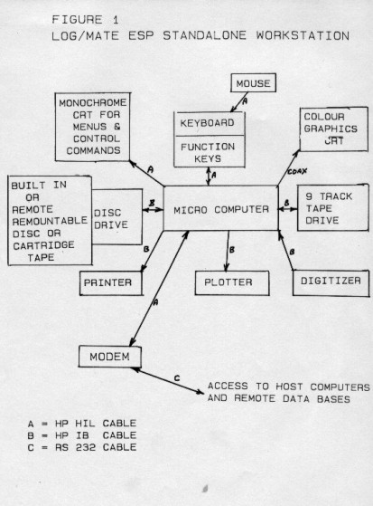
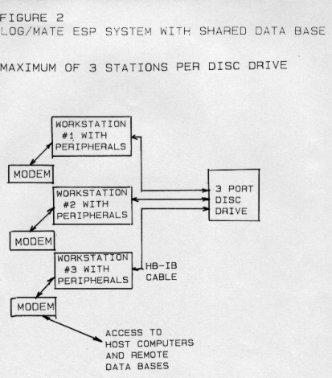
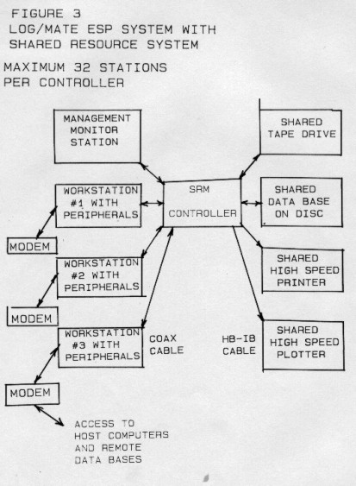
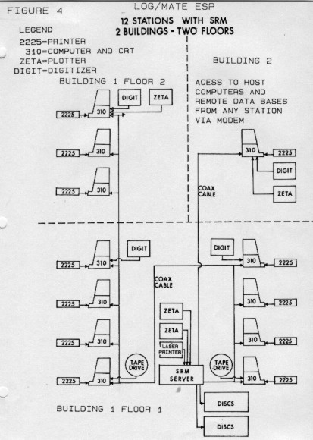
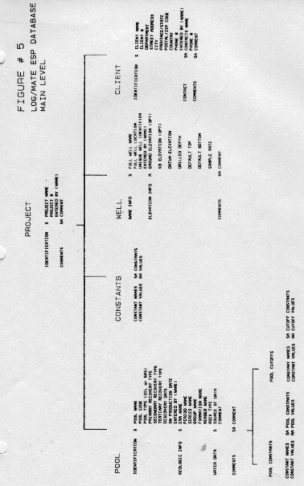 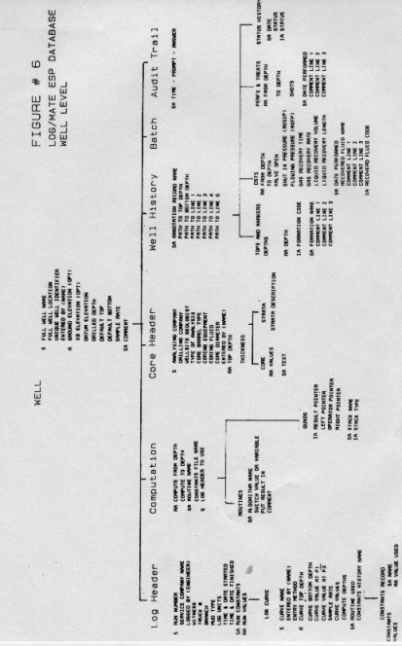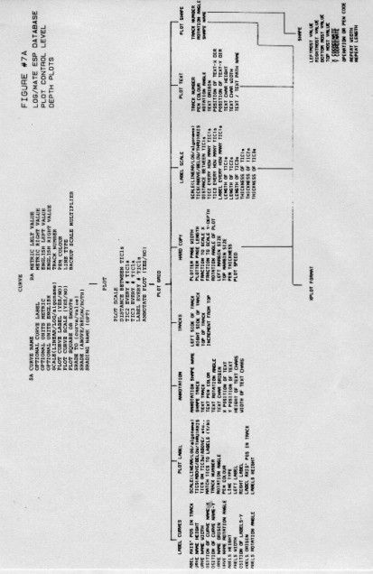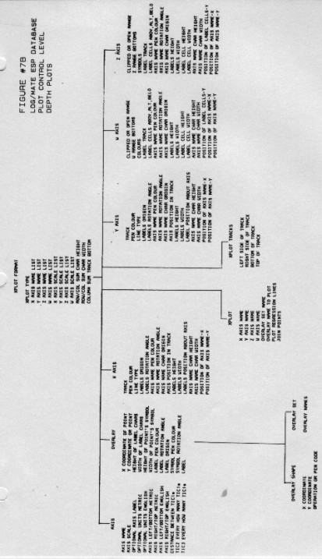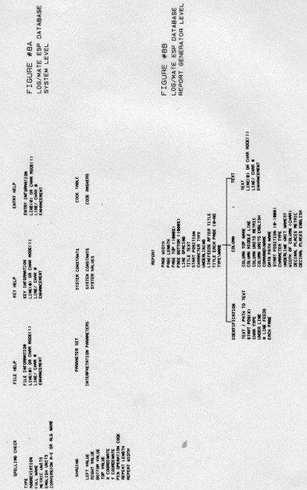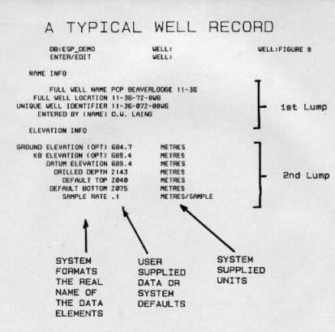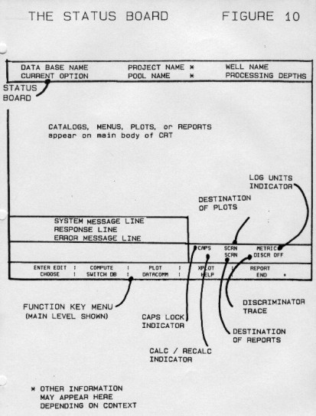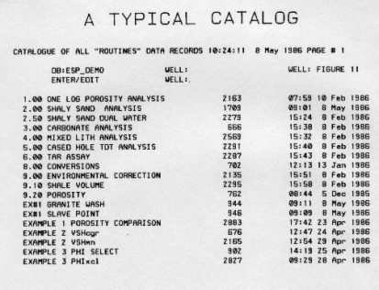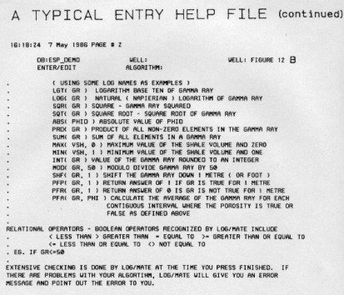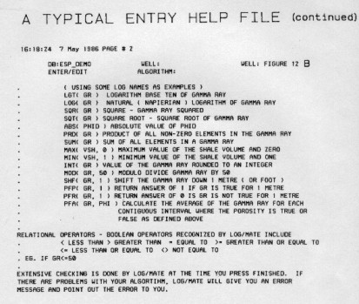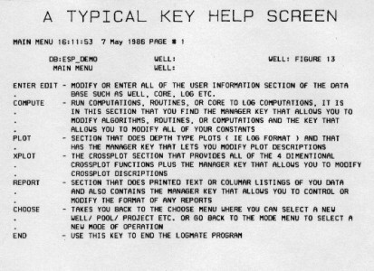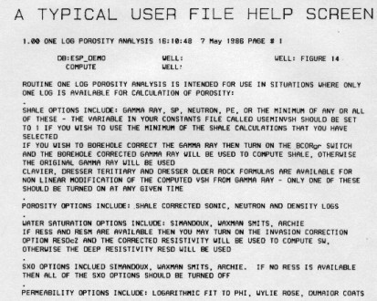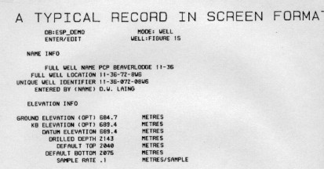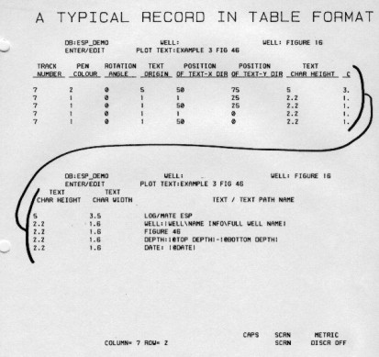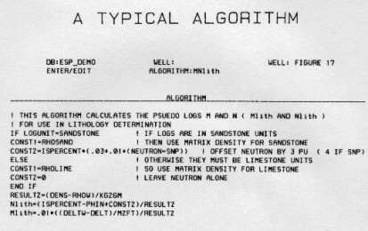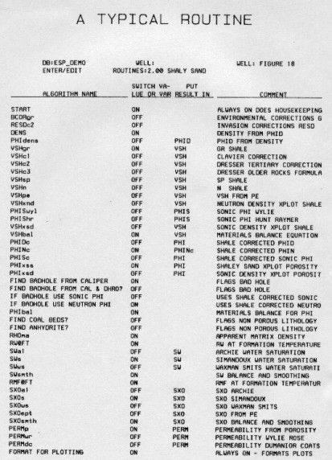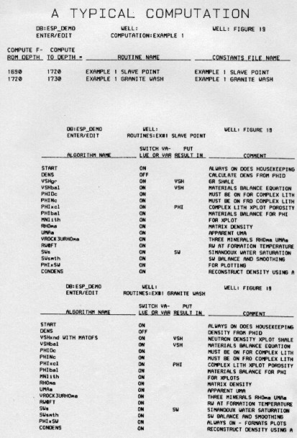s