MYTH-INTERPRETATION
PART 2
E. R. Crain, P.Eng.
Spectrum 2000 Mindware Ltd
Published in CWLS InSite Dec 2005.
Myth #2: Dipmeters Measure True Formation Dip
Dipmeter tools, of course, don’t measure dip directly - they measure a number of conductivity curves that are correlated by computer algorithms to determine a formation dip at a particular depth. The log headings say “True Dip”, but is that really true? The “True” in True Dip actually means the dip direction is relative to true North, but it says nothing about the accuracy of the dip angle or dip direction.
There are half a dozen different ways to correlate the curves and as many ways to average the results for presentation on the log, not to mention the permutations of parameters that can affect the answers. These techniques were outlined in a review paper by the author in “Dipmeter Tools and Presentations”, in Canadian Well Logging Society Journal, Dec 1992.
Certain parameters will exclude high angle dips, so you won’t see fracture or fault planes. Other parameters effectively smooth the results so that you cannot see bedding inside a sand body. If you are mining this sand body with a multi-million dollar shovel, or chasing the sand body along its axis with million dollar wells, this lack of detail could be kind of crucial to your bottom line (or your insurance company).
A bad choice of parameters or computation method can lead to very misleading results. Doublets, even quadruplets, of identical dips are a function of parameter choice and do not represent two (or four) individual dipping beds. On the other hand, the program may find many possible dips within a correlation interval – clustering and pooling will choose one dip angle from as many as 25 or 30 possible candidates. Which one is the real dip?
Much of the problem can be eliminated by comparing calculated dips with formation micro-resistivity image logs. It is amazing how often the computation method or parameters can be shown to be giving inappropriate results after this comparison is made. Fortunately, many dipmeters can be reprocessed with more appropriate parameters, but there are literally tens of thousands in well files that will never see this benefit because the digital data has been lost. So geologists will continue to infer the wrong geological setting from such logs.
The example below is from a forensic analysis project from more than 15 years ago. The problem here was that the client liked the highly smoothed dipmeter presentation he was used to. The fact that the current dipmeters were “noisy” was a bone of contention. These illustrations show the range of possible solutions. Judge for yourself which set of dip results you think reflect the “True Dip”.
Dips can be computed automatically on a microscanner log by the same methods as used for the stratigraphic high resolution dipmeter. MSD, CSB, FMS, and handpicked dips over the same interval are demonstrated in Figures 1 through 4. Each plot has entirely different dip results, emphasizing the need to understand the different dip calculation methods. In particular, the MSD dips in a strongly cross bedded formation suffer badly from the averaging calculation. Compare Figure 1 (MSD) with Figure 2 (CSB). It is clear that MSD dips do not follow the bed boundaries very well and underestimate dip angle at the sand top and base by 7 to 10 degrees.
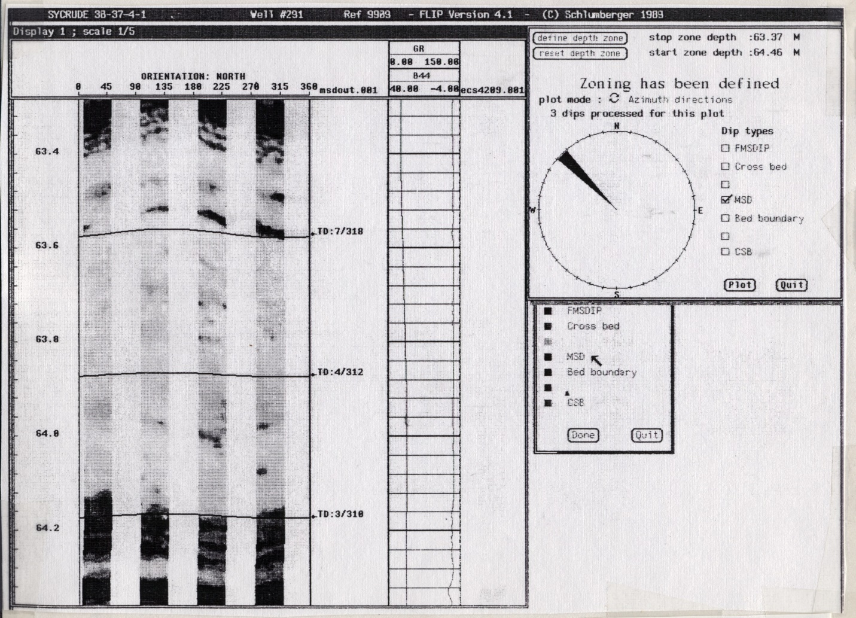FIGURE 1: MSD dips picked from formation microscanner. Maximum dip is 7 degrees.
The FMS dips (Figure 3) use a different form of correlation, so they honour the bed boundaries even better than CSB dips. Computed dips are even steeper than CSB and much steeper than the MSD, indicating the relative degree of averaging being done by the program.
The hand-picked data in Figure 4 is probably the best result, but it is labor intensive. It takes about half a day to compute all FMS dips over a 300 foot interval, delete all unwanted dips manually, and pick additional dips not found in the original computation.
You might want to try a similar study on one of your sandstone plays.
You should appreciate these differences when using conventional dipmeter logs. Any form of best fit or averaged dip will probably underestimate dip angle unless some very dominant bed boundary exists that will swamp all others. The assumption made by the programmers is that major bed boundaries do this, but as you can see from the illustrations, this is not always true. If you can afford it, run FMS or televiewer images to help interpret dipmeter arrow plots. Since the vast majority of existing dipmeters cannot be augmented by FMS, BEWARE of averaged results.
Remember, it’s “True North – Strong and Free”, not “True Dip – Smoothed and Averaged”.

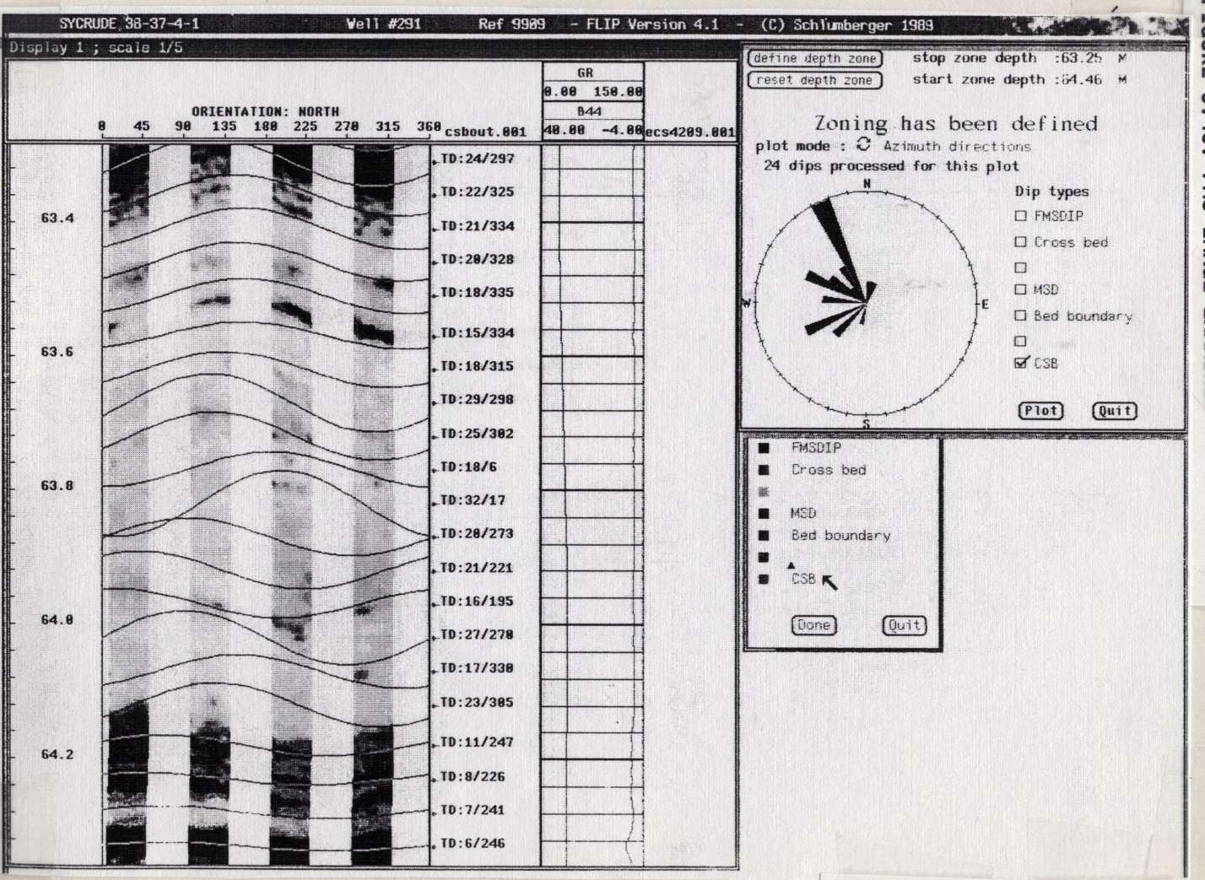FIGURE 2: CSB dips picked from formation microscanner. Maximum dip is 25 degrees.
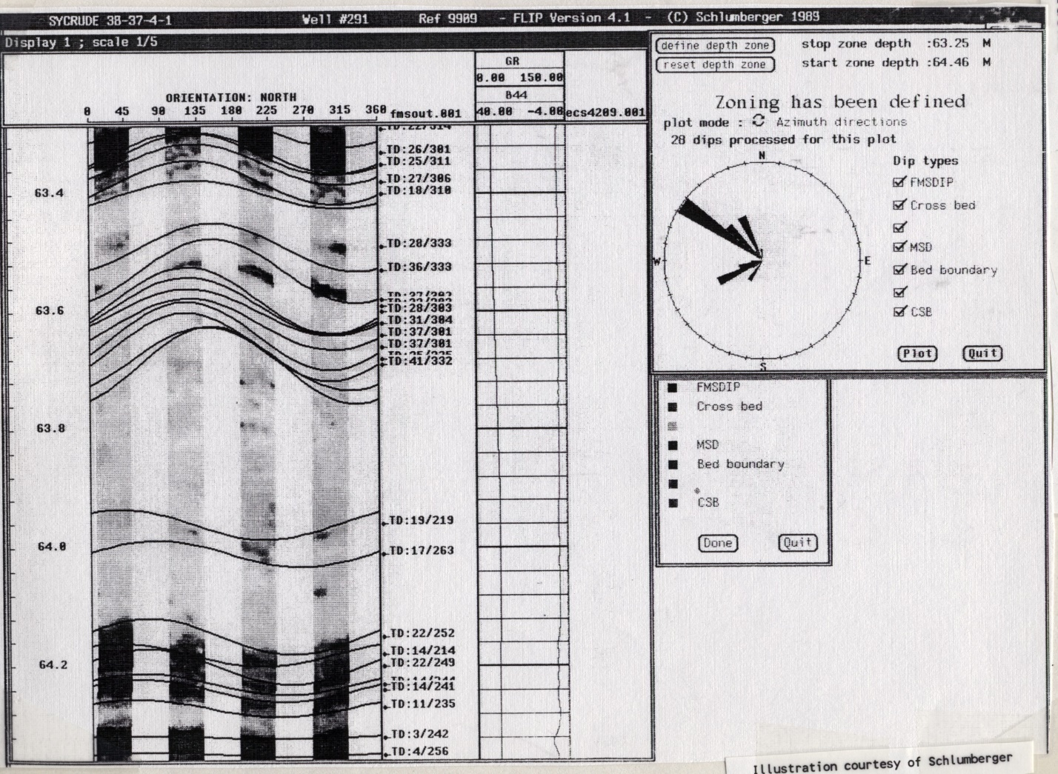FIGURE 3: FMS dips picked from formation microscanner. Maximum dip is 37 degrees.
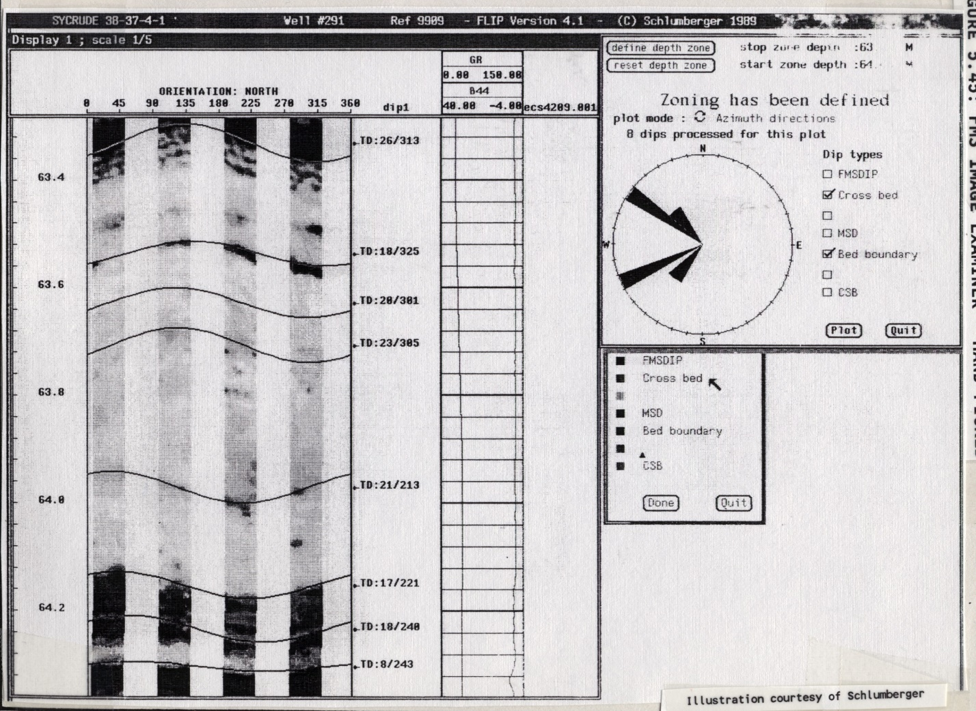FIGURE 4: Hand-picked dips picked from formation microscanner. Maximum dip is 28 degrees.

