UNICORNS IN THE GARDEN OF GOOD AND EVIL
PART 3 – COAL BED METHANE
E. R. (Ross) Crain, P.Eng.
Spectrum 2000 Mindware Ltd
Published in CSPG Reservoir, Jan 2011
Unicorns are beautiful, mythical beasts, much sought after by us mere mortals. The same is true for petrophysical models for unconventional reservoirs. This is the third in a series of review articles outlining the simple beauty of some practical methods for log analysis of the unusual.
COAL BED METHANE BASICS
Coal bed methane (CBM) is an economic source of natural gas that is generated and stored in coal beds. It is a widely occurring exploitable resource that can be easily recovered and used near the well or where gas pipeline infrastructure currently exists.
Coal acts as both source rock and reservoir rock for methane. Methane is generated by microbial (biogenic) or thermal (thermogenic) processes shortly after burial, and throughout the diagenetic cycle resulting from further burial. Much of this gas is physically "sorbed" on coal surfaces. Some higher ends may also be produced by coal, such as ethane, and propane, but usually only a few percent of the total gas.
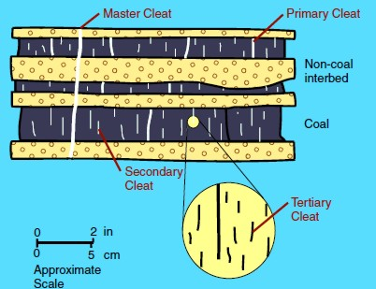
Adsorption is the process of gaining gas on a microporous surface. Desorption is the process of releasing gas from such a surface.
These surfaces are called cleats and range in size from obvious macrofractures to virtually invisible nanofractures. These cleat patterns are crucial for gas production because they allow for the release of sorbed gas within coal beds and migration to the well bore
Figure 1: Illustration of cleats, large to tiny
One gram of coal can contain as much surface area as several football fields and therefore is capable of sorbing large quantities of methane. One short ton (2000 pounds mass) of coal can store about 1,300 m3 of methane. Depending on reservoir pressure, not all the storage capacity is filled with gas.
Coal bed gas content must have reached near-saturation, either by biogenic or thermogenic gas-generation processes, to be economically viable. Cleats must be present to allow for connectivity between sorption sites. If the coal-bed horizons are buried deeply (>2000 meters), cleats are closed because of overburden pressure acting on the structurally weak coal bed. Cleats can also be filled with other minerals, reducing their effective permeability.
Methane sorbed within coal beds is regulated by the hydrodynamic pressure gradient. Methane is maintained within the coal bed as long as the water table remains above the gas-saturated coal. If the water table is lowered by basin or climatic changes, then methane stored within the coal is reduced by release to the atmosphere.
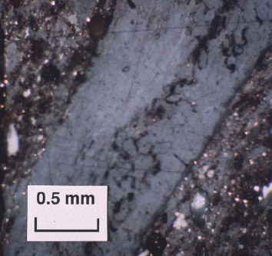
Many coal beds need to be de-watered before they can produce gas. Some coal beds have been de-watered naturally or by crossflows due to previous drilling for oil or gas in nearby wells. Poor quality cement jobs are a major cause of such crossflows.
Figure 2: Micro photo shows cleats are tiny (black) but may be numerous
CBM wells, unlike conventional oil and gas producers, usually show an increase in the amount of production (after initial de-watering). As a coal is de-watered, the cleat system progressively opens farther away from the well. As this process continues, gas flow increases from the expanding volume of de-watered coal. Water production decreases with time, which makes gas production from the well more economical.
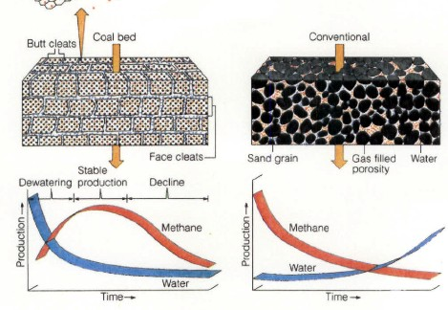
Figure 3: Comparison of conventional gas production and CBM production characteristics

Sorption isotherms FOR COAL BED METHANE
Sorption isotherms indicate the maximum volume of methane that a coal can store under equilibrium conditions at a given pressure and temperature.

The direct method of determining sorption isotherms involves drilling and cutting core that is immediately placed in canisters, followed by measurements of the volume of gas evolved from the coal over time.

The indirect method takes advantage of core or cuttings that have been stored and does not require fresh core, thus making this method more economical. Sorption isotherms are experimentally measured using a powdered coal sample whose saturated methane content at a single temperature is measured at about six pressure points.

Moisture content in a coal decreases the sorption capacity. Because coal loses moisture at a variable rate subsequent to removal from the bore hole, a standard moisture content is used when measuring sorption isotherms.

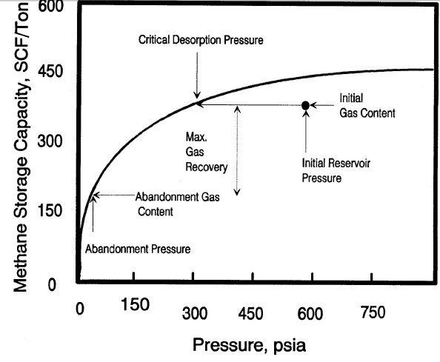
Figure 4: Typical sorption isotherm showing initial reservoir gas content vs pressure, critical desorption pressure, and abandonment conditions Gas will not flow until reservoir pressure is less than critical pressure.

The Langmuir equation is used to predict the maximum gas storage capacity of a reservoir and the equilibrium pressure. Most CBM reservoirs are somewhat undersaturated, so the stored gas is less than the capacity of the reservoir. A few are reported to be hypersaturated. The equations are::
1: K1 = 0.21258 * Tf^0.5
2: K2 = 2.82873 – 0.00268 * Tf
3: K3 = 0.00259 * Tf + 0.50899
4: K4 = 0.00402 * Tf + 2.20342
5: Gmax = 10^(K1 * log(Wfcarb / Wwtr) + K2)
6: Pr = 10^(K3 * log(Wfcarb / Wwtr) + K4)
Where:
Gmax = gas volume at infinite pressure (ft3/ton)
Pr = Langmuir pressure, at which sample’s gas content is ½ Gmax (atmospheres)
Tf = temperature (ºC)
Wfcarb = mass fraction of fixed carbon (fractional)
Wwtr = mass fraction of moisture (fractional)

Wfcarb and Wwtr are usually measured in the lab during a Proximate Analysis. Log analysis methods for obtaining these values are described in the Unconventional Reservoirs section, Chapter Seventeen, on my website https://www.spec2000.net/
Numerical Example:
Given:
Wash | Wfcarb | Wwtr | Pf atm | Tf ºC | DEPTH m
0.20 | 0.48 | 0.32 | 100 | 30 | 1000
Note 100 atm = 1466 psi = 10132 kPa
K1 = 1.2 K2 = 2.7 K3 = 0.6 K4 = 2.3
Gmax = 898.2 Scf/ton Pr = 267.5 atm
GAS CONTENT FROM CORE OR SAMPLE ANALYSIS
Finding the actual gas content, Gc, in the lab can be done directly as part of the Proximate Analysis, or indirectly. The direct method of determining sorption isotherms involves drilling and cutting core that is immediately placed in canisters, followed by measurements of the
volume of gas evolved from the coal over time.
The indirect method takes advantage of core or cuttings that have been stored and does not require fresh core, thus making this method more economical. Sorption isotherms are experimentally measured using a powdered coal sample whose saturated methane content at a single temperature is measured at about six pressure points.
Moisture content in a coal decreases the sorption capacity. Because coal loses moisture at a variable rate subsequent to removal from the borehole, a standard moisture content is used when measuring sorption isotherms.
Two gas content values are recorded. One is the actual gas content of the bulk coal; the second is related to the dry, ash-free state of the coal, as in the table below.
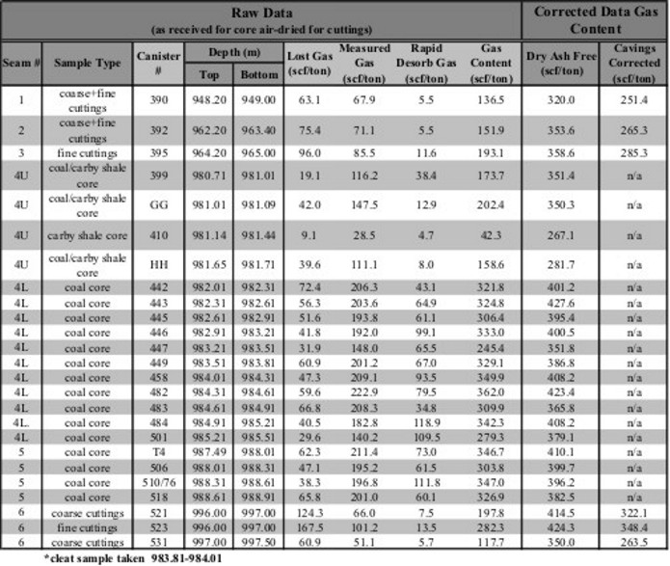
Figure 5: Gas content evaluation of coal beds. Notice that the dry, ash-free values are considerably higher than the actual measured values. As well, an estimate of the "lost gas" was made for each sample to account for gas evolved from the sample before the lab measurements were made.
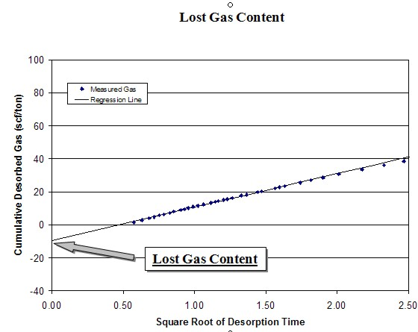
The desorption data obtained during the first several hours can be used to calculate the lost gas component. Cumulative desorbed gas is plotted against the square root of desorption time.
Figure 6: Example of graph for finding “lost gas”
A regression line is drawn through the first 4 to 6 hours of data points and extrapolated back to time zero. The intercept of the regression line at time zero is the lost gas, added to the actual desorbed gas volume to obtain the total actual gas. This value is further adjusted using the ash and water content from the proximate analysis to obtain the dry, ash-free value.
Gas content (Gc) results are usually given as scf/ton or g/cc. Multiply Gc in g/cc by 32.18 to get Gc in scf/ton.
CBM Gas In Place
Gas in place is calculated from the isotherm curve, or from the actual gas content found in the lab, by using coal bed thickness and coal density as measured by well logs:
1: GIP = KG6 * Gc * DENS * THICK * AREA
Where:
GIP = gas in place (Bcf)
Gc = sorbed gas from isotherm or coal analysis report (scf/ton)
DENS = layer density from log or lab measurement (g/cc)
THICK = coal seam thickness (feet)
AREA (acres)
KG6 = 1.3597*10^-6
If AREA = 640 acres, then GIP = Bcf/Section (=Bcf/sq.mile)
Multiply meters by 3.281 to obtain thickness in feet.
Multiply Gc in g/cc by 32.18 to get Gc in scf/ton.
Typical coal densities are in the range of 1.20 to 2.00 g/cc. Older density logs have a hard time reading less than 1.5 g/cc (FDC logs) but modern LDT logs can do it well. Some paper logs may not show the backup scale for density less than 2.0 g/cc - check the digital file. If density cannot be obtained from logs, use lab values or estimates.
CAUTION: If Gc is an actual measurement, the above equation gives reasonable results.. If Gc is for the dry, ash-free case or a theoretical value, the GIP from equation 1 must be adjusted to represent the actual coal by multiplying GIP by (1 - Vash - Vwtr).
Note that free gas in the cleats is assumed to be negligible in most coals. In computer software, coal is usually triggered and PHIe set to zero, and conventional log analysis models used where there is no coal. Triggers are chosen based on density, neutron, sonic, or resistivity, or some combination of these.
Recoverable gas can be estimated by using the sorption curve at abandonment pressure (Ga) and replacing Gc in Equation 1 with (Gc - Ga).
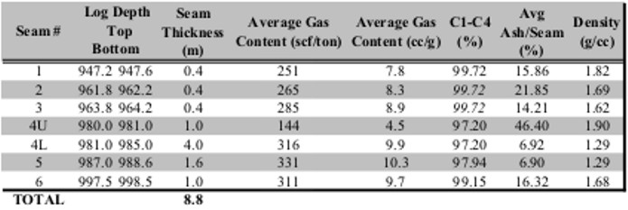
Figure 7: Summary table of gas desorption analysis
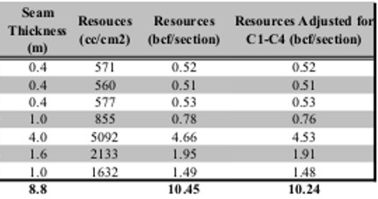
Figure 8: Gas in place calculation based on proximate analysis and gas desorption measurements.
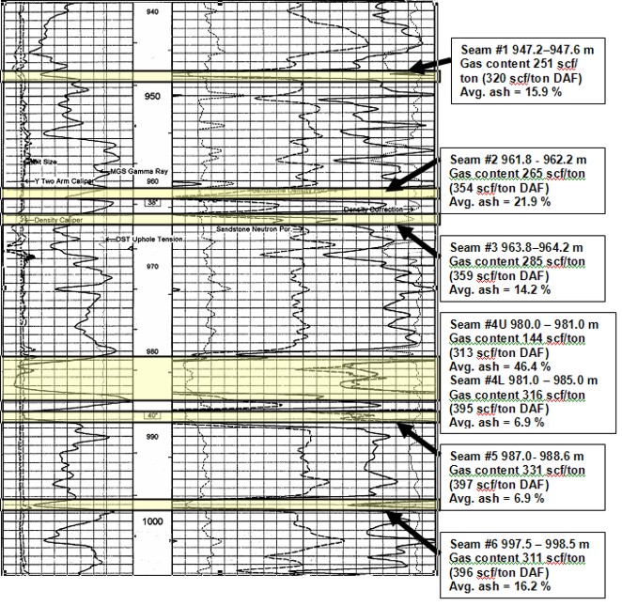
Figure 9: Well log showing location of coal layers analyzed by proximate and gas desorption analysis. Log curves are GR, CAL, PE, neutron, density, density correction.
CALCULATING GAS CONTENT FROM LOGS
These approaches are used where measured Gc values are not available and involve more detailed analysis of the coal itself. This breakdown can be derived from analysis of core data, called proximate analysis, or by analysis of log data. See Coal Analysis Models for details of how to calculate the coal components. Some of the following methods assume a complete coal analysis is available from log or core data. Note that the various authors use a variety of units of measurement, so read their original papers carefully.
1. Mullen equation, based on some average data in New Mexico (San Juan Basin):
8: Gc = 1053 – 542 * DENScoal

2. Mavor, Close, McBaner equation, based on some average data in Utah:
9: Gc = 601.4 – 751.8 * Wash / (1.0 - Wwtr)

3. Kim Equation:
10: Ko = 5.6 + 0.8 * Wfcarb / Wwtr
11: No = 0.39 – 0.1 * Wfcarb / Wwtr
12: Gc = 75 * (1 - Wwtr - Wash) * (Ko * Pf ^ No - 0.14 * Tf)
Where:
Gc = sorbed gas estimate (Scf/ton)
Pf = formation pressure (atmospheres)
Tf = formation temperature (ºC)
4. Modified Kim Equation:
13: Gc = 75 * (1 - Wwtr - Wash) * (Ko * (KG7 * DEPTH/100)^No - 0.14 * KG8 * DEPTH/100 + KG9)
Where:
KG7 = pressure gradient (atm per 100 meters)
KG8 = temperature gradient (ºC per 100 meters)
KG9 = surface temperature (ºC)
DEPTH = average reservoir depth (meters)
Defaults: KG7 = 0.10, KG8 = 1.80, KG9 = 12
This equation uses local gradients relating Pf and Tf to depth. Measured values are usually better but gradient values are useful when no measured data exists. Kim and modified Kim will give identical results if gradients match measured values.
5. Mullen’s correlation between SP development and deliverability:
14: Qg = KG10 * SPmax * THICK
Where:
SPmax = absolute value of maximum SP deflection in coal (mv)
THICK = coal bed thickness (ft)
KG10 = 3100
Qg = gas rate (mmcf/d)
The parameter KG10 should be adjusted for each project area.
Numerical Example:
Given:
Wash | Wfcarb | Wwtr | Pf atm | Tf ºC | DEPTH m
0.20 | 0.48 | 0.32 | 100 | 30 | 1000
Note 100 atm = 1466 psi = 10132 kPa
1. Mullen equation - San Juan Basin
Gc = 402.6 Scf/ton
2. Mavor, Close, McBaner - Utah
Gc = 380.3 Scf/ton
3. Kim Equation
Ko = 6.8
No = 0.2
Gc = 588.1 Scf/ton
4. Modified Kim using default gradients
Gc = 586.1 Scf/ton
CBM ANALYSIS EXAMPLE
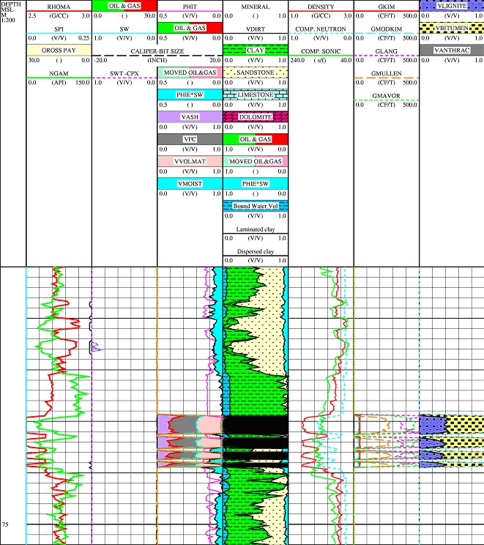
Figure 10: Example of coal bed methane log analysis. Kim and modified Kim gas content curves are shown in 2nd track from the right. If temperature and pressure gradients matched measured values, the results should be identical to each other. The Langmuir gas curve in the same track shows the maximum storage capacity of the coal.
REFERENCES
Figures 1 through 3 are from “Coal-Bed Methane Gas-In-Place Resource Estimates Using Sorption Isotherms and Burial History Reconstruction” by T. A. Dallegge and C. E. Barker1, USGS Professional Paper 1625B. Figure 10 is from “Coalbed Methane Log Analysis” by Michael Holmes, Digital Petrophysics Inc.

