A 12-STEP PROGRAM TO REDUCE UNCERTAINTY
IN KEROGEN-RICH RESERVOIRS
E. R. (Ross) Crain, PEng.
Dorian Holgate, PGeol.
Spectrum 2000 Mindware Ltd
Published in CWLS InSite Apr 2014, CSPG Reservoir, Mar and Apr 2014
INTRODUCTION
In some unconventional reservoirs, the presence of kerogen confounds standard log analysis models. Kerogen looks a lot like porosity to most porosity-indicating logs. Thus a single log, or any combination of them, will give highly optimistic porosity and free-gas or oil saturations, unless a kerogen correction is applied. This tutorial explains how such corrections can be applied in an otherwise standard petrophysical model that can be coded into the user-defined equation module of any software package.

Some quick-look methods “fake” the kerogen correction by using the density log with false and fixed matrix and/or fluid properties in an attempt to match core porosity (where it exists). When mineralogy varies, as in many unconventional reservoirs, the individual porosities calculated at each depth level are wrong, even though the average porosity may be correct. Porosity in the more dolomitic intervals will be too low and those in the higher quartz intervals will be too high. This will not help you decide where to position a horizontal well or help to assess net pay intervals because the porosity profile is extremely misleading.

Over-simplified techniques are dangerous, unprofessional, and unnecessary. Drawing an arbitrary straight line on a density log won’t “hack-it” in a world where wells cost multiple millions and a company’s stock price depends on the accuracy of the numbers in quarterly reports.

The 12-Step deterministic solution described here is easy to understand, easy to apply, and reasonably rapid. It is easier to manage than multi-mineral / statistical / probabilistic models. Parameter changes in later steps of the workflow will not change prior results, as happens in the multi-min environment. Each step in the model can be calibrated directly to available data before moving on to the next step. The workflow is simple, straight-forward, logical, controllable, and above all, predictable.
BASIS FOR THE MODEL
The methodology outlined below makes use of well-known algorithms, run in a deterministic model that can be calibrated with available ground truth at every step of the process. Because of the sparse nature of some of the calibration data, it may have to come from offset wells, which forces us to analyze those wells in addition to the wells of primary interest. This extra work can be minimized when the proper data collection and lab work is planned as part of the initial drilling program.

One of the most widely used petrophysical porosity models in conventional reservoirs is the shale-corrected density-neutron complex lithology crossplot. It handles varying mineralogy and light hydrocarbon effects quite well and can use sonic data if the density goes AWOL in bad hole conditions. By extending the model to include a kerogen correction to each of the density, neutron, and sonic curves, we have a universal model that has proven effective over a wide range of unconventional reservoirs around the world. The model reverts to the standard model when kerogen volume is zero.

Other steps in the workflow use existing standard methods chosen because they work well in low porosity environments. There are many alternate models for every step and you may have a personal preference different than ours. Be sure to run a sensitivity test to confirm that the results are reasonable at low porosities with high clay volumes.

THE 12-STEP WORKFLOW
The petrophysical model for correcting porosity for kerogen involves calculation of kerogen weight and volume from suitable petrophysical models, and the modification of a few equations in the standard shale corrected density-neutron porosity model.
Step 1: Shale Volume
Shale (or clay) volume is the most important starting point. Since many unconventional reservoirs are radioactive due to uranium associated with kerogen or phosphates, the usual clay volume model that depends on the gamma ray log needs special attention. Calibration to X-ray diffraction data (see example in Figure 1), or thin section point counts, is essential. The basic mineral mix also is developed from the XRD data set.
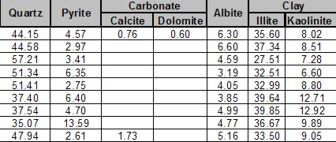
Figure 1: Typical XRD analysis of a silty gas shale showing clay-quartz ratio averages of about 40:60% by weight. This would not be obvious from the gamma ray log due to uranium associated with the kerogen and/or phosphate minerals. Some radioactive reservoirs have nearly zero clay, so the XRD bulk clay volume is the best starting point for a petrophysical analysis

Shale volume calculations from a uranium corrected gamma ray curve (CGR) is the best bet:
1: VSHcgr = (CGR - CGR0) / (CGR100 - CGR0)
When CGR is not available, we fall back to the thorium (TH) curve from a spectral gamma ray log:
2: VSHth = (TH - TH0) / (TH100 - TH0)
When CGR and TH are missing, the total gamma ray curve (GR) can still be used by moving the clean (GR0) and shale (GR100) lines further to the right compared to conventional shaly sands:
3: VSHgr = (GR - GR0) / (GR100 - GR0)
This last equation may take a little skill and daring, but that is what the XRD clay volumes are for. You can also test your clean and shale line picks in wells with CGR or TH curves then move that knowledge into other wells.
Unless shale volume is reasonably calibrated, nothing else in this workflow will work properly.
Step 2: Kerogen Weight Fraction
Kerogen weight fraction can be calculated from the resistivity log and a porosity log, using Passey or Issler methods. The Passey model is often called the “DlogR” method, with the “D” standing for “Delta-T” or sonic travel time. He also published density and neutron log versions of the equations. We have changed the abbreviations to reflect the three possible combinations:
4: SlogR = log (RESD / RESDbase) + 0.02 * (DTC – DTCbase)
5: Wtoc = SF1s * (SlogR * 10^(0.297 – 0.1688 * LOM)) + SO1s
OR
6: DlogR = log (RESD / RESDbase) -- 2.5 * (DENS – DENSbase)
7: Wtoc = SF1d * (DlogR * 10^(0.297 – 0.1688 * LOM)) + SO1d
OR
8: NlogR = log (RESD / RESDbase) -+ 4.0 * (PHIN – PHINbase)
9: Wtoc = SF1n * NDlogR * 10^(0.297 – 0.1688 * LOM)) + SO1n
Where:
XXXXbase = baseline log reading in non-source rock shale
SlogR or DlogR or NlogR = Passey’s number from sonic or density or neutron log (fractional)
LOM = level of organic maturity (unitless)
Wtoc = total organic carbon from Passey method (weight fraction)
SF1s,d,n and SO1s,d,n = scale factor and scale offset to calibrate to lab values of TOC
The constants in the Passey equations require DTC values in μsec/ft and density in g/cc.

The baseline values are supposed to be picked in non-source rock shales in the same geologic age as the reservoir, but there may be none in the area of interest. This makes the Passey model difficult to calibrate, hence the scale factor SF1 and scale offset SO1. LOM is seldom measured except as vitrinite reflectance (Ro). There is a published chart for converting Ro to LOM. LOM is in the range of 6 to 11 in gas shale and 11 to 18 in oil shale.

Issler’s method, which is based on WCSB Cretaceous data is preferred as no baselines are needed. It still needs a scale factor for deeper rocks. Tristan Euzen's multiple regressions of the Issler graphs give:
10: TOCs = 0.0714 * (DTC + 195 * log(RESD)) - 31.86
11: Wtoc = SF2d * TOCs / 100 + SO2d
OR
12: TOCd = -0.1429 * (DENS – 1014) / (log(RESD) + 4.122) + 45.14
13: Wtoc = SF2s * TOCd / 100 + SO2s

Where:
Wtoc = total organic carbon from Issler method (weight fraction)
SF2s,d and SO2s,d = scale factor and scale offset to calibrate to lab values of TOC

The Issler equations expect density in Kg/m3 and sonic data in μsec/m.

Mass fraction organic carbon (Wtoc) results from log analysis MUST be calibrated to geochemical. lab data (see example lab report in Figure 2) using the scale factor and scale offset. These scale factors will vary from place to place even within the same geological horizon. Using the Passey or Issler models without local calibration is strongly discouraged – results are often 2 to 3 times too high.

Depth | TOC | S1 | S2 | S3 | Tmax | Ro | SI | OI
m | wt% |  |  |  | °C | %
X025 | 1.35 | 0.05 | 1.72 | 0.63 | 444 |  | 128 | 47
X040 | 1.18 | 0.05 | 1.65 | 0.57 | 443 |  | 140 | 49
X050 | 0.83 | 0.03 | 1.31 | 0.55 | 443 |  | 158 | 66
X065 | 0.8 | 0.04 | 1 | 0.58 | 440 |  | 126 | 73
X075 | 0.75 | 0.05 | 1.04 | 0.72 | 438 |  | 138 | 96
X090 | 1.04 | 0.09 | 2.52 | 0.29 | 452 |  | 241 | 28
X110 | 1.02 | 0.05 | 1.16 | 0.56 | 441 |  | 114 | 55
X135 | 1.05 | 0.05 | 1.32 | 0.57 | 443 |  | 125 | 54
Figure 2: Geochemical lab report with TOC weight % values. Both Passeyy and Issler methods overestimate TOC by large factors in this particular shale gas, forcing us to use scaling factors to calibrate log derived Wtoc. Both methods can be made to give virtually identical results when calibrated to XRD.

Step 3: Kerogen Volume Fraction
Kerogen volume is calculated by converting the TOC weight fraction (Wtoc). The lab TOC value is a measure of only the carbon content in the kerogen, and kerogen also contains oxygen, nitrogen, sulphur, etc, so the conversion of TOC into kerogen has to take this into account. The kerogen conversion factor (KTOC) is the ratio of carbon weight to the total kerogen weight. The factor can range from 0.68 to 0.95, with the most common value near 0.80.
Converting mass fraction to volume fraction is as follows:
14: Wtoc = TOC% / 100 from core, or as found from Passey or Issler methods described above.
15: Wker = Wtoc / KTOC
16: VOLker = Wker / DENSker
17: VOLma = (1 - Wker) / DENSma
18: VOLrock = VOLker + VOLma
19: Vker = VOLker / VOLrock
Where:
KTOC = kerogen conversion factor Range = 0.68 to 0.95, default = 0.80
Wker = mass fraction of kerogen (unitless)
DENSker = density of kerogen (Kg/m3 or g/cc)
DENSma = matrix density (Kg/m3 or g/cc)
VOLxx = component volumes (m3 or cc)
Vker = volume fraction of kerogen (unitless)
DENSker is in the range of 1200 to 1400 Kg/m3, similar to good quality coal. Default = 1300 Kg/m3.
Lower values are possible in low maturity kerogen.
Step 4: Kerogen and Shale Corrected Porosity
Effective porosity is best done with the shale corrected density neutron complex lithology model, modified to correct for kerogen volume:
21: PHIDker = (2650 – DENSker) / 1650 (if PHIN is in Sandstone Units)
22: PHIdc = PHID – (Vsh * PHIDsh) – (Vker * PHIDker)
23: PHInc = PHIN – (Vsh * PHINsh) – (Vker * PHINker)
24: PHIe = (PHInc + PHIdc) / 2
PHINker is in the range of 0.45 to 0.75, similar to poor quality coal. Default = 0.65.
This model compensates for variations in mineralogy AND kerogen.
If the density log is affected by rough borehole, the shale corrected sonic log porosity (PHIsc) can be used instead:
24: PHISker = (DTCker – 182) / 474 (if PHIN is in Sandstone Units)
25: PHIsc = PHIS – (Vsh * PHISsh) – (Vker * PHISker)
26: PHInc = PHIN – (Vsh * PHINsh) – (Vker * PHINker)
27: PHIe = (PHInc + PHIsc) / 2
DTCker is in the range of 345 to 525 μsec/m, similar to good quality coal. Default = 425 usec/m.
This model is moderately insensitive to variations in mineralogy AND compensates for kerogen.

Effective porosity from a nuclear magnetic resonance (NMR) log does not include kerogen or clay bound water, so this curve, where available, is a good test of the modified density neutron crossplot method shown above (illustrated in Figure 3).
In all cases, good core control is essential. If porosity is too low compared to core porosity, then shale volume or kerogen volume are too high. Revisit the calibration of these two terms.
Some so-called shale gas zones are really tight gas with little kerogen or adsorbed gas, so the kerogen corrected complex lithology model works well because it reverts to our standard methods automatically when Vker = 0.

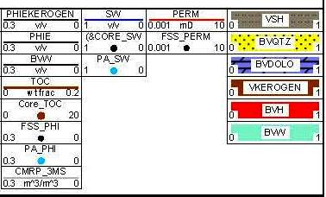
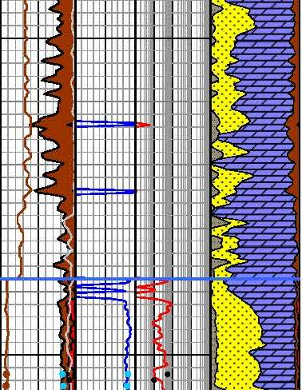
Figure 3: Example of TOC weight fraction (left hand curve in Track 1) calibrated to geochemical lab data in the Montney (2 dots near bottom of log segment – another 20+ data points are not shown to conserve space). Kerogen volume derived from TOC is displayed as dark shading to the left of effective porosity (shaded red) in Track 1. In the Doig above the Montney, there is no geochem data, so the CMR effective porosity (light grey curve) was used to back-calculate the TOC, based on the difference between raw neutron-density porosity and PHIEnmr values. Scale factors for the Doig and Montney are markedly different regardless of the TOC calculation method employed. Depth grid lines are 1 meter apart.

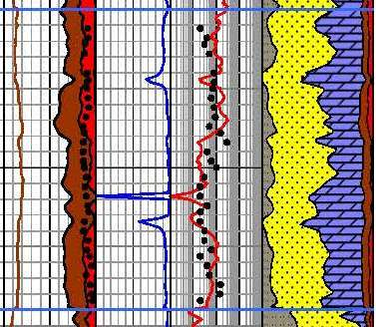
Figure 4: Example of TOC and density-neutron effective porosity after kerogen correction in a Montney interval, showing close comparison to core effective porosity (black dots). TOC reaches 4 weight percent, which converts to near 10% by volume (dark shading). Note that permeability of the free porosity is in the range of 0.01 to 0.1 milliDarcies, not the nanoDarcy range quoted in core reports based on the GRI protocol, which uses crushed sample grains instead of core plugs.

Step 5: Lithology
Lithology is then calculated with a kerogen and shale corrected 2-mineral PE model or a 3-mineral model using kerogen-and shale corrected PE, density, and neutron data. Calibrate results to XRD data. Modify mineral selection or mineral end points to achieve a reasonable match.

Some people use a multi-mineral or probabilistic software package to solve for all minerals, including porosity and kerogen, treating the latter two as "minerals". In the case of rough borehole conditions, this method gives silly results unless a bad-hole discriminator curve is also used. These models are more difficult to tune because it is not possible to calibrate shale volume, TOC weight fraction, effective porosity, and mineralogy in a step-by-step sequence, as can be done with the deterministic model described here. Changing parameters in the multi-mineral model, to strive for a better match to ground truth, often gives unexpected results. It is a multi-dimensional jigsaw puzzle and some of the pieces just won’t fit unless you trim them in the correct sequence.

To reduce this problem, calibrate shale volume kerogen volume and effective porosity by the deterministic method shown earlier, then use these as input curves as constraints in the multi-mineral model.
Recently, we have seen excellent examples of elemental capture spectography inversions that produce both TOC, clay, and mineral weight fractions. TOC and XRD lab data are still used to drive the inversion in the correct direction.

Step 6: Water Saturation
From here onward, petrophysical analysis follows normal procedures. Water saturation is best done with the Simandoux equation, which is better behaved in low porosity than most other models. Dual water models may also work, but may give silly results when shale volume is high or porosity is very low.
In many cases, the electrical properties must be varied from world average values to get Sw to match lab data. Typically A = 1.0 with M = N = 1.5 to 1.8. Lab measurement of electrical properties is essential. Skipping this step is the worst form of false economy. The wrong M and N values can give zero OGIP!
Calibration can be done with core water saturation or capillary pressure data. Both pose tricky problems in unconventional reservoirs, especially those with thin porosity laminations, so common sense may have to prevail over “facts”.

Step 7: Permeability
Permeability from the Wyllie-Rose equation works extremely well even in low porosity reservoirs. We generally assume that the calculated water saturation is also the irreducible water saturation for this model, although this assumption may be incorrect in a few cases. The calibration constant in the Wyllie-Rose equation can range between 100,000 to 150,000 and beyond, and is adjusted to get a good match to conventional core permeability.

An alternative is the exponential equation derived from regression of core permeability against core porosity. The equation takes the form Perm = 10^(A1 * PHIe + A2). Typical values for A1 and A2 are 20.0 and –3.0 respectively. This model will match conventional core permeability quite well, but will probably not match the permeability derived from crushed samples using the GRI protocol. High perm data points caused by micro- or macro fractures should be eliminated before performing the regression.

Step 8: Reconstruct the Log Curves
Reconstructed or synthetic logs have become an important part of a competent petrophysical workflow. We go to some pains to use only valid data in our petrophysical analysis, omitting bad data from our models. Reconstructed logs are generated from those results using the Log Response Equation.

There are two reasons for reconstructing the well logs. The first is to verify that the parameters used in all steps are reasonable. In good borehole conditions, the reconstructed logs should be close overlays of the original logs. If they are not, possibly some bad data snuck in, or some parameters in the overall model are wrong. You will need to use your CSI skills to chase down the guilty party and rectify the problem. A good match between reconstructed and original logs is not a guarantee of success, but it is one more piece of evidence pointing in that direction.
The second reason for reconstruction is to prepare a strong foundation for calculating rock mechanical properties. Mechanical properties developed from raw logs often contain spikes and noise, or worse, that destroys the stimulation design results. We strongly recommend that stimulation design should ALWAYS use edited or reconstructed logs, which presupposes that sufficient time and talent be allowed by management for this step to take place.
During reconstruction, we can also create missing logs, such as the shear sonic curve, for use in the mechanical properties calculation or for comparison to other wells in the project.

Step 9: Rock Mechanical Properties
All well completions in unconventional reservoirs involve expensive stimulation programs. Hydraulic fracture design depends on an accurate evaluation of rock mechanical properties based, in turn, on an advanced petrophysical analysis. Most frac design programs have only a rudimentary capacity to perform petrophysical analysis. Worse still, frac design software uses the raw, unedited log data with all its problems. Nothing good can come from this. So it is better to do the work outside the frac software and import the mechanical property curves.
The first step to accurate mechanical properties is a reconstruction of the sonic shear and compressional and density data to remove the effects of bad hole and light hydrocarbons. The frac design programs need the water filled case so the reconstruction is always needed in gas zones. More information on how to do this can be found at www.spec2000.net/10-mechsyn.htm.
The usual outputs from this step are shear modulus, velocity ratio, Poisson’s ratio, bulk modulus, Young’s modulus (both dynamic and static), Lame's constant, and a brittleness coefficient. The original and reconstructed log curves, and the lithology track, are displayed with the mechanical properties results.

Triaxial (static) and dynamic lab measurements can be used to help calibrate the mechanical properties calculated from the petrophysical model. In the absence of lab data, most of these results must fit within known ranges, depending on lithology. If values are out of range, we must suspect the input data and check the log reconstruction procedure. This in turn depends on the current state of the petrophysical results, leading us to double check all parameters and calibration steps. This kind of manual iteration is a normal part of a petrophysicist’s daily grind.

Step 10: Net Reservoir and Net Pay
Once all these checks and balances are satisfied, we can get on with finding the “real” answers. Unfortunately, this is where the world gets a little fuzzier.
In many shale gas and some shale oil plays, typical porosity cutoffs for net reservoir are as low as 2 or 3% for those with an optimistic view, and between 4 and 5% for the pessimistic view.

The water saturation cutoff for net pay is quite variable. Some unconventional reservoirs have very little water in the free porosity so the SW cutoff is not too important. Others have higher apparent water saturation than might be expected for a productive reservoir. However, they do produce, so the SW cutoff must be quite liberal; cutoffs between 50 and 80% SW are common.

Shale volume cutoffs are usually set above the 50% mark. Multiple cutoff sets help assess the sensitivity to arbitrary choices and give an indication of the risk or variability in OGIP or OOIP calculations.

Step 11: Free Gas or Oil In Place
Now we move into the reservoir engineer’s territory, but it doesn’t hurt to know where our petrophysical results end up. If you have never done the math before, it can be quite instructive – it is much easier to compare zones or wells on the basis of OOIP or OGIP instead of average porosity, net pay, or gross thickness.

Free gas in place is calculated from the usual volumetric equation:
1: Bg = (Ps * (Tf + KT2)) / (Pf * (Ts + KT2)) * ZF
2: OGIPfree = KV4 * PHIe * (1 - Sw) * THICK * AREA / Bg

For oil reservoirs:
3: OOIP = KV3 * PHIe * (1 - Sw) * THICK * AREA / Bo
Where:
Bg = gas formation volume factor (fractional)
Bo = oil formation volume factor (fractional)
Pf = formation pressure (psi) Ps = surface pressure (psi)
Tf = formation temperature ('F) Ts = surface temperature ('F)
ZF = gas compressibility factor (fractional)
KT2 = 460'F KV3 = 7758 KV4 = 0.000 043 560
If AREA = 640 acres and THICK is in feet, then OGIP = Bcf/Section (= Bcf/sq.mile). OOIP is in barrels per square mile. Multiply meters by 3.281 to obtain thickness in feet.

Step 12: Adsorbed Gas In Place
TOC is widely used as a guide to the quality of shale gas plays. This only pertains to adsorbed gas content and has no bearing on free gas or oil. Some deep hot shale gas plays have little adsorbed gas even though they have moderate TOC content.
Using correlations of lab measured TOC and gas content (Gc), we can use log derived TOC values to predict Gc, which can then be summed over the interval and converted to adsorbed gas in place. Sample correlations are shown in Figure 5.
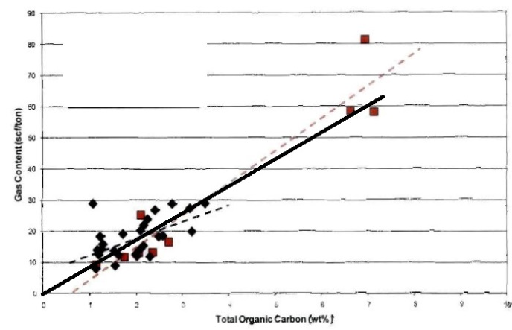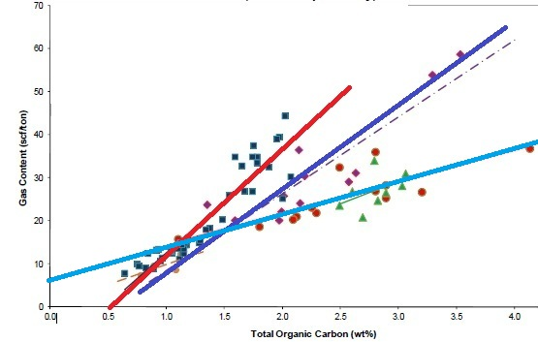
Figure 5: Crossplots of TOC versus adsorbed gas (Gc) for Tight Gas / Shale Gas examples. Note the large variation in Gc versus TOC for different rocks, and that the correlations are not always very strong. These data sets are from core samples. Cuttings give much worse correlations. The fact that some best fit lines do not pass through the origin suggests systematic errors in measurement or recovery and preservation techniques.
Gas content from a best fit line versus TOC can be applied to log derived TOC:
4: Gc = KG11 * TOC%
Where:
Gc = gas content (scf/ton)
TOC% = total organic carbon (percent)
KG11 = gas conversion factor range = 5 to 15, default = 9
Adsorbed gas in place is derived from:
5: OGIPadsorb = KG6 * Gc * DENS * THICK * AREA
Where:
DENS = layer density from log or lab measurement (g/cc)
KG6 = 1.3597*10^-6
If AREA = 640 acres and THICK is in feet, then OGIP = Bcf/Section (= Bcf/sq.mile)
Multiply meters by 3.281 to obtain thickness in feet.
Multiply Gc in cc/gram by 32.18 to get Gc in scf/ton.
A more sophisticated approach uses the Langmuir adsorption curve which can be derived from reservoir temperature and pressure. The correlation of Gc wth TOC seems to be adequate but the Langmuir method would be a useful calibration step.
CONCLUSIONS
A full suite of TOC and XRD mineralogy from samples, along with core porosity and saturation data, are needed to calibrate results from any petrophysical analysis of unconventional reservoirs. Bulk clay and TOC are the two critical lab measurements required through the interval of interest.
Without valid calibration data, petrophysical analysis will have possible-error bars too large to allow meaningful financial decisions.

The deterministic shale and kerogen corrected workflow allows all available ground truth to be used in a logical and consistent manner at each step to calibrate and refine results.

Petrophysical analysis results travel well beyond the initial need to know porosity and water saturation. Oil and gas in place, reservoir stimulation, placement of horizontal wells, even financial reports, are impacted. Shortcuts are not acceptable.

In the end, the cost of the full analysis is trivial compared to the cost of completion, or worse, the cost of an unsuccessful or unnecessary completion.

