APPLES AND AARDVARKS – A TUTORIAL ON PETROPHYSICAL ANALYSIS IN OIL SANDS
E. R. (Ross) Crain, P.Eng.
Spectrum 2000 Mindware Ltd
Published in CSPG Reservoir, Jul/Aug 2014.
INTRODUCTION
Peter Pond called them "tar sands" in 1778 and in the early days of the oil business, tar sands were commonly called tar sands with a little bit of pride. The largest oil deposit in the world with a 400 year life span could not be sneered at. In today's politically-correct double-speak, we now call them "oil sands", not to be confused with conventional oil sands. So oil sands it will be.

The oil sands of Alberta appear to be an easy task for a petrophysicist. After all, the sands are pretty clean, quite porous, and the fluid properties are reasonably well known. Even a novice geologist should be able to do it. However, a series of forensic log analyses over the last 30 years or so suggest that there are some basic misunderstandings about how oil sand cores are analyzed and how to calibrate log analysis results to that data.

In each case, the forensic analysis was undertaken at the request of a client who was unsatisfied with prior work that did not appear to provide an adequate description of the hydrocarbon potential in an oil sands reservoir.

Standard petrophysical analysis models are used for the volumetric determination of clay, porosity, water, and oil, and from this a realistic permeability estimate. Unfortunately, the Dean-Stark core analysis method, widely used to assess oil sand cores, does not measure volumes. Instead, the technique measures oil mass, water mass, and mineral mass. These are converted to mass fraction and then to calculated porosity and water saturation. Rarely, there may be some helium porosity and permeability data, but this is difficult in unconsolidated oil sands.

It is tempting to compare log analysis volumetrics to the Dean-Stark calculated volumetrics, and adjust log analysis parameters to obtain a “good match”. The biggest problem is that this form of core analysis gives a measure of porosity that is sometimes called “total porosity”, which includes clay bound water. In real life, some of the clay bound water is not driven off by the Dean-Stark method, so the core porosity falls somewhere between total and effective porosity.
Figure 1: In shaly sands, Dean-Stark core porosity (black dots) is often less than total porosity (black curve) and higher than effective porosity (left edge of red shading). In clean sands, Dean-Stark matches effective porosity extremely well.

The calculated water saturation from Dean-Stark also falls somewhere between total and effective, when some clay is present. Since log analysis gives effective porosity and saturation, we are comparing apples to aardvarks. The message is that log analysis cannot be calibrated directly to the core volumetric data when clay is present. Virtually all oil sands have some clay content somewhere in the interval of interest.

But we CAN calibrate to Dean-Stark core data in the mass fraction domain, by converting the volumetric petrophysical analysis results to mass fraction. That allows us to compare apples to apples, and let the aardvarks go about their own business. Oil sand quality is judged by its oil mass fraction and net pay is determined by an oil mass fraction cutoff, not porosity and water saturation as in conventional oil. So oil mass fraction is a mandatory output from a petrophysical analysis.
There are additional problems to resolve, as will be discussed below.
WORKFLOW
Petrophysical analysis of oil sands follows the standard methods that have been in use for more than 40 years: The math for these steps is at www.spec2000.net/01-quickmath.htm , except where noted in the test.
Step 1: Load, edit, and depth shift the full log suite, including resistivity, SP, GR, density, neutron, PE, caliper, and sonic, where available. If a thorium or uranium corrected GR (CGR) are available, load these too. Create a Bad Hole Flag if one is needed.

Step 2: Calculate clay volume. Because some uranium may cause spikes on the GR, use the minimum of the gamma ray and density-neutron separation methods. This eliminates false “shale” beds that would otherwise appear to act as baffles to the flow of steam or oil. The SP is unlikely to be a useful clay indicator due to the high resistivity of the oil zone.

Step 3: Calculate clay corrected porosity from the complex lithology density-neutron crossplot model. This model accounts for heavy minerals if any are present, compensates for small quantities of gas if present, and reduces statistical variations in the porosity values. DO NOT USE THE DENSITY POROSITY LOG ALONE. It will read too low if heavy minerals are present and too high if gas is present. The statistical variations at high porosity can give a noisy result. Some oil sands have enough coal or carbonaceous material to look like a coal bed. Set a coal trigger on the density and neutron and set porosity to zero when the trigger is turned on. There is nothing complex about the complex lithology model, so use it. See “Special Cases” below if there is gas crossover in the oil zone.

Step 4: Calculate clay corrected water saturation from the Simandoux or dual-water equations. These default to the Archie model in clean sands but give more oil in shaly sands.

Step 5: Correlate core porosity and core permeability on a semi-logarithmic graph, if any data is available. The resulting equation takes the form Perm = 10^(A * PHIe + B) where A is the slope and B is the intercept at zero porosity on the graph. See Example in Figure 2.
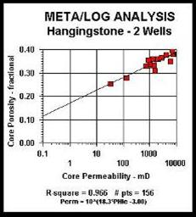
Step 6: Calculate permeability as a continuous curve versus depth, using the regression analysis in Step 5.

Steps 1 through 6 cover the conventional volumetric analysis of an oil sand, but we are not finished yet.

Step 7: Convert log analysis volumetrics to mass fraction values.
1: WToil = (1 – Sw) * PHIe * DENSHY
2: WTshl = Vsh * DENSSH
3: WTsnd = (1 - Vsh - PHIe) * DENSMA
4: WTwtr = Sw * PHIe * DENSW
5: WTrock = WToil + WTshl + WTsnd + WTwtr
Oil mass fraction:
6: Woil = WToil / WTrock
7: WT%oil = 100 * Woil

Typical densities are DENSMA = 2650, DENSW = DENSHY = 1000, DENSSH = 2300 kg/m3.
Step 8: A bitumen pay flag is calculated with a log analysis oil mass fraction cutoff, usually between 0.050 and 0.085 oil mass fraction. A gas flag should also be shown on the depth plots where density neutron crossover occurs on the shale corrected log data.

Step 9: Oil in place is calculated from the standard volumetric equation. However, some operators, especially surface mining people, work in tonnes of oil in place. This equation is:
1: OILtonnes = SUM (Woil * DENSoil * THICK) * AREA
Thickness is in meters and Area is in square meters.

If the oil equivalent in barrels or cubic meters is needed, the standard equation can be used:
2: OOIP = KV3 * SUM(PHIe * Soil * THICK) * AREA / Bo
Where:
KV3 = 7758 bbl for English units KV3 = 1.0 m3 for Metric units
AREA = spacing unit or pool area (acres or square meters)
Bo = oil volume factor (unitless)
OOIP = oil in place as bitumen (bbl or m3)

Recovery factor for surface mining operations is very high, maybe 0.98 or better. For SAGD, RF = 0.35 to 0.50 are used. Since we can't keep the steam away from the shaly sands, recovery will vary with the average rock quality in a SAGD project.
Water has a very high latent heat, so the volume of water to be steamed is as important to the economics as the volume of bitumen. High water saturation is bad news here, just as in conventional oil. Top water, top gas, and cap rock integrity are also major SAGD issues. The petrophysical analysis needs to look at the rocks well beyond the bitumen interval.
SPECIAL CASE – Mid-Zone and Top Gas
The conventional equation for porosity in a gas sand is:
1: PHIe = ((PHInc^2 +PHIdc^2) / 2) ^ (1 / 2)

This equation is accurate enough for most gas zones, but in very shallow gas sands, it will underestimate porosity. The above equation must be replaced by:
2: PHIe = ((PHInc^X + PHIdc^X) / 2) ^ (1 / X)

Where:
X is in the range of 2.0 to 4.0, default = 3.0.
PHIdc and PHInc are shale corrected values of density and neutron porosity respectively.

The exponent X is adjusted by trial and error until a good match to core porosity is obtained.

This porosity is then used to find water saturation as in Step 4, described earlier.

Many, but not all, gas zones related to oil sands have some residual oil. Hydrocarbon saturation needs to be partitioned between bitumen and gas by the following method:
3: Vwtr = PHIe * Sw
4: Vhyd = PHIe * (1 – Sw)
5: GasOilRatio = Max(0, Min((1 – OIL_MIN), (PHIDc – PHINc) / MAX_XOVER))
6: Vgas = GasOilRatio * Vhyd
7: Voil = (1 – GasOilRatio) * Vhyd

Where:
OIL_MIN = minimum oil volume in gas zone as seen on core analysis, could be zero.
MAX_XOVER = maximum density neutron crossover in a gas zone (fractional)
Figure 3: Calculated tar mass from log analysis (black curve) matches Dean-Stark
oil mass (black dots) in the mid-zone gas as well as in the bitumen interval.

Oil weight is calculated in a fashion similar to Step 7 described earlier, but using the partitioned oil and gas volumes.
CONCLUSIONS
Appropriate shale, porosity, and water saturation methods are required for a top quality oil sand analysis. Oversimplified methods are not sufficiently accurate.

Due to the incompatibility between the Dean-Stark total porosity model and the effective porosity model used in standard log analysis, we find that there is no point in comparing these two porosity values, except in perfectly clean sands. Direct comparison in clean sands offers no insight as to the correctness or otherwise of the porosity in shaly sands. Comparing tar mass is the only way to put both models on an equal footing. Oil mass is not difficult to calculate so there is no excuse to avoid doing the extra step.

Mid-zone gas and top gas may not receive the porosity they deserve using the standard density-neutron crossplot model. The modified equation, plus the hydrocarbon partitioning model, allow both accurate porosity and accurate oil mass to be calculated.

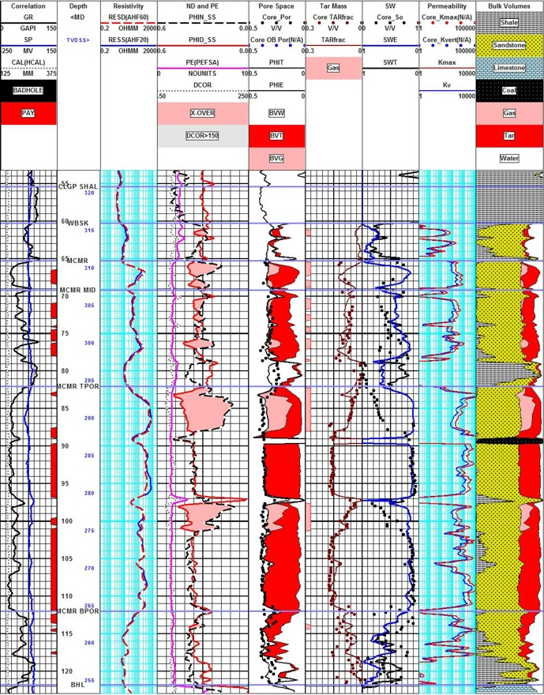
Figure 4: Oil sand analysis with top water, bottom water, top gas, and mid zone gas. Core and log data match - but oil mass (third track from the right) is the critical measure of success. Core porosity is less than total porosity and greater than effective porosity in shaly zones. Minor coal streaks occur in this particular area. Oil mass matches core extremely well, even in the mid-zone gas interval (pink shading in porosity track and in the density-neutron track), showing the efficacy of the hydrocarbon partitioning and gas correction models.

