POTASH PETROPHYSICS – THEN AND NOW
E. R. (Ross) Crain, P.Eng.
Spectrum 2000 Mindware Ltd
Published in CSPG Reservoir, Sep 2014
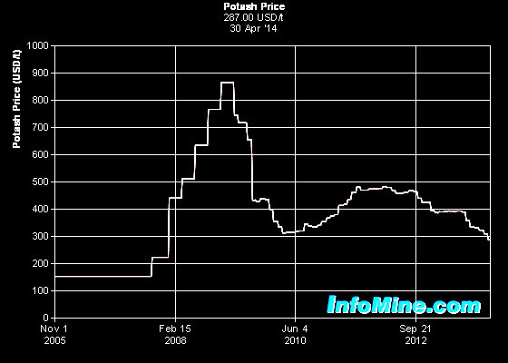
INTRODUCTION
Potash was a hot topic in the early 1960’s when I was a young logging engineer assigned at Lanigan, SK with one operator and a bread wagon (equivalent to today’s “cube-van”). We dripped oil-base mud into the motel and all along the Yellowhead from Saskatoon to Yorkton. Potash price peaks in 2010 encouraged a renewed interest in potash, especially on Indian Reserves and deeper plays where solution mining is more practical than subsurface mining.

Figure 1: Recent potash price per tonne FOB
Vancouver, courtesy InfoMine.com

The price peak in 2010 has subsided to more rational levels but exploration and development, not to mention talk of acquisitions and mergers, are still active. This level of interest has generated a modest amount of petrophysical analysis, using logs that date from the mid-1960’s to the present.

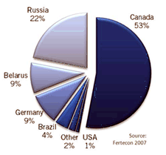
The major source of potash in the world is the Devonian Prairie Evaporite Formation in Saskatchewan, which provides 11 million tonnes per year. Russia is second at 6.9 million and the USA (mostly from New Mexico) at 1.2 million tonnes per year. A dozen other countries in Europe, Middle East, and South America produce potash from evaporite deposits.
Figure 2: Potash production statistics 2010
The main potash salts are sylvite, carnalite, langbeinite, and polyhalite, mixed in varying concentrations with halite (rock salt). The main use of potash is as fertilizer. Sylvinite is the most important ore for the production of potash in North America. Most Canadian operations mine sylvinite with proportions of about 31% KCl and 66% NaCl with the balance being insoluble clays, anhydrite, and in some locations carnallite.

PETROPHYSICAL PROPERTIES OF POTASH MINERALS
Potassium is radioactive so the gamma ray log is used to identify potash bearing zones. Potash minerals have distinctive physical properties on other logs, so conventional multi-mineral models can be used to determine the mineral mixture, just as we do in carbonates in the oil and gas environment.

Table 1 POTASH MINERAL PROPERTIES
Mineral Halite Sylvite Carnallite Insolubles Langbeinite Polyhalite Units
Formula NaCl KCl KMgCl₃●6H₂O Clay K₂SO₄Mg₂(SO₄)₂ K₂SO₄Mg(SO₄)(Ca(SO₄))₂●2H₂O
Potassium (K) Content 0.00 0.524 0.141 0.08 - 0.10 0.188 0.130 weight fraction
Gamma Ray 0 747 200 120 - 150 268 185 API Units (linear tool)
Apparent K2O Content 0.00 0.63 0.17 0.10 - 0.15 0.225 0.156 weight fraction
Hydrogen Index 0.00 - 0.02 0.60 0.30 - 0.40 - 0.01 0.25 fractional
Sonic Travel Time 67.0 74.0 78.0 90.0 - 120.0 52.0 57.0 microseconds per foot
Density (log) 2.03 1.86 1.57 2.35 - 2.65 2.82 2.78 gram/cc
Density (true) 2.16 1.98 1.61 2.35 - 2.65 2.83 2.79 gram/cc
Photoelectric 4.72 8.76 4.29 1.45 - 3.50 3.56 4.32 capture units

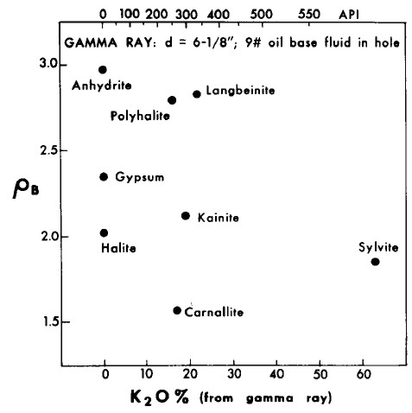
The Vp/Vs ratio for most salts is near 1.90, so shear travel time is about 1.90 times the compressional travel time given above.

A density versus K20 (or gamma ray) crossplot helps to define which minerals might be present.

Figure 3: Gamma ray versus density crossplot of
evaporite minerals used for mineral identification.

POTASH ANALYSIS CONCEPTS – OLDER LOGS
Since potassium is radioactive, the K2O content can be derived from gamma ray logs, and this technique has been used since the mid 1960's (Crain and Anderson, JCPT, 1966).

Most analog oil-field GR logs were non-linear above about 300 API units due to dead time in the counting circuit. These older logs are still available in the well files. The non-linear relationship is shown below. Digital tools from the 1980’s and onward were more linear. Hole size and mud weight corrections are still needed for both the old and the new versions of the logs.

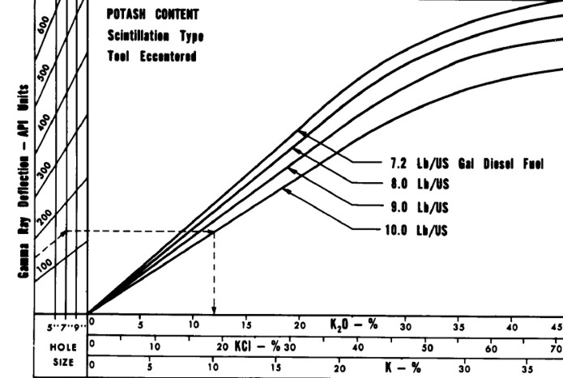
Figure 4: K2O versus Gamma Ray relationship for analog Schlumberger tools circa 1960 - 1980, run in open hole with oil based mud. Tools from other service companies may differ. Correlation between log and core assay data for specific cases is strongly recommended.

POTASH ORE GRADE FROM GAMMA RAY LOGS
K2O from GRc
GR API | K20
0 | 0.0
45 | 2.5
90 | 5.0
135 | 7.5
175 | 10.0
220 | 12.5
265 | 15.0
310 | 17.5
355 | 20.0
400 | 22.5
435 | 25.0
470 | 27.5
505 | 30.0
530 | 32.5
550 | 35.0
565 | 37.5
580 | 40.0
590 | 42.5
600 | 45.0
605 | 47.5
K2O content was derived from GRc using the lookup table shown at the right. It is linear up to 400 API units and exponential thereafter. Values in the table represent a 6 inch borehole filled with diesel at 7.2 lb/gal. The linear portion of the lookup table is represented by:
3: IF GRc <= 400
4: THEN K2O = 0.05625 * GRc
5: OTHERWISE Use Lookup Table

The slope in the above equation can be determined by correlation to core assay data for other hole sizes or other tool types.

The non-linear relationship must be honoured while analyzing these older logs for potash. The effect is negligible for conventional oil field applications. Modern digital tools are linear up to about 1000 API units so the discussion in this section does not apply.

NON-OILFIELD GAMMA RAY TOOLS
Many potash exploration wells in the USA and elsewhere were logged with slim hole GR tools intended for uranium work. While they may have been more linear, they were not usually calibrated to any standard, suffered from larger borehole effects, and were recorded in counts per second (cps). Specific correlations to core assay data on a well by well basis are required. For more on this, see Potash Analysis in Chapter 18, Green Economy Petrophysics.
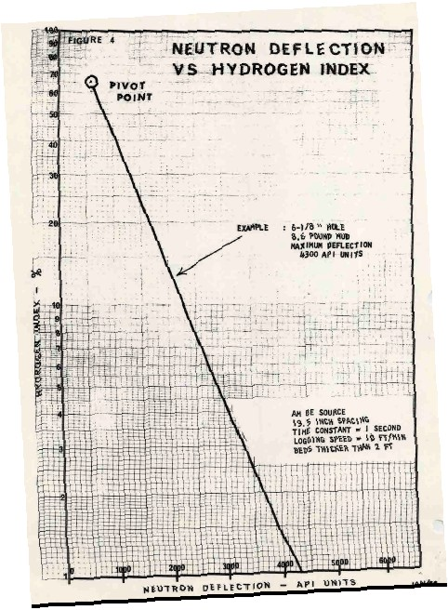
USING ANCIENT NEUTRON LOGS
Due to the water of hydration associated with carnallite, the neutron log is very useful for distinguishing between carnallite and sylvite. High neutron count rates mean low hydrogen index, thus sylvite and not carnallite.
Figure 5: Empirical neutron porosity chart for old neutron logs
To quantify the relative amounts of carnallite and sylvite, the neutron response must be converted to porosity from count rates using the standard semi-logarithmic relationship. A typical transform for a 1960's era Schlumberger tool is shown at the right. Charts for other tools can be found in ancient service company chart books. With the advent of the sidewall neutron log in 1969 and later the compensated neutron log, this transform was no longer required.
USING SONIC AND DENSITY LOGS
Some older wells were logged with sonic and/or density logs which also could be used quantitatively with the GR and neutron to provide a potash assay. This was important where core was lost or for regional exploration when core data, but not the logs, were proprietary. The logic behind these models is shown below. A later section of this article deals with the use of more modern logs.
POTASH ANALYSIS ModelS
The original computer program for potash analysis was written for the IBM 1620 in Regina in 1964. The model was based on four simultaneous equations that define the response of the available logs. Although this seems like a long time ago, nothing has changed except the improved tool accuracy.
Once K2O has been found from the GR, we can set up a set of linear simultaneous equations and solve them. The minerals sought are halite (rock salt), sylvite, carnallite, and insoluble (clay). The only logs available on old wells are resistivity, sonic, neutron, and total gamma ray. The resistivity is not a helpful discriminator, except as a shale bed indicator, so it is not used in the simultaneous solution.
In middle aged wells, the density log is also helpful, and in modern wells the PE curve can be added. Further, the gamma ray response is linear on modern wells so the transform to K2O is not as difficult to obtain.
The linear equations are:
1.00 = Vsalt + Vsylv + Vcarn + Vclay
K20 = 0.00 * Vsalt + 0.63 * Vsylv + 0.17 * Vcarn + 0.05 * Vclay
PHIN = 0.00 * Vsalt + 0.00 * Vsylv + 0.65 * Vcarn + 0.30 * Vclay
DELT = 67 * Vsalt + 74 * Vsylv + 78 * Vcarn + 120 * Vclay
K2O is obtained, after borehole correcting the GR, from the equations and lookup table shown earlier, or from a fresh correlation based on specific data from the wells under study. Note that the chart and table given earlier are in percent K2O and this set of equations expects fractional units for K2O, neutron porosity, and all output volumes. Parameters in the sonic equation are in μsec/foot.
When solved by algebraic means, these equations become:
1: Vclay = 0.0207 * DTC - 0.23 * K20 - 0.29 * PHIN - 1.3891
2: Vcarn = 1.54 * PHIN - 0.46 * Z
3: Vsylv = 1.59 * K20 - 0.41 * PHIN + 0.04 * Vclay
4: Vsalt = 1.00 - Vclay - Vsylv - Vcarn
These equations were derived with DTC in μsec/ft, PHIN and K2O in decimal fraction. All constants will be different if DTC is in μs/m.
To convert from mineral fraction to K2O equivalent (K2O equivalent is the way potash ores are rated), the final analysis follows:
5: K2Osylv = 0.63 * Vsylv
6: K2Ocarn = 0.17 * Vcarn
7: K2Ototal = K2Osylv + K2Ocarn
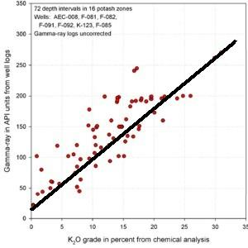
With a modern suite of calibrated logs, we can use conventional multi-mineral models to calculate a potash assay. With GR, neutron, sonic, density, and PE, we can solve for halite, sylvite, carnallite, clay (insolubles or shale stringers), and water (occluded in many salts as isolated pores). The potassium curve from a spectral gamma ray log might also prove useful, if the detector system is linear and does not saturate.

Figure 6: K2O vs GR correlation for a modern GR log

The mathematical methods are similar to those shown above, except that more log curves can be added to the simultaneous equation set, and constraints for occluded water can be replaced by specific numerical solutions.

If other potash minerals are present, such as polyhalite, these can be added to the equation set if enough log curves are available to maintain an exactly- or over-determined solution. Matrix rock properties for the minerals were shown earlier in this article. Water is treated as a "mineral" so that it can be segregated from the water of hydration in carnallite.

The first step is to correct the gamma ray for borehole and mud weight effects, using the appropriate service company correction charts. The other logs seldom need much correction as the potash is not especial deep or hot. However, if a water based mud was used, it will have a high salinity, so a salinity correction for the neutron log may be required.

The second step is to confirm the GR to K2O correlation using any available potash core assay data. Since modern GR logs are more linear than older tools, the relationship should be a relatively straight line and can be extended beyond the available core data, as shown in Figure 8.
POTASH ANALYSIS EXAMPLES
A sample of computed results from this log analysis model compared to core data is shown below. The GR was borehole corrected but no bed thickness corrections were applied.
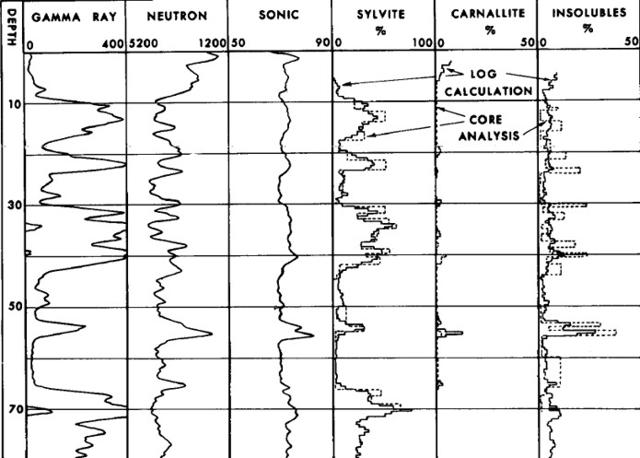Figure 7: Example log analysis showing excellent match to core data (Crain and Anderson, 1966). Raw data is shown but note the scales are opposite polarity to normal oilfield presentations.
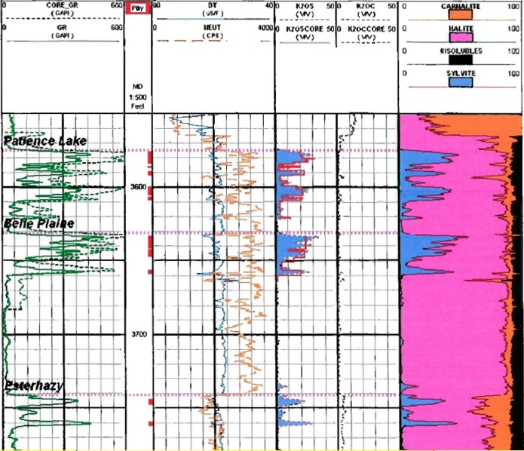Figure 8: Potash evaluation of 1960's logs with a modern log analysis program using Crain and Anderson’s original algorithms, calibrated to core data (see data in K2OS and K2OC tracks).
(Example log analysis courtesy Encanto Potash, analysis performed by Chapman Petroleum Consultants)

