PETROPHYSICS IN THE GREEN ECONOMY
PART 1 – WATER: FOR EVERY PURPOSE
E.R. Crain, P.Eng.
Published in CSPG Reservoir Jul – Aug 2022
INTRODUCTION
Water is the "New Oil". Like oil, water is valuable and has myriad uses. Like oil, water is wasted and mis-used. In many parts of the world, water for human and agricultural use is already scarce, contaminated, or too distant from potential users. Industrial uses compete against those needed to sustain life. The green economy will seriously impact availability and cost of water. For example, electrolysis of water to produce hydrogen as a fuel requires huge amounts of distilled water – where will it come from when the fresh water supply is already strained? None of the “net zero” goals has a plan for where the necessary water will come from or what it might cost.
Many parts of western North America, much of Australia, and elsewhere are struggling with drought and reduced river flows, affecting irrigation for agriculture and potable water supplies for cities.

These needs can be met at a cost – the cost of treating water from deeper sources, some of them containing meteoric water with low to moderate salinity. This article describes how petrophysics can locate the least costly, most useful water sources that can satisfy these new and growing needs.
POTABLE AND NEAR-POTABLE WATER
We use the term aquifer to describe a rock that contains water, as opposed to the word reservoir as used when the rock contains oil or gas.
Water that has been in the rock since the rock was formed is termed connate water. It's salinity can vary from saturated (300,000 ppm NaCl equivalent) to brackish (10 - 30,000 ppm). However, many aquifers outcrop at the surface, sometimes 1000s of miles away. These aquifers capture rainfall, often called meteoric water, which mixes with whatever connate water was there. Over millions of years, such reservoirs become fresher than nearby aquifers that do not receive recharge water from surface. Salinity often increases with increased depth, so any aquifer with a lower salinity than the trend may contain meteoric water, possibly fresh enough to be treated for use by humans, animals, or crops.
Aquifers are used for many purposes besides potable and near-potable water, such as waste water disposal, geothermal energy, CO2 sequestration, lithium extraction, and sources for oilfield water floods.
But protecting water that can be treated economically for humans, animals, or crops is paramount. That includes water up to about 10,000 ppm TDS as it is cheaper to treat than seawater.
Water sources are divided between surface sources (streams, springs, rivers, lakes) and underground, produced from shallow or deep wells.
Exploration for new sources of water makes use of existing well logs from oil and gas wells or from slim holes drilled for shallow water. From a petrophysical point of view, we are usually interested in the portion of the well below surface casing, because they have well logs that can tell us something about the quality of the rock and water. We can also use the water analyses from well tests or produced water. This information may be found in oil company well files, commercial data bases, or regulatory agency files. Some technical societies, such as the Canadian Well Logging Society and London Petrophysical Society, publish water resistivity catalogs that help us find meteoric water at depth.
The shallow interval in oil field wells behind surface casing is seldom logged. A gamma ray log for shale vs sand and a neutron log for porosity may exist. These give some rock quality information but nothing about the water quality. Water at these shallow depths is usually assumed to be of low salinity and a possible source of treatable water.
Water quality is divided, somewhat arbitrarily, into fresh, brackish, and saline. Fresh water is defined as having less than 1000 mg/liter total dissolved solids (TDS). Good drinking water has less than 300 mg/liter TDS but many shallow water wells run up past 500 mg/liter. Water with more than 10,000 mg/liter TDS are termed saline or salt water. Typical sea water has a salinity around 32,000 mg/liter, somewhat less in the Arctic regions.
Brackish water has a salinity between 1000 and 10,000 mg/liter TDS. Brackish waters are common, but need some treatment before use and deep wells are needed to produce them. Brackish water is often encountered during the drilling of oil and gas wells. Rock and water samples, and petrophysical well logs, are available from 10's of millions of oilfield wells. Considerable technical data can be derived about such aquifers and the water contained in them.
To put these salinities into terms of water resistivity (RW) at 25C (77F), the fresh water cutoff of 1000 mg/l is about 5.5 ohm-m, the brackish water cutoff of 10,000 mg/l is 0.55 ohm-m, and typical seawater of 32,000 mg/l is 0.20 ohm-m. Saturated salt water at 300,000 mg/l would have an RW around 0.030 ohm-m at 25C.
These values are near room temperature. Water resistivity decreases with increased temperature, which in turn increases with increased depth in the Earth. Arp's Equation is used to convert water resistivity from one temperature to another:
1: FT = SUFT + (BHT - SUFT) / BHTDEP * DEPTH
2: KT1 = 6.8 for Fahrenheit units KT1 = 21.5 for Celsius units
3: RW@FT = RW@TRW * (TRW + KT1) / (FT + KT1)
TRW is the temperature at which the RW was measured. This could be a lab (surface) temperature or a formation temperature. FT is formation temperature OR any arbitrary temperature for which an RW is needed.
Underground sources of drinking water (USDW) is the current term used to cover fresh and brackish water resources that could be exploited by drilled wells, in contrast to water from surface sources such as lakes and rivers. The base of fresh water (BFW) is the true vertical depth of the deepest aquifer that can produce water of a specified TDS. BFW can be contoured to provide insight into the disposition of USDW. Porosity-thickness and permeability-thickness maps can be generated from petrophysical analysis results. These give volumetric and productivity information that will aid water source development.
Some governments are taking more interest in USDWs. The US EPA defines any aquifer with less than 10,000 mg/liter TDS as potentially useful water for humans. Many aquifers in the USA are protected by the EPA, which means that these aquifers cannot be used for disposal of oilfield or industrial waste water. Other restrictions on use may also be in force in specific cases. Some aquifers are exempt from protection rules due to existing licenses that permit injection.
Shallow water wells are logged by observation of the drill cuttings and potential porous and permeable intervals are noted. Copies of the report are given to the well owner and to appropriate government agencies who assess and map aquifer quality and thickness. A pump-down test is used to determine flow capacity in gallons or liters per minute.
Very few petrophysical logs are run in shallow wells, although I ran a single point resistivity log using a crowbar taped to the end of the logging cable to find the porous interval in a newly drilled town water well (way back in 1964). Potable fresh water is high resistivity compared to clay and shale.
Deep wells drilled for water are logged with conventional oilfield tools.
Petrophysical analysis can tell you quite a bit about an aquifer – salinity, porosity, permeability, flow capacity, even potential flow rate. The need for drinking and agricultural water is paramount, but many industrial and energy related uses are growing rapidly as well. Whether you are involved with protecting underground water or exploiting it for hydrogen production, carbon storage, lithium extraction, geothermal power, waste water disposal, or enhanced oil recovery, you need to know about the water sources near your project.
Petrophysics, with help from other geosciences, will confirm the quality and quantity of water available – social needs and a strong moral compass will tell us how to share the most valuable resource in the universe.
USING WATER ANALYSES To Find Meteoric Water
Gathering water sample reports from oilfield tests or production are a good place to start a search for near-potable water. Each jurisdiction handles the collection and filing differently, so some local knowledge will be needed. Once the reports or summaries are located, make a spreadsheet containing things like well name and location, test depth, formation name, water resistivity, and NaCl equivalent salinity.
Below is a small sample from the CWLS 1987 Water Catalog, after a sort to bring the lowest salinity to the top of the list. There were 600+ samples in the <11,000 ppm category, gleans from 5500+ samples.
CWLS 1987 RW CATALOG FRESH / BRACKISH (< 11,000 ppm)
 | UID | LAT | LONG | RW@25C | CALC TDS
4627 | 100132800711W300 | 49.59515 | -107.44266 | 3.730 | 1,158
5285 | 109160600113W300 | 49.01274 | -107.71742 | 3.133 | 1,413
5113 | 100053100211W300 | 49.16563 | -107.46691 | 3.039 | 1,463
4663 | 109160600309W300 | 49.18748 | -107.19135 | 2.999 | 1,485
4957 | 100121900403W300 | 49.31488 | -106.40085 | 2.948 | 1,515
5358 | 109160605018W200 | 53.29223 | -104.61148 | 2.945 | 1,516
The CWLS 2002 Water Catalog has 10 times as many water samples and they are already sorted into "normal" and "recharge" samples. Some samples may be contaminated with mud filtrate so be sure that several samples confirm a possible source of near-potable water.
If there is no Water Catalog in your area, form a committee and get after it - get an expert to help review the chemistry for signs of mud filtrate contamination.
USING Log ANALYSIS To Find Meteoric Water
Most oilfield wells have no logs in the interval behind surface casing so shallow water sources are hard to find. If a gamma ray and neutron log were run to surface, it gets easier as we can assume all porous intervals are water bearing down to a certain depth, determined from existing water wells. The lack of a resistivity log over the shallow interval means we cannot determine water quality (salinity).
In ancient wells with only resistivity and SP, analysis is more difficult. The SP is usually flat and featureless so we must rely on resistivity. High resistivity is fresh or brackish water. Low resistivity is shale, clay, marl, or saline water. Beyond that, we are blind.
In wells that have a reasonable log suite, there are some techniques that are useful to evaluate water quality and well performance.
The usual results from analysis of well logs are shale volume (Vsh), total and effective porosity (PHIt, PHIe). Lithology (mineralogy), water saturation (Sw), and permeability (Perm). The first three results tell us how much water is present and what kind of rock it is in. The last item can be used to estimate initial flow rate of the water. In water zones, we assume water saturation (Sw) is very near 100% and use that fact to calculate the apparent water resistivity (Rwa). From that value, we can calculate the equivalent sodium chloride salinity (WSa) of the water, which in turn is a close approximation of the total dissolved solids (TDS).
Below are the details of the petrophysical analysis steps required for a complete evaluation of aquifer and water quality.
STEP 1: Calculate shale volume.
The most effective method is based on the gamma ray log:
1: Vshg = (GR - GR0) / (GR100 - GR0)
Adjust gamma ray method for young rocks using the Clavier equation, if needed:
2: Vshc = 1.7 - (3.38 - (Vshg + 0.7) ^ 2) ^ 0.5
To account for radioactive sands and volcanics, calculate Vsh from density neutron crossplot
3: Vshxnd = (PHIN - PHID) / (PHINSH - PHIDSH)
The minimum of these three values is shale volume Vsh. The spontaneous potential (SP) method is not very useful in fresh and brackish water zones.
STEP 2: Calculate total and effective porosity.
The best method available for modern, simple, log analysis involves the shale corrected density neutron complex lithology crossplot model.

Shale correct the density and neutron log data and calculate total and effective porosity:
4: PHIdc = PHID – (Vsh * PHIDSH)
5: PHInc = PHIN – (Vsh * PHINSH)
6: PHIt = (PHIN + PHID) / 2
7: PHIe = (PHInc + PHIdc) / 2

This model is quite insensitive to variations in mineralogy. A gas correction is needed for greater accuracy in gas zones, but this will not affect the results in water zones. A graph representing this model is shown below.
The shaly sand version of the density neutron crossplot is not recommended because it underestimates porosity in sands with heavy minerals.
If density or neutron are missing or density is affected by rough hole conditions, choose a method using the sonic and/or neutron logs will suffice.
STEP 3: Calculate mineralogy.
If the well penetrates a young sand shale sequence, this step is not usually required as there are few heavy minerals in the sands. In Lower Cretaceous and older rocks, choose a method from the Handbook Index appropriate for the log curves available.
STEP 4: Calculate permeability and flow capacity.
If the analysis is for water quality (salinity, TDS) only, this step is not required. If the aquifer is being assessed for injection of waste water or production of industrial or drinking water, this step is essential.
Estimate irreducible water saturation from porosity-saturation product using assumed Buckle's Number (KBUCKL). Graph at right shows the intimate relationship between porosity (vertical axis), irreducible water saturation (horizontal axis), permeability (diagonal lines), and Buckle's Number (hyperbolic lines running from top left to lower right). A constant Buckle's Number indicates a uniform rock type. The equation is:
8: SWir = KBUCKL / PHIe / (1 - Vsh)
Calculate permeability from Wyllie-Rose equation:
9: Perm = CPERM * (PHIe^6) / (SWir^2)
For coarse to medium grained sands, KBUCKL = 0.0300 to 0.0500, higher for fine grain, lower for carbonates. Default = 0.0400.
Default for CPRM = 100,000. Adjust to calibrate to core permeability.
Flow capacity is:
10: Kh = Perm * (BASE - TOP)
Where TOP and BASE are measured depths of top and base of this aquifer. Note that in a horizontal well, Kh is Perm times the length of the wellbore exposed to the aquifer.
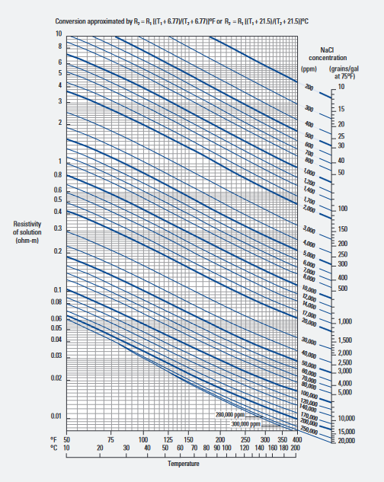
STEP 5: Calculate apparent water resistivity at formation temperature.
In relatively clean rocks, the Archie model using appropriate electrical properties is sufficient:
11: Rwa@FT = (PHIt ^ M) * RESD / A
It is useful to also calculate Rwa at 75F or 25C using Arp's equation, to allow us to compare log derived values to lab water analysis reports or water catalogs:
12: Rwa@75F = Rwa@fT * (FT+ 6.8) / (75 + 6.8) with temperatures in Fahrenheit
OR 13: Rwa@25C = Rwa@fT * (FT+ 21.5) / 275 + 21.5) with temperatures in Celsius
FIGURE 1: Graph of Arp’s Equation showing the relationship between water resistivity, temperature, and salinity .
RECOMMENDED PARAMETERS:
for carbonates A = 1.00 M = 2.00 (Archie Equation as first published)
for sandstone A = 0.62 M = 2.15 (Humble Equation)
OR A = 0.81 M = 2.00 (Tixier Equation - simplified version of Humble Equation)
STEP 6: Convert Rwa@FT to NaCl equivalent (ppm) and TDS (ng/l)
Calculate formation temperature:
14: FT = SUFT + (BHT - SUFT) / BHTDEP * DEPTH
IF FT is Celsius, convert to Fahrenheit
15: THEN FT1 = 9 / 5 * FT + 32
16: OTHERWISE FT1 = FT
Using Crain's Equation inverted for water salinity WSa in ppm NaCl equivalent:
16: WSa = 400000 / FT1 / ((RWa@FT) ^ 1.14)
An alternate method Baker Atlas (2002)
17: WSa = 10 ^ ((3.562 - (Log (RW@75 - 0.0123))) / 0.955)
Convert WSa (ppm) to TDSa (mg/l) using the density of the water plus its solute:
18: DENSw = 1.00 + (WSa * 2.16 / 1000000)
19: TDSa = WSa * DENSw
CAUTION: If hydrocarbons are present, Rwa will be higher and TDSa will be lower than the truth. Always investigate the well history file, especially the sample log, for indications of oil or gas in the interval to be studied.
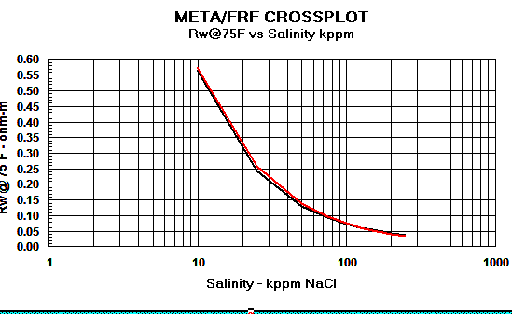
Graph 1: Rw Models - Red line = Crain, Black = Bateman and Konen, Blue= Kennedy
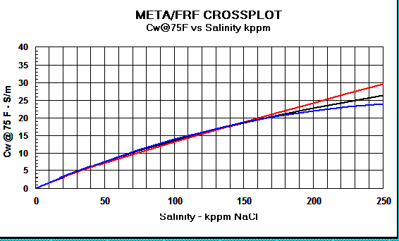
Graph 2: Cw Models - Red line = Crain, Black = Bateman and Konen, Blue = Kennedy.
LOG ANALYSIS EXAMPLE – AQUIFER EVALUATION
The example in Figure 2 shows how conventional petrophysical analysis can assist in evaluation of potential water wells. The salinity curve, derived from the porosity and resistivity log data, can be used to determine the base depth to any given water quality (salinity).
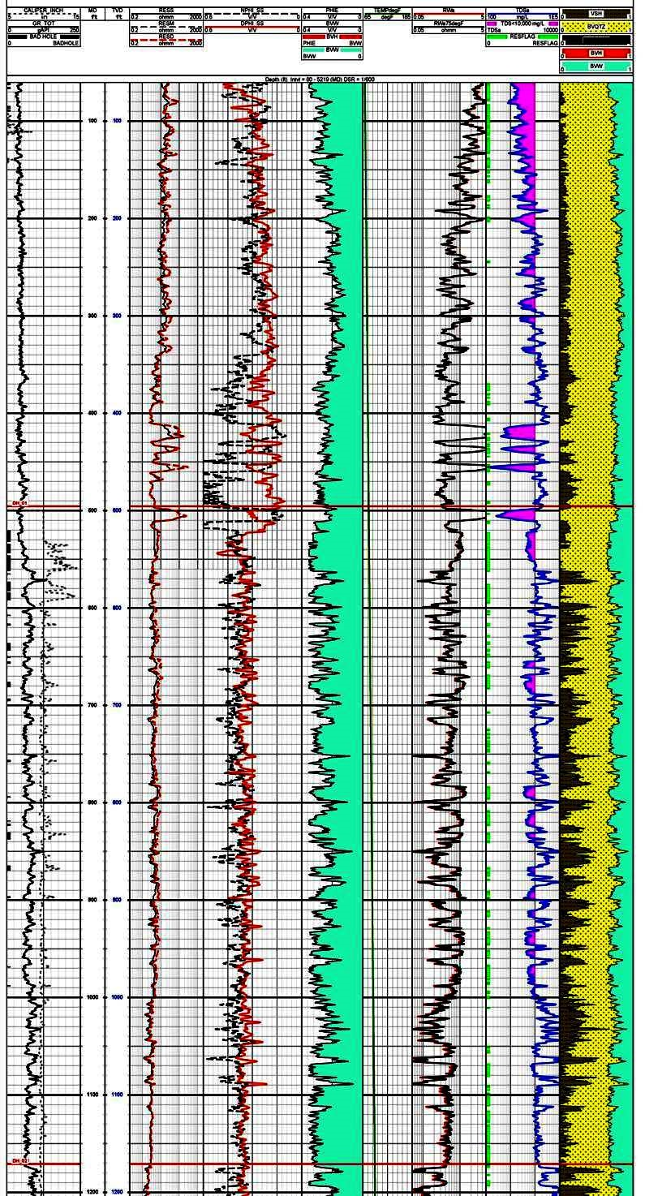
FIGURE 2: Track 1 contains gamma ray and caliper, Track 2 is deep resistivity, Track 3 is density and neutron porosity. This raw data is used to calculate shale corrected porosity (Track 4), apparent water resistivity (Rwa in Track 5), and salinity in Track 6. The right hand track shows the lithology with shale volume shaded black. The salinity curve is shaded between the curve and 10,000 ppm total dissolved solids (TDS) to help identify useable water sources. Note that TDS values in shaly zones seldom indicate useful water zones. (Image courtesy Aptian Technical).
ACKNOWLEDGEMENT
Thanks to Dorian Holgate of Aptian Technical for providing the example in Figure 2.

REFERENCE
1. Crain’s Petrophysical Handbook online, 2022
Chapters 5, 11, 12, 13, 15,

